Marinus van der Made
Marinus van der Made, was born 29 of May 1916 in the village Made in Holland.
A Dutch Korps Marinier on the Hr.Ms Piet Hein, Marinus was taken prisoner of war in 1942.
Suffering abuse at several POW slave labor camps, Marinus arrived in Fukuoka Camp 17 on 19 June 1944
with group of Australian, British & Dutch POWs on the hellship Teia Maru.
Many of the men were coming from Burma-Thailand railroad on the Frenchboat, the Aramis. The Aramis (French
Boat) is the same as the ship Teia Maru. The Aramis was seized by the Japanese and dubbed the Teia Maru.
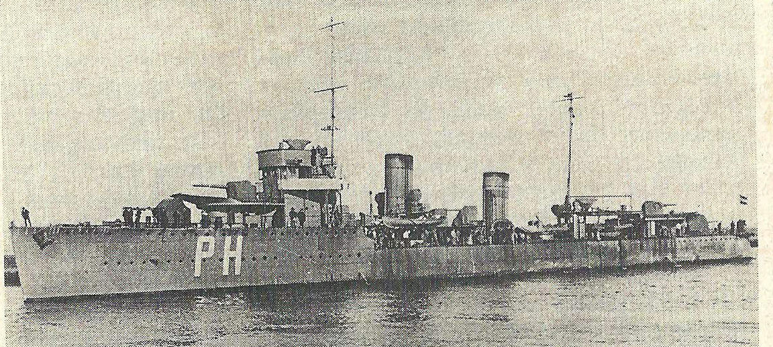
His marine ship, the Piet Hein (photo above), was torpedoed in the gulf of Siam and was 48 hours later sent with some survivors on Bali. Marinus Made's POW camps included...
He became free on 15 September 1945. The Red Cross organization deported him to Manila with a Dutch Army Chaplain named Pastor Cools from Rotterdam Holland.
Later he traveled by Red Cross support with a group Dutch POW's to New York where they where shipped on the Queen Mary to England. His friend, the Dutch Chaplain Cools was the one who had taken care of the POW's the last mouths in Camp Omuta. Pastor Cools also was on the Brewster and the Queen Mary.
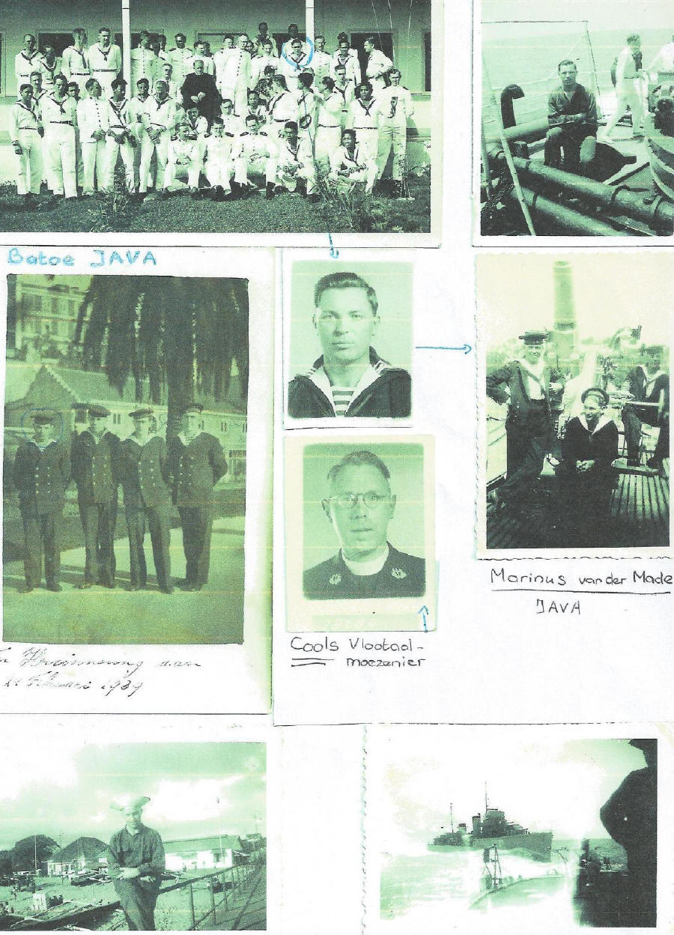
Rank or position at the last position: Corporal Machinist.
Last Post for a prisoner: Her Majesty Piet Hein.
2 September 1936 acted in the service of the Royal Dutch Navy as a stoker military.
Promoted:
8/09/1937 to third Class Stoker
01/07/1938 to second Class Stoker
07/01/1939 to first Class Stoker
01/08/1940 to Stoker o/m
01.12.1941 to Corporal Machinist
Placements on board:
Her Majesty Medusa from May 1938 until August 1938
Her Majesty Z. 5 from September 1938 until February 1939
Her Majesty Destroyer in May 1939 to March 1942
Established in prisoner of war held on February 20, 1942.
Stayed in the camps:
Bali from February 1942 to April 1942
Java from April 1942 to October 1942
Singapore from October 1942 to January 1943
Thailand from January 1943 to June 1944
Japan from June 1944 to August 1945

Photo left is of Marinus and his bride, A.J. van Gils (called Jaantje) on 5th of September 1945
Photo center is Marinus near the Dutch Memorial for POW'S of WWII from Japan ~ in the Hague of their diplomatic town.
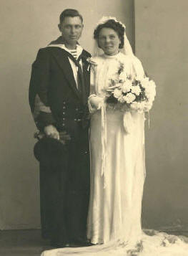
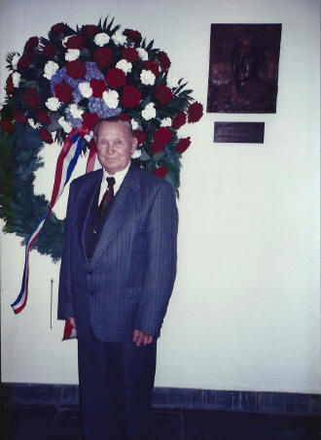
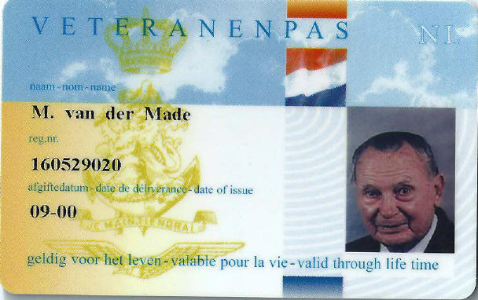

Submitted by his daughter, Jeanne Bot – van der Made

Click here for more photos and documents Biographies Page Main Page

