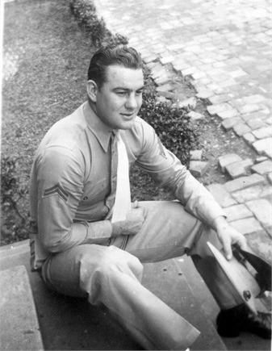
James Howard Malone
Obituary

HOWARD MALONE IS KILLED IN KANSAS
Former Fairfield Boy, Son of Mrs. Nell Harper Here, Dies Instantly in Wreck
Howard Malone, 32, former Fairfield boy, Son of Mrs. George Harper here was killed in a car accident near Ulysses, Kansas Thursday afternoon. His car struck a sand bar which had formed on the road and overturned. He was instantly killed. Malone had been working the past six months at Ulysses as a salesman for a car and farm implement firm.
A member of the Marine Corps for nine years, from 1940, Malone was a Japanese war prisoner four years and was a survivor of the famed Bataan death march.
James Howard, son of Oga Malone and Mrs. Nell Harper, was born in Wayne County September 3rd, 1921. Early in life he united with the Pin Oak Baptist church. He attended Fairfield Schools.
On August 26th, 1946, he was married to Ann DeAngelis, of New Orleans, La. To this union three children were born: Sharon Ann, Age 6; James Howard Jr., age 5; and Charles Lee, Age 2.
Surviving are his wife and three children of Salem, Oregon; his father, Oga Malone of McLeansboro; his mother, Mrs. Harper of Fairfield; two brothers, Bernard, of Alton, and Wilburn L. of Fairfield; One sister, Mrs. Mildred Atchinson of Rock Falls; a step-father, George Harper of Fairfield; a step-mother, Mrs. Elizabeth Malone; three nephews and two nieces.
Wayne County Press, Fairfield, Illinois

Submitted by his cousin, Linda Adams

