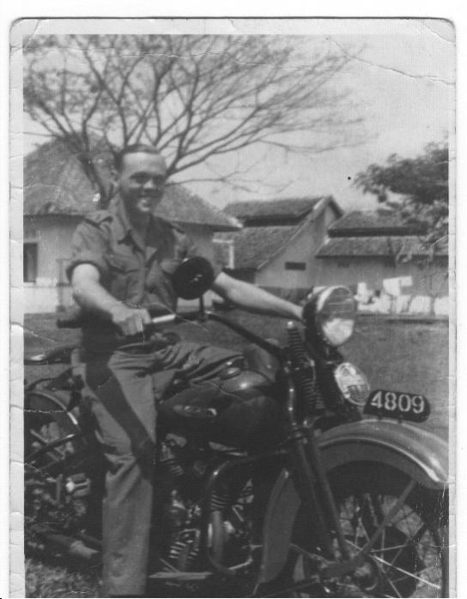
Herman MenGerink
Table Life-Time for Herman MenGerink
Incident | Date | Place
Birth | 9 september 1920 | Enschede Nthl
Enrolment Royal Dutch Indian Army | 1938 | Nijmegen
Imprisonment to Japanese Army | 1942 | Java, Dutch Indies
Liberation Japanese Imprisonment | August 1945 | Probably in vacinity of Nagasaki, Japan.
Transport to Philippines | August – December 1945 | Japan – Philippines to American Camp.
Commitment as MP in KNIL | First Half 1946 | Sumatra
Commitment in liberation war Indonesian rebels  Promotion to corporal | 1946/1948 | Dutch Indies
Visit Netherlands  Marriage  Return to Dutch Indies | 1948 | Netherlands  Dutch Indies
Independence Indonesia  Dutch retreat  Embark to Netherlands | 1950 | Indonesia  Netherlands
Transition to Dutch Royal Army | 1950 | Netherlands
Death | 11 February 2005 | Netherlands
Submitted by Herman’s son, Rob MenGerink.
In a conversation with Rob, he told me, “My father has had a hard life, because of these terrible experiences and because it has influenced his further life as well. I know he tried and found some good years in Australia once out of the Dutch army. In the end he suffered because in his mind he had to relive the terrible memories because of his illness. In the end he found his peace. He died in 2005.”

