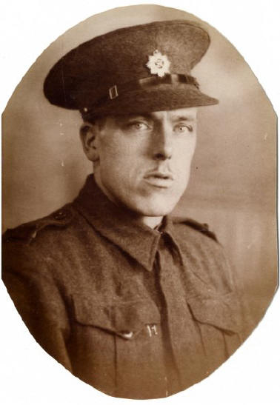
WALTER MORRIS
British Driver - Royal Army Service Corps
Service Number: T/71223
Died in Camp 23 December 1944: aged 32,
of acute enteritis and beri beri
Buried at Yokohama Cemetery

Dedication and photo submitted by grandson - David Morris

