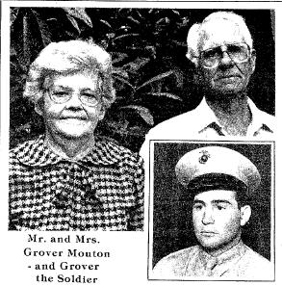
Grover Ernest Mouton
The Story of a Flag - But not just ANY flag!
In August 2005 one of the many e-mails I received regarding my website came from Tommy Mouton son of Grover Ernest Mouton, Camp 17 POW # 438. Grover Moulton was one of the original/first 500 prisoners of war to enter Fukuoka Camp 17, arriving in August of 1943. After other POW arrivals to the camp these men referred to themselves as “The old 500”.
In his e-mail Tommy wrote that he had in his possession “...the Japanese Flag which flew over the camp at the time the Bomb was dropped. My dad and a friend shimmied up the pole, obtained the flag and apparently circulated it for signatures. I have never counted the signatures on the flag but I guess there are 50 - 75 Signatures”. Later, upon closer inspection for detail Tommy would write “ …
I counted approx. 100 signatures; I can read the majority of them and can probably compile a list for you. I don't know how many signatures were POW's in his camp since he left early on. I noticed a couple of signatures had "war correspondence" next to their signatures.
(I was to wonder, and ask Tommy, if one could perhaps be that of George Weller, the Chicago Sun Correspondent so many of the POW’s spoke of; the first war correspondent into camp upon liberation).
In a following e-mail Tommy wrote the following about the flag and his father…
“the flag was in a local museum but it now hangs in my living room. I believe most of the signatures may be from individuals he met as he was trying to leave Japan. I know he and some friends left the camp as soon as it was abandoned. I never asked about the signatures, I'm sure some are from POW's in the camp. My dad and mom raised 8 kids, 7 boys and 1 girl, the flag hung in one of the boys room for years when we were young and didn't really understand the value or meaning at the time...in other words...the flag was not taken real good care of...that's how my dad was, family first.... My dad died approx. 10 years ago and told us some of what he experienced. My dad however never complained to anyone and was a Saint of a person.
Note: Unfortunately I have lost contact with Tommy Moulton as his e-mail address is no longer in service. If you read this Tommy, please contact me.
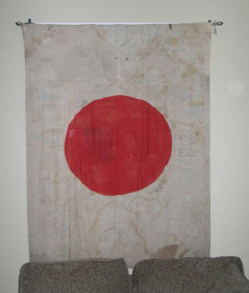
Flag Brought Home by Grover
Unfortunately I lost contact with Tommy before he
could make a file of the names and information on the flag.
If anyone recognizes a name, please contact me.
I can send you the original photos.
Linda – Fukuoka Camp 17 Project Manager:
lvbataan@gmail.com
News articles follow flag photos (see below)

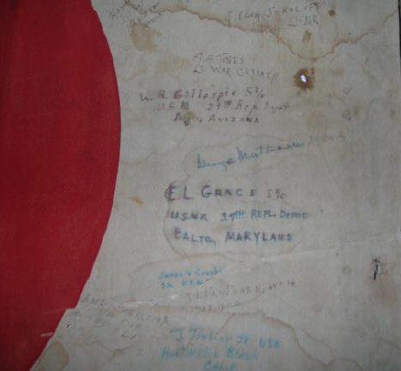
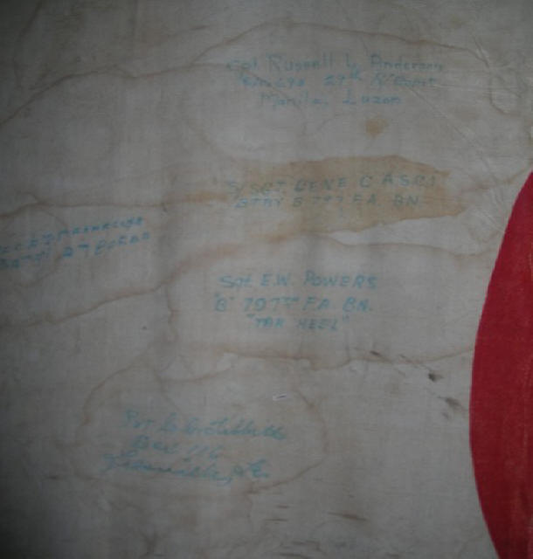

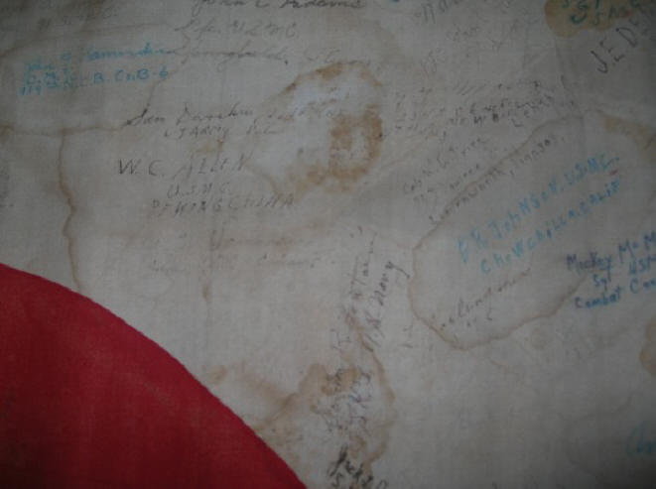

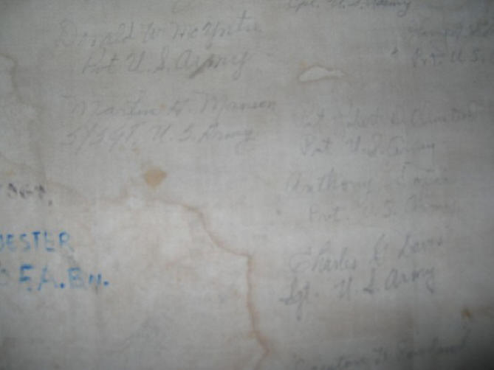

More info – Next Page
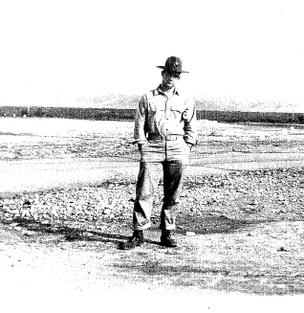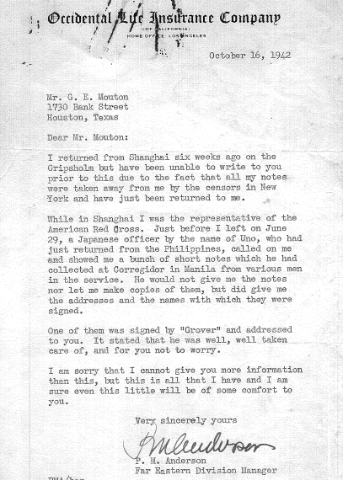
Grover in San Diego – Pre War

