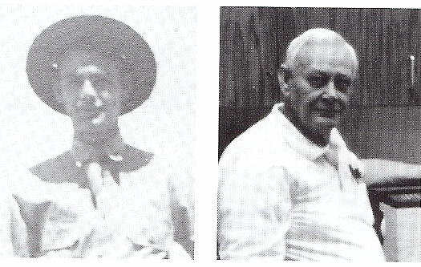
LOUIS G. MUELLER, JR.

LOUIS G. MUELLER, JR., was born Jan. 12, 1921 in St. Joseph, MO.
He enlisted in the Army November 1939 and was shipped out to March Field, CA.
Assigned to 234th separate Q.M. Co., he went to the Philippines October 1939.
There Louis was assigned to 33rd Q.M. Truck Co. C. He spent most of his time servicing the units trucks getting ready to the go to the Burma Road. The outbreak of war prevented this move. Once war did come to the Philippines, Louis drove with a large convoy to Bataan, but then back to Manila port area to salvage anything useable, food, clothing, ammo, etc. He lost two trucks, one by Japanese planes, the other being forced off a mountain road, of which he survived.

He was forced to make the Bataan Death March, then being interned at Camp O’Donnell, Cabanatuan, Bilibid Prison, Las Pinas. He spent the last year in Japan mining coal at Fukuoka Camp No. 17.

Louis returned to the States in September 1945, re-enlisting and retired Army, March 1960. Louis worked civil service until 1978. He married Irene V. Kinney in 1947. They raised seven children, and now have eight grandchildren. They live in the Valley of the Sun, Mesa Arizona.

Credit: History of the Defenders of the Philippines Guam and Wake Islands 1941-1945 Turner Publishing Co

