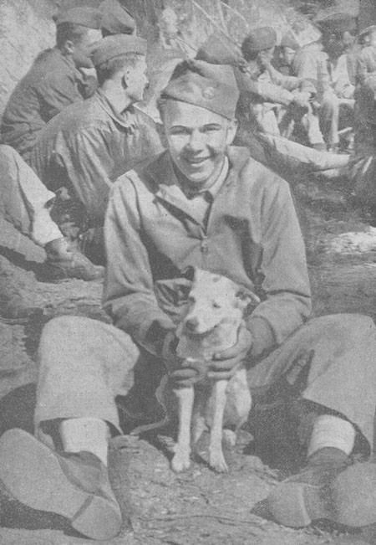
Robert Vaughn Parr
Pvt. Robert V. Parr was born in Fort Dodge, Iowa on December 9, 1918, and grew up on the north side of Chicago.
He graduated from LaSalle Grade School in 1932 and Lane Technical High School in 1936.
In 1941, Robert was drafted into the army. He took his basic training at Fort Knox, Kentucky, and was then assigned to B Company, 192nd Tank Battalion. This was done because the army needed to replace the original National Guardsmen who had been transferred from the company to Headquarters Company when it was created. At this time, the army was still trying to fill vacancies in in the company with "drafties" from the home state of the company.
Robert recalled that there were only three tanks for training. This meant that the members of the company were given KP or guard duty frequently. Due to the limited number of training tanks, when the soldiers did train in the tanks, they would almost always train with different members of the company. Robert took part in maneuvers in Louisiana and then sent to Camp Polk. There, the battalion was informed it was being sent to the Philippine Islands for further training. After saying his goodbyes, Robert reported back to Camp Polk and with his company sent to Angel Island in San Francisco Bay. There they received the required shots and boarded ships for the Philippines.
Photo Pvt. Robert V. Parr and Company B mascot "P 40" on the Island of Luzon. Courtesy of William Hauser Family.
The first part of the trip was normal, it was only after the transports left Hawaii that the soldiers realized how serious the situation they were entering was. The second portion of the ship was done in complete blackout. When a ship was spotted by the convoy, and it did not identify itself, the escort destroyers went after it.

Upon arriving in Manila, the soldiers were boarded onto trucks and sent to Fort Stostenburg. For the next two weeks, they spent their time preparing their tanks and ammunition for the additional training they were expecting.
When the news of the attack on Pearl Harbor reached the Philippines, Robert and the other tankers were sent to guard Clark Field. The tanks were positioned around the perimeter of the airfield. At lunchtime, each tank crew was allowed to send tow members at a time to get a meal. It was at this time that the soldiers spotted bombers approaching the airfield. At first, the men thought the planes were American. It was only when the explosions began that they realized that the planes were Japanese.
For the next four months, Robert and the other tankers fought to stop the Japanese in the Philippines. This in Robert's opinion was an impossible task since they had no navy or air force and were low on rations. In addition, what supplies they did have were leftover from World War I. Despite of this, what kept the Americans going was the belief that help was on the way. Robert recalled that he and the other soldiers heard that a convoy was on its way with troops and ammunition. Three days later, he and the other soldiers were told that the convoy diverted to Australia because it could not get through the Japanese blockade of the Philippines. It was then that Robert knew the defenders on Bataan were doomed.
When the surrender came, Robert like the other soldiers of his company destroyed whatever they believed that the Japanese could use against Corregidor. He then marched to Mariveles on the southern tip of the Bataan Peninsula and started the march from there. Robert remembered the march as an event were everything was bad. There was no food or water, and the prisoners had the hot Filipino sun beating down on them.
Suffering from a stomach wound, Bob was having a difficult time keeping up with the other members of B Company. He began talking about "dropping out." The other members of the company kept telling him that if he did he would be killed. To prevent this from happening, Sgt. Nick Fryziuk carried Bob "piggyback" style for most of the last thirty-five miles of the march.
As a Prisoner of War, Robert was first held at Camp O'Donnell. He was then sent to Nichols Field to build runways. Afterwards, he was returned to Cabanatuan. Next he was sent to Bilibid Prison in Manila. From there, he was boarded onto a "Hell Ship" for Japan.
The ship that Robert was put on for the trip to Japan was Canadian Inventor. The ship sailed from Manila on July 4, 1944, but returned to Manila. It sailed a second time on July 16th. During the voyage, the Canadian Inventor stopped at Takao and Keelung, Formosa. It then sailed for Naha, Okinawa before finally arriving at Moji, Japan on September 1, 1944. When the ship finally arrived in Japan, the trip had taken 62 days.
In Japan, Robert worked in a coal mine at Fukuoka Camp #17. He recalled that the prisoners in the camp did not always know how the war was going, but there were times that they heard some news. The prisoners knew the war was over the day they were told that they did not have to go to work. Later, they officially were told of the surrender.
Robert was liberated from Fukuoka #17 and returned to the Philippines. After gaining weight, he was sent home to Chicago in November of 1945. He married and raised a family. Robert V. Parr passed away on October 7, 2006 in Sarasota, Florida.

