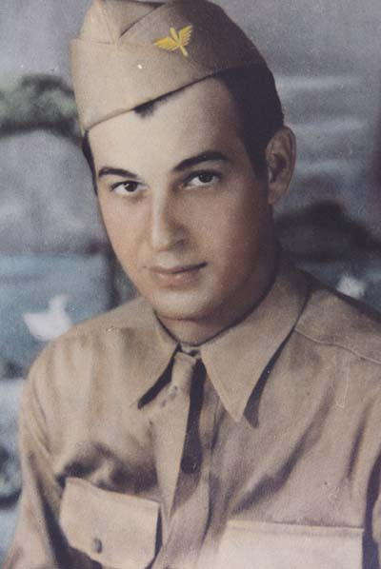
Wayne J. Petrie

Wayne J. Petrie was born in Milton-Freewater OR. on September 18, 1918. He grew up in Touchet, WA., moving to and graduating from Lewiston High School (Lewiston, Idaho) in 1937. Wayne enlisted in the Army Air Corps (now the USAF) in 1941. Upon completion of Basic Training Wayne was shipped to the Philippines, on the Island of Luzon, in May of 1941.
Eight hours after the bombing of Pearl Harbor, Japan attacked the Philippines. The newspapers would call it "The Newest Alamo". Eisenhower would state, "Never has so much been done with so little" due to the 4 1/2 month heroic stance of troops outnumbered by the entire 15th Imperial Japanese Army. Wayne was among the last troops to hold the final MLR becoming wounded in the final days of the battle. For this he would receive the Purple Heart.
Starvation, disease and lack of weapons and supplies forced the American and Filipino Troops to surrender the Bataan on April 9, 1942. The next 42 months of mental and physical torture were survived only by "a will to live and a faith in prayer", Wayne stated.
Recalling the infamous Death March Wayne stated, "It was indescribable. For 24 days the Japanese marched us on one meal and very little water. Some soldiers had no food and little water for a full ten days. We moved at a snail's pace and those who were too weak to keep going were bayoneted or shot."
"We were finally imprisoned at Camp O'Donnell, 20,000 of us."(camp photo) The final number would be over 60,000 POW's from at least four different nations. Wayne's first assignment would be burial detail. "There was one spicket of water available. We finally sent details to a stagnant pond. Malaria broke out. Several hundred American and Filipino POW's died daily. Escape was nearly impossible. The Japanese told us that for each American to escape, ten would be shot. Once when an American escaped, the POW's were forced to sit in the hot sun wondering who they would pick to die. Since we were all numbered the guards selected men with numbers 5 below and 5 above the escapee. Our boys were forced to dig their own graves."
By early June the Japanese began moving POW's to three camps all named Cabanatuan.
Eventually all three would be combined into one camp. Wayne would be interned in Cabanatuan until the summer of 1943. One of the worst camps on the Philippines, Wayne would take the advice of a doctor and volunteer to get on a labor detail in Japan.
Wayne had no idea of the "whole kind of new hell" he would have to survive as he was shipped to Japan on the "Hell Ship" Clyde Maru. This ship was a captured freighter. He would arrive in Mojo, Japan on August 9, 1943. There he would travel by train to Fukuoka Camp #17 near the town of Omatu. Little did Wayne know that Fukuoka 17 would become known as one of the worst Japanese slave labor camps of WWII.
"I was there two years, 10 days and 8 hours", Wayne recalled. We were forced to work in the coal mines which had previously been condemned, 18 hours a day with one day every 11 days for rest. This one day of rest was spent cleaning camp for Japanese inspectors and standing at attention the hot sun for 8-10 hours at a time. Wayne told of a high number of broken bones received in mine accidents. Some purposely inflicted to avoid the severity of the work. "There were 1,732 men in camp. 1,400 received broken bones from mine accidents. There were 250 amputations of legs and arms that I know of", Wayne recalled. "In the two years I was there (at Fukuoka 17) we lost at least a man a day to accidents in the mine, starvation and brutalities."
Wayne himself was injured in a mining accident. The roof caved in with five men buried underneath. Wayne's left hand was broken and he was given two days rest for what would have been a two month rest in an American hospital.
Wayne recalled frequent beatings, explaining that the Japanese preferred a club or baseball bat to beat prisoners. They also used whips, belts and ropes. "We came to think a slap or hit two to three times a day was nothing. We usually were beaten without provocation." Many of the beatings were for such things as failure to bow, ask permission to use the latrine, or follow orders quick enough to suit the guards.
Finally the Allied forces began to bomb the area and Wayne recalled cheering. Fukuoka 17 was never officially liberated, the guards simply walked away. When the country collapsed due to the atomic bombs, "...about 15,000 soldiers were grateful, otherwise we would have been in direct line of the allied bombings." Some of the men left the camp as soon as the guards deserted it. Wayne was one who did not wait for help to arrive, but instead commandeered a freight train and went to the northern part of the island from which he and fellow prisoners were shipped home. The USS Joseph Dyckman would take Wayne to San Francisco. After receiving medical attention, he would be transferred to Fort Lewis for a series of medical check-ups and rest. From Fort Lewis Wayne would gain transportation to Lewiston, Idaho, arriving home 2 weeks before Christmas of 1945.
Sgt. Wayne J. Petrie would be officially discharged from military service on March 17, 1946 almost 4 1/2 years to the date of the beginning of the heroic BATTLE FOR THE BATAAN.
Wayne’s Outline of War Events
MARCH 4, 1941 - MARCH 17, 1946
1. Enlisted in the United States Air Corps March 4, 1941. Shipped overseas, from San Francisco May 1, 1941, arriving in Manila. Stationed at Clark Field, now known as Clark Air Force Base, on the island of Luzon.
2. November 1941 Wayne’s Squadron was moved to Nichols Field, thus avoiding the attack which would take place on Clark Field.
3. 8 hours after the bombing of Pearl Harbor, on Dec. 8, 1941 (due to time zones), Japan attacked Clark Field.
4. Approximately 12,000 Air Corp men, mostly ground and bomber personnel, were formed into the Provisional Air Corps Regiment. This would be an infantry battalion. It would be divided into two battalions, Wayne being in the 2nd Battalion. They would later make up part of Bataan’s MLR (Main Line of Resistance) near the east coast. This small regiment would have the distinction of being the only all-American Unit to serve in either of the two Bataan fronts during the Battle. (Not to be confused with the 31st, which was the only all-American fighting unit, however the 31st did not fight on both of the battlefronts.)
5. January 7, 1941 MacArthur gives the command of the Bataan to General Jonathan M. Wainwright. General Wainwright would divide the troops into 2 Corps, known as Corps I and Corps II. Wayne was assigned to Corps II, and the overall command was given to Major General George F. Parker. Other commanders for Wayne’s Squadron would be: Col. Irwin E. Doane, General Cliffton Bluemel, Lt. Col. David L. Hardee, Capt. John Coleman and Brig. General Edward P. King
It would later be noted that Wainwright & Bluemel in particular would be greatly admired by all the men they served. Each would risk their lives more than once, each being called, “A soldier’s soldier”. Both would go down in history as putting up a ”stubborn and gallant fight”, fighting beside their men to the very end. Now would be a continuation of what would be “4 months of living hell” for the men defending Bataan. Newspapers around the world would call it “The Newest Alamo”.
6. The Japanese broke through the left flank of Corps II which was the Mauban-Abucay Main Line of Resistance. These units would have to withdraw to a defensive position behind the Pilar-Bager Road. (see map) This is the line that Wayne’s Squadron was holding, a line than ran from Bagac to Orion. Also known as the Bagac-Orion MLR, it was divided into four sectors. These were named Sectors A, B, C and D. Wayne was in Sector B, which would be the right flank, defending a 4-mile branch road, a cut off road that went from Orion to the beach. By Jan. 26 all Corps II units fighting this area would have withdrawn to this line. It would become the final MLR before a final withdraw.
During this time period (January) the men defending Bataan were down to 1/2 rations. This would amount to less than 1,000 calories a day by March. It would consist (depending upon what unit received what supplies) something in the order of 8 oz. of rice, 4 oz. of bread per man, per day, with 2 oz. of milk and 1 small can of salmon for every 15 men. By the final end many, especially those on the front lines who did not receive supplies as easily, would have gone 2 or more days without food. Then their food being what little they could scrounge for in the way of lizards, monkey, bugs, greens or anything else they could find. Disease, illness and starvation would have as many as 40 a day dying in foxholes. Some men too exhausted to even lift their rifles.
7. March 31st, Good Friday and a Japanese holiday celebrating the death of the first Emperor of Japan, the Japanese began an all-out bombardment of Bataan. Five hours of this had windows 30 miles away in Manila shaking. By April 3, 1941 the final Japanese attack began.
Because Wayne mentions his injuries as being bomb fragments received during the Battle for Bataan, we can guess that it was during the final Battle for Bataan that he was injured. Most of the fighting on the MLR was artillery, the heavier bombardment being in the final days of the battle. The hardest fighting done by the Provisional Air Corps was on this MLR and they held the line, along with only one other unit for their Sector (Sector B) until the final withdraw before surrender. This is reason to believe it was during the first week in April that Wayne received his injuries and that he was involved in the final battle.
At the time of the Battle for Bataan there were over 90,000 American and Filipino troops in a 200 square mile area, having withdrawn to the Peninsula of Bataan. The final battle would be one of the greatest battles of our nation’s history in regards to the fortitude of holding the MLR’s under circumstances of disease and starvation. Yet still today this part of WWII history is greatly ignored, as your government does not want to admit it how ill prepared it was, nor how it abandoned our own troops.
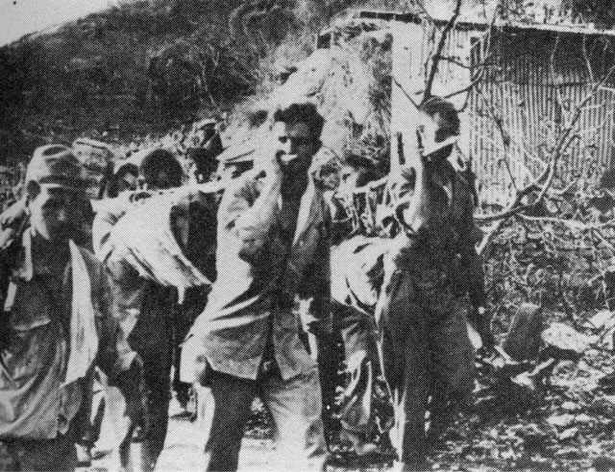
8. On April 7, the Japanese Nagano Detachment attacked the American Provisional Air Corps as they were the sole possessor of Sector B, other units having to withdraw to the San Vincente Line. Heavy attack began by 9:00 a.m. By 10:00 a.m. Capt. John Coleman led the withdraw of his airmen. This triggered a domino-effect collapse of the entire line as, not long after that, reacting solely to the impact of the bombardment, the 32nd Infantry and the 51st Combat team followed suit. Whenever a stand of any kind was attempted, according the Col. Young of the 51st, low flying planes that bombed or fired on troops hit them. General Bluemel, himself near exhaustion from 2 days without food, led a gallant fight/withdraw, leading men so exhausted they collapsed. The General led the withdraw to the Mamala River on the afternoon of the 7th. At 9:00 p.m., seeing the danger of this area, that it would leave troops wide open to the enemy, he pushed them 2 1/2 miles further south to the Alangan River. This would be the Provisional Air Corp Regiment’s (and other units) final line before surrender.
9. The final assault would be south of the Alangan River on April 8th. Planes were bombing so heavily that fires were set near foxholes. Having not slept or eaten for nearly 4 days, the exhausted, starving, diseased men had to fight fire to avoid being burned out. By noon on the 8th the Negamo Attachment again hit, forcing units to withdraw leaving the final Corps II Battle of the Bataan to the Provisional Air Corps men and the Philippines Constabulatory, the only two units left, “...to go it alone”. And go it alone they would...for a while.
10. Holding their own through the afternoon of the 8th, the inevitable happened. The Japanese discovered gaps in the depleted line. By 6:00 p.m. the Philippine Constabulary and the Provisional Air Corps at the East Road had to fall back or risk facing encirclement. Of the approximately 1,000 men left on this line only 20% were fit for light duty. Yet they repulsed everything thrown at them and now had to walk away from it! The troops would try to hold near Lamao.
11. MacArthur insisted they continue to fight, correspondence going back and forth by the hour. Wainwright knew this was impossible, but knew he had to pass the order onto all of the commanders. In issuing the orders to General King, Wainwright, knowing the impossibility of this, expressed the orders and added his own thoughts, telling King “...do what you have to do”. Eventually General King, to spare more deaths, would defy orders and surrender. Respecting Wainwright King said, “I do not want (Wainwright) to be compelled to assume any responsibility (of surrender)”.
General Wainwright would also wind up defying MacArthur’s orders, to avoid the entire army on Corregidor from being bombed and killed.
12. Bataan would fall and officially surrender on April 9, 1942. President Roosevelt would later be quoted as saying, “Never has so much been done with so little”.
13. Although the Commander of the Japanese Army on the Philippines, Lt. General Masaharu Homma, had previous instituted a plan for moving the POW’s to O’Donnell in a humane fashion, many factors led to the breakup of such a plan from the first day of surrender. One main factor was the overwhelming number of POW’s. Estimated at less than half of what it really was. Approximately 78,000 American and Filipino troops needed to be transported. This did not include the 26,000 civilians trapped behind the line. The prisoners would begin their long trek on April 12th, most finishing by April 24th, though a few stragglers arriving as late as early May.
Thus began what was to be known as “The March”. Later, due to the large number of atrocities, massacres, disease and death, the transporting of the POW’s would become known as “The Death March”. 14. The POW’s surviving the March would arrive in San Fernando. The relief they felt in seeing that they would be transported by rail, rather than having to walk, was not to last. The 25-mile rail ride from San Fernando to Capas turned into another “living hell” as soldiers were to later to say. They would also say, “It was the accumulation of all the horrors we prisoners had encountered the past few days.”
Men were crowded into boxcars so tight, they could not move. Many died of suffocation. Given no food or water or ventilation (except those lucky enough to be near knot holes in the wooden boxcars) many would pass out. Others would lose all sense of sanity, triggering a domino effect of those around them. Dysentery victims (and victims of other diseases) led men to lose control of body fluids, thus the stench alone causing men to vomit, pass out or go mad.
After the arrival in Capas, most arriving by late April, the surviving POW’s were to march the final miles to Camp O’Donnell. The Japanese Camp commander was Captain Yoshi Tsuneyoshi. A cruel and sadist commander, POW’s, upon arriving at camp, were forced to listen for hours, at attention to Yoshi’s speech. This speech led them to know their “living hell” was not over. Only those with a determination to live would do so, and even then those with such a determination would fall to the atrocities and barbarity of the Japanese guards and soldiers.
More than 60,000 POW’s would arrive at Camp O’Donnell, 9,300 of them Americans. 1,530 of these Americans would die at Camp O’Donnell, 1 in every 6 American soldiers. The death rate was much higher for the Filipino POW’s with about 25,000 dying at Camp O’Donnell. The hospital, manned by American and Filipino’s, with virtually no medicine or supplies, was to become known as St. Peter’s Ward, by the prisoners, due to the fact that all men knew that once you went to the hospital, you usually “...went to meet St. Peter next”. In just over a month, (late May) the Japanese determined that too many POW’s were dying. The guards were concerned for their own welfare as the diseases were spreading among the Japanese also. But especially being fearful of answering to this extremely high death rate to Japanese Headquarters who wanted slave labor, (though this labor was STRICTLY against the Geneva Convention), it was decided the POW’s would be moved to Camp Cabanatuan.
In the photo above, Wayne is carried a body on what he called “burial detail.”
15. Beginning June 6th, 1942 prisoners were moved to one of three camps in Cabanatuan Camp. This is where Wayne would stay until the summer of 1943. Cabanatuan would be a continuing nightmare for the POW’s. The men in the three camps were eventually all put together at Cabanatuan, Camp #1, the facilities in the others being inadequate for even the inhumane attitude of the Japanese. This camp would be the largest POW Camp, in numbers of POWs, in the Far East during WWII. Yet it fell far short of room for housing the thousands of POW 's who would be held there. This left water, food, etc. - all necessities for life, in very short demand. Death would continue at an alarming rate. The hospital at Cabanatuan would be know as “Zero Ward”, “...because you chances of coming out alive were zero”.
Prisoners were dying at a rate of 40 a day. By the end of June (in just one month) over 500 were dead. By the end of July another 790 died. It was calculated that if the prisoners had stayed at this camp, with this same rate of death continuing, virtually EVERY prisoner would have been dead within 10 months! Only later did the death rate fall back and conditions improve. The worst atrocity of all the deaths of Americans however, was caused by their own countrymen; “Camp Predators”. This also occurred among Filipino soldiers.
16. By early August 1942 the Japanese began moving prisoners to various parts of the Philippines and transporting them to Japan. Aug. ‘42 - Dec. ‘42 the majority of Cabanatuan POW’s were moved, leaving behind medics, those assigned to camp details, or those too sick to move. Wayne, due to illness, was not among these POW’s moved. This illness, though still having to survive Cabanatuan, would turn out to be a blessing for Wayne. Many of the prisoners first moved were sent on work details (in the Philippines) far worse (if one can imagine) than Camp #17 where Wayne would eventually be imprisoned. And those prisoners moved after Wayne would be subject to the worst of the horrors of the Hell Ship voyages as most of the attacks on the ships occurred after Wayne's ship left. So Wayne’s blessing came in the form of a short time period in which he would avoid the very worst work details and also avoid transport aboard Hell Ships that would become bomb targets.
17. Some of Wayne’s Experiences at Cabanatuan:
a. Although still described as one of the worst camps, the death rate reached normal by March of '43, only 9 out of 6,000 dying that month.
b. 1/3 of the POW’s were forced to work as extras in a Jap movie called “Down with The Stars and Stripes”. It would be interesting to know if Wayne was one of these.
c. Prisoners farmed a 300-acre farm, though seldom did they receive any of the food except a few “greens” put in their soup. All prisoners were forced to take their turns on the farm, so we know this is one of the labors Wayne endured, for several hours a day under blistering tropical temperatures. Without food or water!
d. One of the most daring underground, black market and spy rings during WWII was run out of a Manila Nightclub to aid Cabanatuan POW’s. An American female, Claire Phillips, nicknamed “High Pockets”, posing as an Italian ran this ring with the help of many others who risked their lives for the POW’s. They smuggled food, medicine and correspondence into the camp. It is a historically recorded fact that thousands of POW’s survived due to this operation. Later, High Pockets would be captured, severally and brutally tortured, yet never giving in, she would survive the war. Her story alone is a must for WWII reading.
e. Col. Curtis C. Beecher was one of the American Sr. officers. An unpopular position to be the mediator between the Japanese and the prisoners due to the necessity of keeping middle ground (friendly to both sides). Though unpopular with most of the men, he would go down in history as being one of the most successful in maintaining this middle ground position which allowed men in Cabanatuan to be much better off because of his skills.
f. Wayne has access to some news as Lt. Homer T. Hutchinson had assembled a radio from spare parts. Ironically another POW at another camp was also named Hutchinson, Capt. Russell J. and he too ran a hidden radio. The radio news was picked up from San Francisco.
18. Christmas 1942:
Wayne’s first Christmas was much better than that of most POW’s in other camps, throughout Asia and the Philippines. The men received notice that they would be awarded Red Cross packages. This spurred an enthusiasm for a Christmas celebration, which surprisingly the Japanese guards allowed and even joined in. Chaplains scheduled services. Choirs, musicians and entertainers practiced parts. The Japanese even promised time off (from labor) at Christmas and New Year’s with meat and extra rations for both holiday meals. Christmas Eve Carolers moved through the hospital area and midnight mass was held. On Christmas morning (using Red Cross supplies) a generous breakfast of rice with raisins and hot cocoa was presented. Then the Red Cross Relief Packages were distributed. Thus Wayne was to receive his “Christmas Gifts”.
Some of the contents were as followed: (packages varied)
Small pkgs. containing soap, pencils, thread, toilet kits and other convenience items. Cookies, candy, sugar and most all containing chocolate bars , cigars and cigarettes, cans of hash, soup and beans, spam, shoes and clothing articles. These also contained much needed medicines and medical supplies, but as with all the packages in most every camp, the Japanese first took what they wanted; always the medicine and often the chocolate and some clothing. For Christmas dinner Wayne had all the rice, hash, tomato soup and beans he could eat. Along with candy and cookies for dessert and cigars to top off the meal. A few POW’s had an extra surprise, their first correspondence from home.
19. New Year’s 1943 at Cabanatuan:
Another food package was issued. Half received American packages, half received Canadian, and though they varied a little, this was the general contents: 14 oz. can of evaporated milk, 1 8 oz. biscuit (hardtack),1 8 oz. tin of cocoa, 1 8 oz. cheese, 1 15 oz. tin of sardines, 1 lb. tin of margarine, 12 oz. of corned beef, 2 5 oz. sweet chocolate bars, 1 2 oz. pkgs. of sugar, 1 pkg. of 10 cigarettes, 2 3 oz. pkgs. of powdered orange concentrate, 2 2 oz. cans of soup, 16 oz. pkg. prunes, 1 4 oz. tin instant coffee, 1 2 oz. pkg. smoking tobacco. As at Christmas bulk food was delivered, making a grand meal. Vitamin pills were even allotted for the kitchen hospital, used for the most extreme cases of deficiency.
Cabanatuan was considered to be the most beneficial receiver of all the POW camps of the Red Cross supplies. The largest concentration of both sick and well POW’s, the full allocation was needed and usually given at Cabanatuan during the first Christmas and New Year’s. Many survivors would later attest to the belief that these packages saved many lives. Again prisoners were allowed to celebrate the holiday.
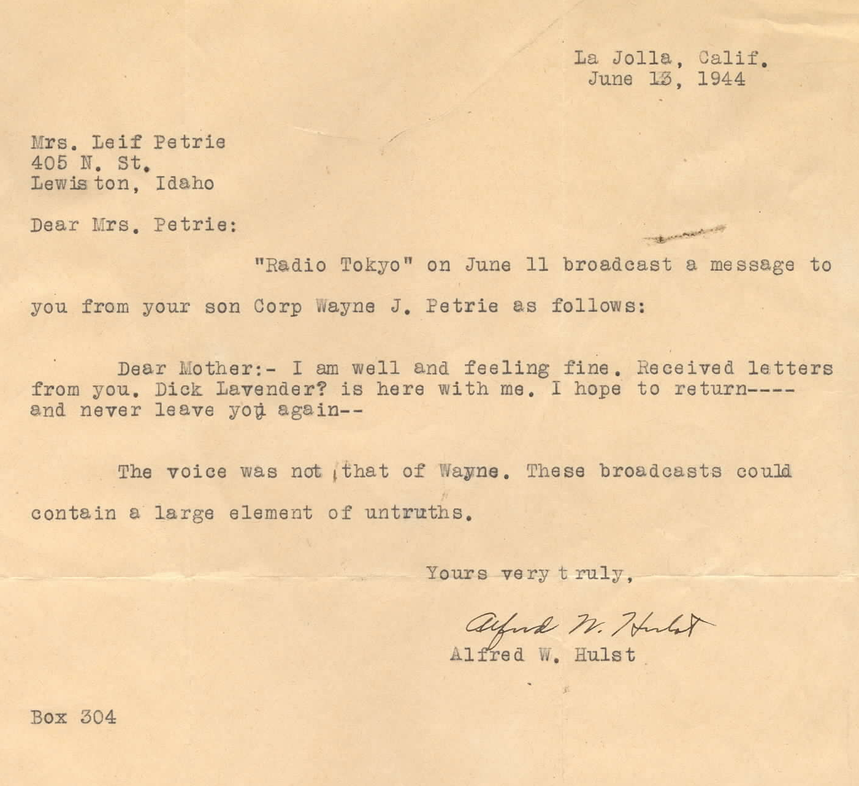
20. Summer of 1943: the demands for the Japanese to provide labor and replenish their labor pool resulted in more moves of POW’s to camps in Japan. Wayne would be a part of the first shipment that summer. 500 men (10 officers and 490 enlisted men) boarded a ship, the Clyde Maru, in Manila in late July. Arrived in Mojo, Japan on August 9, 1943 with surprisingly (and very unusual) no deaths. From Moji, Wayne and fellow POW’s traveled by train to Fukuoka Camp #17, on the island of Kyushu, near the town of Omuta. In an unusual display of anger and emotion, the villagers stoned the POW’s as they walked to the gates of the camp.
21. Some of Wayne’s experiences at Camp #17:
a. One of the first Camp Commandants was Lt. K Uri. Know for being arrogant and a very strict disciplinarian, he issued frequent beatings, tortures and even death sentences for the smallest of incidents.
b. One of the American Sr. Officers was Major John R. Mamerow, and although very unpopular, it was Navy Lt. E.N. Little that would be hated by all. Lt. Little would also be tried for war crimes–for actions against fellow prisoners.
In one incident Lt. Little turned in to Uri a Marine Corporal for stealing food. The Marine was severely beaten, left in the guardhouse for over a month until he eventually died of starvation. Despite the fact that this was one of several incidents of abuse and treason against his own countrymen, Little was ultimately cleared of all charges.
c. Wayne’s Christmas of 1943 was not much of a Christmas at all. No Red Cross packages were distributed, though available. When they were issued, in early 1944, these packages were only given to those who had good work records and good work attendance. This left the sick and disabled in hospitals, the ones needing them most, to go without.
d. It was here that Wayne worked in the coalmines. Fortunately an American POW had mining experience that was said to save many a life. But the labor was so hard and so barbaric that many men would purposely break their arms or legs to avoid the slave labor they were forced to endure.
22. The experiences of the end of WWII at Camp #17:
a. Men knew the end was close due to smuggled radio news of the surrender of Germany, as well as many learning to (somewhat) read Japanese and steal the papers to read.
b. 2 days after the first bomb was dropped, the U.S. still heard no response from their correspondence and warning to surrender, so another bomb was dropped, this time at the port city of Nagasaki. Men at Camp #17 would see and experience it first hand. Some POW’s could see the mushroom cloud from across the bay. They continue their work, mystified, even more so when an acrid odor reached the camp.
c. At Camp #17 the 1,700 POW’s were surprised to have their work called off with no explanation. Later funeral services were allowed, which again surprised the POW’s.
d. Once the evacuation of POW’s to Allied forces began, Toyko issued warnings to Japanese camp personnel. It read... “Personnel who mistreated prisoners of war and internees or who are held in extremely bad sediment by them are permitted to take care of it by immediately transferring or by fleeing without a trace. Moreover documents which would be unfavorable for us in the enemy hands are to be treated in the same way as secret document is and destroyed when finished with.” This would be a blessing for prisoners in camp #17 as the guards; especially those known for their brutality disappeared.
e. Many camps, including #17, were abandoned by guards and personnel and thus many prisoners impatient to wait for Allied forces to appear, took off on their own. Many of the men at Camp #17 headed for port cities, often by train, in hopes of securing passage on ships.
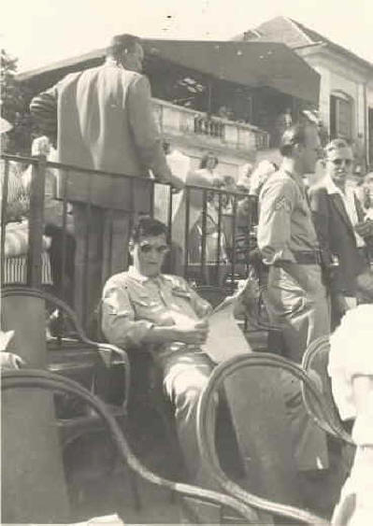
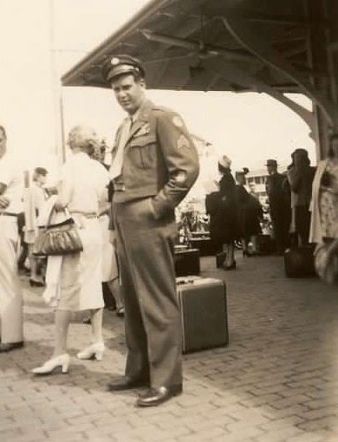
Wayne’s Photo Gallery

Wayne (r & L) shortly after the war,
and after medical recovery, on his way home.
Below-Left: Wayne’s son, Lt. Col. Gordon Petrie visits the New Mexico Death March Memorial in Las Cruces. His memories of his father follow.

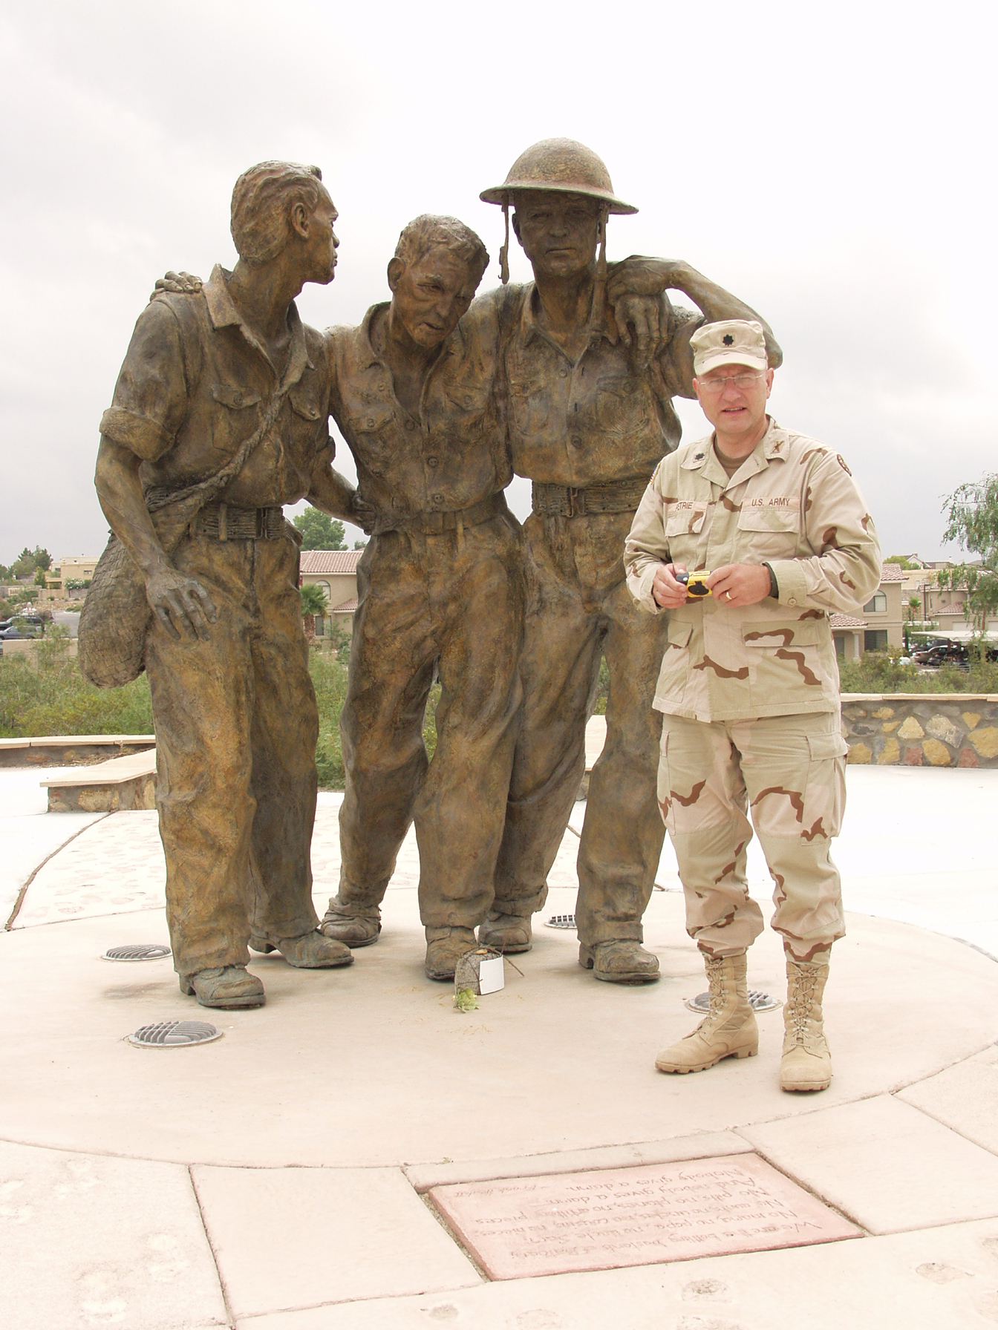

Below: Wayne’s 1st car after returning from the war

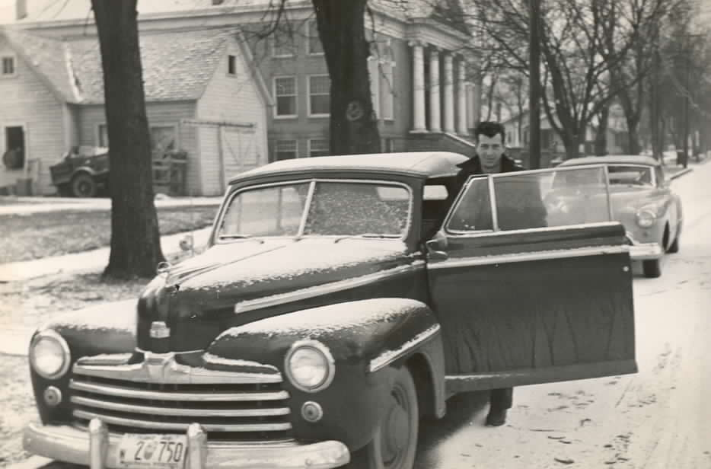

A SON'S MEMORIES
In about 1962 (just after the 20th anniversary of the fall of Bataan) dad hosted a Japanese POW gathering at our place on 18th Ave. in Lewiston, where my mom still lives. It was quite the event and as a teenager I sat around enthralled listening to a 'bunch of really old guys'...you know, to a teenager, as they were in their mid to late forties...all talking about the "Japs". The stories were very familiar, similar to the ones dad talked about over the years with friends or neighbors during a barbecue or the like. In speaking of Fukuoka, dad's comments on the occasion, and on others, usually evolved around the following:
Life in the mine was hellish. In addition to being literally starved to death and having to work long hours, prisoners were usually dehydrated most of the time. If a prisoner wanted or needed a day off, he had to injure himself, something like put a pick in his foot or have a limb broken.
Dad often said he held no grudges against the Japanese...he called them "Japs", like most of his peers, it was just the term that was used, but not in a form of racism. Dad often remarked they (the Japanese) were just doing their job, like the American soldiers. He did make an exception, however, for Tojo and Hirohito. Dad was glad Tojo was found guilty of war crimes and executed. But dad thought the Emperor should have been charged also. He had little patience for the concept that we needed to save the Emperor in order to win the hearts and minds of the Japanese people against the rising tide of international communism. Dad did not think the Japanese would go along with the Russians, no matter what we did to the Emperor. They had always been natural enemies, to dad's way of thinking.
Dad also remarked that when they heard the engines of the B-29's flying over on bombing missions, especially at night, he and his fellow prisoners figured it was just a matter of time before the Americans won. Dad said they did not know they were B-29's, but they did know they were some new kind of improved American bomber. He also mentioned they knew "the whole thing was all about over" after the first A-Bomb was dropped. They had heard from the guards about a "terrible new weapon", which only took one to destroy a whole city. Dad also said they knew the Americans were beginning to win and the end of the war was near because the guards started treating them like long-lost fraternity brothers!
These are some of the things I remember my dad talking about. It has been over 3o years since I last heard his stories, but I believe I recall them correctly.
by Gordon Petrie, January 2002
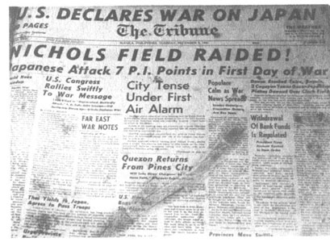
A Personal Recollection - 2 November 1955 - Lewiston ID – by Wayne Petrie
The following is a true and actual account of my war record while with the 2nd Observation Squadron, USAF, in the Far East.
I enlisted in the Air Corps, 4 March 1941, and shipped overseas from San Francisco, 1 May 1941. I was assigned to the 2nd Observation Squadron, then stationed at Clark Field, on the island of Luzon.
A short time prior to the outbreak of World War II, our squadron was moved to Nichols Field on the outskirts of Manila. We were there when war was declared against Japan. On the night before Manila was declared an open city, we withdrew to the peninsula of Bataan, where we were formed into the 2nd Battalion, United Air Force Provisional. Infantry. Our forces were finally overcome by the superior number of enemy forces.
I was wounded in action, having received several bomb fragments about the legs and lower part of my body during the Battle of Bataan. I was issued the Purple Heart with two stars. After the capitulation of our forces to the enemy, I survived the infamous "Death March" and was interned at Camp O'Donnell. A short time later I was transferred to Cabanatuan. There I contracted malaria and was advised by the camp doctor to get on a labor detail to Japan so as to be in a milder climate.
Taking his advice, I shipped to Japan on a 500-man labor detail, where we spent about two years. We landed on the southern tip of the islands at a town called Omuta Camp #17 Fukuoka Furyoshuyosho. We were immediately put to work mining a very poor quality of slag coal. This mine was one of the largest in the Orient. Though it had been condemned many years before, it mined every day, 24 hours a day, by the Japanese; consequently, many accidents and deaths occurred to the Allied forces that were forced to work there. I was injured in such an accident. On a 10-day week, working in three shifts, were in the mine working 14 hours and out-of-camp 16 hours. We were allowed to rest on the 11th day. This day was spent in cleaning our barracks and standing at attention for about 8 hours while we were inspected by the Japanese camp commander.
Upon the unconditional surrender of Japan, I was flown to the Philippine Islands, and from there was shipped by boat to the United States. ~ Wayne Petrie

Wayne’s Awards and Decorations: American Theater Ribbon; Asiatic-Pacific Theater Ribbon with Two Bronze Stars;
American Defense Service Medal with One Bronze Star; Good Conduct Medal; Presidential Unit Citation with 2 Oak Leaf Clusters; Philippine Defense Ribbon with One Bronze Star; The Purple Heart

Wayne died very young, at the age of 52. Original obituary follows…..
