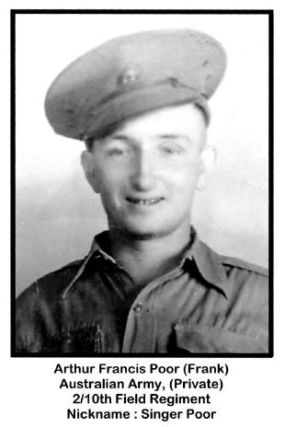
Arthur Francis Poor
Australian Army
Arthur Francis Poor was born in Queensland in 1919. He was the youngest child and youngest son, of a Sugar Cane Farmer in the Yandina/Maroochy River area.

Dad was a very healthy and robust young man. He worked on the Farm alongside his father. At the age of approximately 12 years old he was working picking bananas. This was heavy work for a young person because the banana trees were grown on hillsides which meant a tiring walk to the job and then a full day of work hauling the bunches of bananas up and down the hillside. After his father passed away in 1938, his Mother moved to Brisbane.

Two years later Dad enlisted in the Army, he was aged 20 years and 6 months at the time. Dad's place of enlistment was Kelvin Grove in Brisbane, Queensland, Australia.

He was captured when Singapore fell and spent his 21st Birthday in a Prison Camp. Dad spent time in Changi Goal, then on the Burma Rail and finally ended up in Japan working in the coal mines.
Here are just a few points about Dad.

1. Dad often liked to sing, men in his group nicknamed him "Singer Poor". (A play on his name and the location of Singapore as well.)

2. Dad also wrote poetry under the name of "Singer Poor". A newspaper was written for the men in Singapore before it fell, and some of his poetry was included in these newspapers. (Copies of the newspaper were donated to the Australian War Memorial by a Mother of another soldier).

3. During their time as POW's, my Dad and 3 other men trapped birds to get food to eat. They managed to trap a sparrow and boiled it up in a pot with what little vegetable they had. The sparrow went into the pot "feathers and all" and the meal was shared between the 4 men.

4. He returned home to Australia via the Philippines and then to Darwin and then on to Brisbane. One of his worries in traveling home via aircraft was that he did not have a parachute. The Pilot told Dad not to worry because he did not have one either and that he had no intention of crashing the aircraft!

5. (A Mother's Story) >From the time of the Fall of Singapore and during Dad's time as a POW, his mother did not know whether he was dead or alive, she only knew that he was missing. She received a letter dated 2 June 1945 which stated that the Army had recently interviewed POWs who had been rescued after the sinking of a Japanese Transport Ship. From these POWs the Army received news of other men, and they were able to say that in August 1944 that my father was still alive.

In Brisbane, Dad's Mother finally got news that he was at Greenslopes Hospital and she would be allowed to visit him. Grandma was overwhelmed with the news and was in such a hurry to see him that she failed to notice she had put her dress on inside out. She travelled on the Tram all the way from Ashgrove to Greenslopes like that.

On reaching the Greenslopes Hospital she spoke to the person at the Gate who gave her directions to the Hospital Ward to find her son. Grandma walked up to the Ward, but Dad had received news that she was at the front gate, so he headed to the front gate. Each travelling a different path and not seeing each other. Grandma broke down when she arrived and did not find him, the Nurses got her to sit and wait and told her he would return to the Ward. Eventually Mother and Son were reunited.

6. At a reunion after the War, Dad was asked by one of his Officers if he had had enough bloody rice now! Apparently before they left Australia to go to Singapore, Dad had asked if they could have some Rice Pudding included in their meals.

7. I do not remember Dad talking much about the brutality of his POW experiences, only a little, he would say that the Guards had been cruel and that he had been rifle butted because once he did not respond when his number was called. Apparently the number had been called in Japanese and Dad did not recognize it, but he learned very quickly the Japanese words for the different numbers.

8. He was truly a nice man and a great character who loved life and loved to garden and would try his hand at many things. (Many of this came from the things his father taught him but there was much in my Dad that he learned from his Army service and his time as a POW.)

In spite of what he had seen as a POW and the experiences and hardships that he had survived through, he was a wonderful father. He came home from the War, married my Mother, and then raised 4 children.
Dad enjoyed his life, loved his family, and also enjoyed a good joke. He loved gardening and grew flowers and vegetables and had fruit trees as well.

Arhtur passed away on the 8th January 1973 from Cancer. A type of blood cancer somehow related to the tropical ulcers he suffered during his time as a Prisoner of War.

