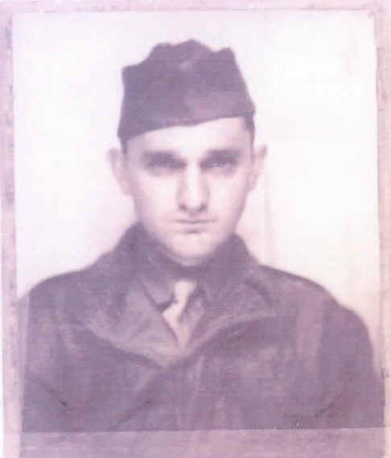
Bernard (Bernie) M. Pothier
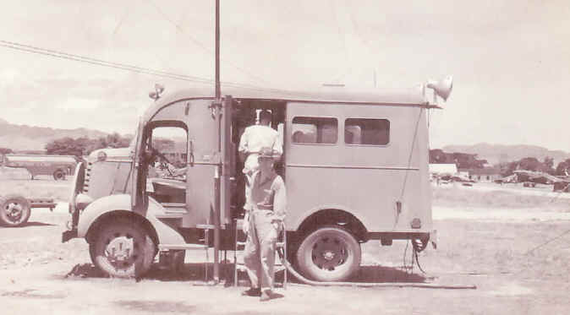
Account as told to Linda
Photos:
Right: Bernie Pothier October 1945, on way back to the West Coast. He had gained 25 lbs. in one month after liberation.
Right: Bernie in front of Mobile Radio Transmitter he worked with.
Bernie was a Radio Operator on Clark Field when the Air Field was bombed. His job was to control flight in and out of the area. Bernie 22 at the time war broke out, 26 when he got out.
When the Americans were being bombed – a shell tore thru the truck Bernie was in, tearing thru the transmitter.
Americans shot down one plane and when they examined it they found it was armed with a Browning machine gun manufactured in Connecticut.
Only food Christmas Day 1941 was a dried cheese sandwich. Like dry bread that had been sitting in the sun, it was curled up on the edges.
Bernie and many others had no respect MacArthur at all. Bernie expressed he had not even known MacArthur had come "once" to Bataan, as most believed MacArthur never ventured from Corregidor at all. Bernie said, of MacArthur, "He was a lousy commander". And told of the soldiers calling MacArthur "Dugout Doug" due to his "hiding" in the tunnels that ran through the island and Corregidor.
When Pearl Harbor was bombed, Bernie said they were told MacArthur locked himself in a hotel suite in Manila and refused to come out for hours. "Wainwright was left ‘holding the bag’", said Bernie.
About the mines...they worked 9 days with one day off. Drilling and shoveling coal. ½ mile down.
Dark, only small light by headlamp. 2 meals a day. Rice.
When asked about Camp 17...It was "dog eat dog" in camp. Stayed in small groups, cautious of others. Predators. Anything to get food. "There were some pretty rotten, dirty Americans. But they were also mentally and physically sick." "We talked about food all the time. First food and then our parents".
We would describe how our mother’s made certain meals. We would give detailed descriptions of the meals. They were so elaborate, and most of them were never anything our mother’s even cooked! We would make up meals and tell about how we cooked them, and most of us never even cooked before. But still we would say it as if we had."
"If you were a cook in Camp, well to be a cook was ‘prime’".
"POW's would trade cigarettes for food, even though they were starving. I tell young people I talk to about that addiction. So bad that they would give up food for one cigarette. I never could believe how they could do that".
One civilian told everyone he owned a gold mine. He kept telling everyone he would write them out an IOU for $100 - if they would give him their share of food.
Bernie remembers the day a bus load of civilians came in. There were civilians in the Camp.
About the mess kit, (see photo) "Yes, I was lucky it survived. I always kept it tied on my belt. I do not know why the Japanese did not take it. I was more concerned keeping it in camp, due to predators. I slept with it day and night and did not let it out of my sight."
Bernie did not find all Japanese to be bad. He met some civilian Japanese who were nice, even kind. One in the mines said he worked in a bank before the war. He had a house and chickens, but then they (Japanese Army) came and made him go to work in the mines. When he talked to me he would look around to be sure no one heard. He even snuck food in to us.
Bernie attributes surviving to: his faith – Catholic, and because...."I was in very good condition; athletic, excellent shape before the war, so because I took care of myself, I believe that helped. Looking back I must have been a pretty tough guy…I don’t know how I made it".
"It took a lot to stay alive. I saw too many guys who said, ‘I can’t make it. I give up’. The next day or that night they were dead."
When a Chicago News reporter came to tell Fukuoka 17 POW’s about the "drops" of troops and supplies, Bernie decided he wasn’t going to wait around. He took off on the train with some others. The train zigzagged for over 200 miles. The guards disappeared, "all of a sudden" after they came back from work in the mines.
Bernie expressed that everything seemed "...so strange when I came home. So new, a new world to me. I remember 6 months after returning home, I went to buy a car with 'slave labor money'". The car dealer laughed at him, as he told Bernie he had a waiting list of over 500 waiting for a car.
"So I wrote a letter to Wainwright, telling him my problem and could he help me get a car? Two weeks later I got a call from a Ford car dealership. They had a car for me. A brand new Green Ford Sedan!"
As we ended our conversation Bernie said he wanted to share with me the following...
OLD ITALIAN PROVERB: If the enemy has nothing to lose, there is nothing to win.

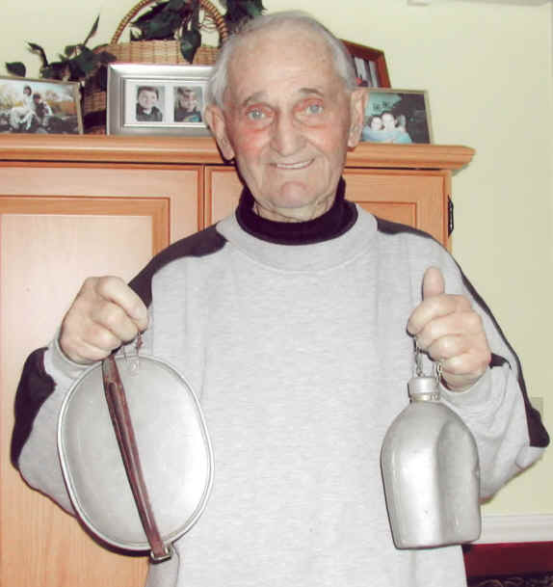
Photo: Bernie with his mess kit that made it through WWII

Articles and Videos honoring Bernard M Pothier

Video honoring Bernie: https://www.youtube.com/watch?v=vuWa4PR3mPw

Local survivor Bernie Pothier recalls BatAan Death March
on 75th anniversary of heinous event by David Maroney - Apr 13, 2017

This is the first of a 2- part series on Corporal Bernard M. Pothier, a survivor of the Bataan Death March and his subsequent 3.5 year imprisonment, mostly in Japan, until the Atom bomb dropped on Nagasaki on August 9th, 1945. He is a Reading resident now and the last Massachusetts living survivor of Bataan among the approximately 66 in America still with us. He was given the Bronze Star on Veterans Day, November 11, 2016).
One of the most inhumane events of World War II was the Bataan Death March which began on April 9th of 1942, 75 years ago. Reading resident Bernard Pothier is one of approximately 66 American soldier-survivors living today. While other Massachusetts soldiers survived the Bataan March, Bernie is the only Massachusetts one still with us. As sharp as ever and about to celebrate his 99th birthday on May 18th, Corporal Pothier told his story to Kevin Bohmiller, Reading’s Veterans’ Services Officer and the author.
You can read history books and go on line to get third party information from many authoritative sources but nothing beats a first-hand account. However, for those of us not familiar with the Bataan Death March, here’s a little background.
America’s involvement in World War II began with the Japanese attack on Pearl Harbor, Hawaii on December 7th, 1941. At that time, the Japanese also attacked Clark Field in the Philippines where we had a substantial Army Air Corps presence. Our air force was part of our army at the time but, subsequently created as a separate defense force on a par with our Navy and Army.
Clark Field was decimated by the attack and the combined forces of about 30,000 American and Filipino soldiers retreated about 100 miles south to the Bataan Peninsula, fighting fiercely along the way.
They surrendered on April 9th, 1942 and began the 5 day death march from Mariveles, Bataan Peninsula to San Fernando, about 65 miles north and then dispersed to several prison camps. Bernie was in the march to San Fernando, imprisoned for several months in the jungle area there and subsequently transported to Camp Fukuoka, prison camp #17 in Honshu, Japan, where he was identified as POW #1279. He spent approximately 3.5 years as a POW at the brutal hands of the Japanese.
Bernie was a radio operator and only 22 at the time of the invasion and in good physical shape. He joined the Army in 1940 and was assigned to the Headquarters Squadron of the 24th Pursuit Group in the Pacific Theatre during World War II. He was stationed at Clark Field in the Philippines when the Japanese invasion began.
Now on to Bernie Pothier’s story in his own words with minor grammatical edits:
At the start of World War II, I was stationed at the U.S. Army Air Corps base, Clark Field, about 40 miles northwest of Manilla in the Philippines. We were bombed the same time Pearl Harbor was being bombed. We were wiped out--- and talking to Japanese pilots after the war, they were surprised to see all the planes lined up in straight rows---easy pickings.
The Japanese landed large amounts of soldiers and supplies. We backed south about 100 miles to the Bataan Peninsula and fought for 3 months. The Japanese lost 6,000 dead and 120,000 wounded or sick and were sent back to Japan, a big blow to them. It forced them to bring a whole army from Singapore to battle us. Helping the US were Philippine Scouts who were a top quality, fighting group with American officers. The native Philippine army were very poor fighters, but I cannot say enough about the Philippine Scouts, as without them, Bataan would have fallen much sooner.
“Dugout Doug”, as we called General McArthur, never visited Bataan. He stayed on the fortified island of Corregidor, about 2 miles from Bataan, spending much time in the tunnels.
We were gathered in groups, all told about 30,000, and we destroyed all our equipment before the camp was overrun on April 3rd, 1942, and I was captured on April 9th. I put my wallet, camera and a few things between 2 large trees and a big rock. After the war, I went back to look for them but the jungle had taken over.
We (about 75,000 Americans and Filipinos) started marching, just a few miles the first day under a blazing sun (100°+, without hats and wearing old Japanese uniforms) and passed many artesian wells. If anyone tried to get water, they were shot, stabbed or had their heads chopped off. (They treated officers and enlisted men the same). You can go a long way without food but not without water. The native Philippine Army was dropping all over the place…bodies all over the place. At one point, they made the prisoners dig a hole in the middle of the road. If they refused, they were shot and (the guards) made other prisoners do it. Then the Japs put 5 prisoners in the hole and (other prisoners) covered them up alive.
Finally, we reached our objective, a place called Cabatuan, where we were shoved into grass huts with one water faucet. We lined up all day in a long line to fill our canteen and that was all the water we got. We were all put to work on farms, rice patties, and forests cutting down trees that were shipped to Japan. I volunteered to work the trees because they gave us extra food to keep up our strength.
One day, we were told we were being shipped to Japan to work in a coal mine. As we marched to the ship, local Filipinos had a jute box playing “God Bless America” sung by Kate Smith. The Japs never understood this but it meant a lot to us. We boarded the dirty troop ships and went to Japan.
During the personal interview with Bernie, he informed Kevin and the author that over 19,000 Americans and Filipinos died on the death march, many more Filipino than Americans. He attributed his ability to survive on being in good condition, not smoking, and swimming as well as climbing mountains frequently. They survived on eating insect laden rice and drinking dirty water, sometimes from roadside mud puddles. Bernie kept his most valuable possessions, his mess kit and canteen on him at all times.
He maintained that all Japanese weren’t bad but the worst were those forced into military service. One good one owned a farm and raised chickens before they took his farm away and put him in the service. He would sneak food into the prisoners at great risk to himself.
In addition to his being in good shape, having a strong instinct to survive and his Catholic faith, Bernie attempted to maintain his sense of humor. He told one of the prison guards that he reminded Bernie of a very famous American movie star, Mickey Mouse. The guard was flattered until he found out who Micky Mouse really was whereupon Bernie was severely beaten with a baton.
Bernie believed that going to work in a coal mine in Japan was better than building a road in a death camp in the jungle of the Philippines so he “volunteered” to go.

Article Celebrating Bernie’s 100 Birthday:

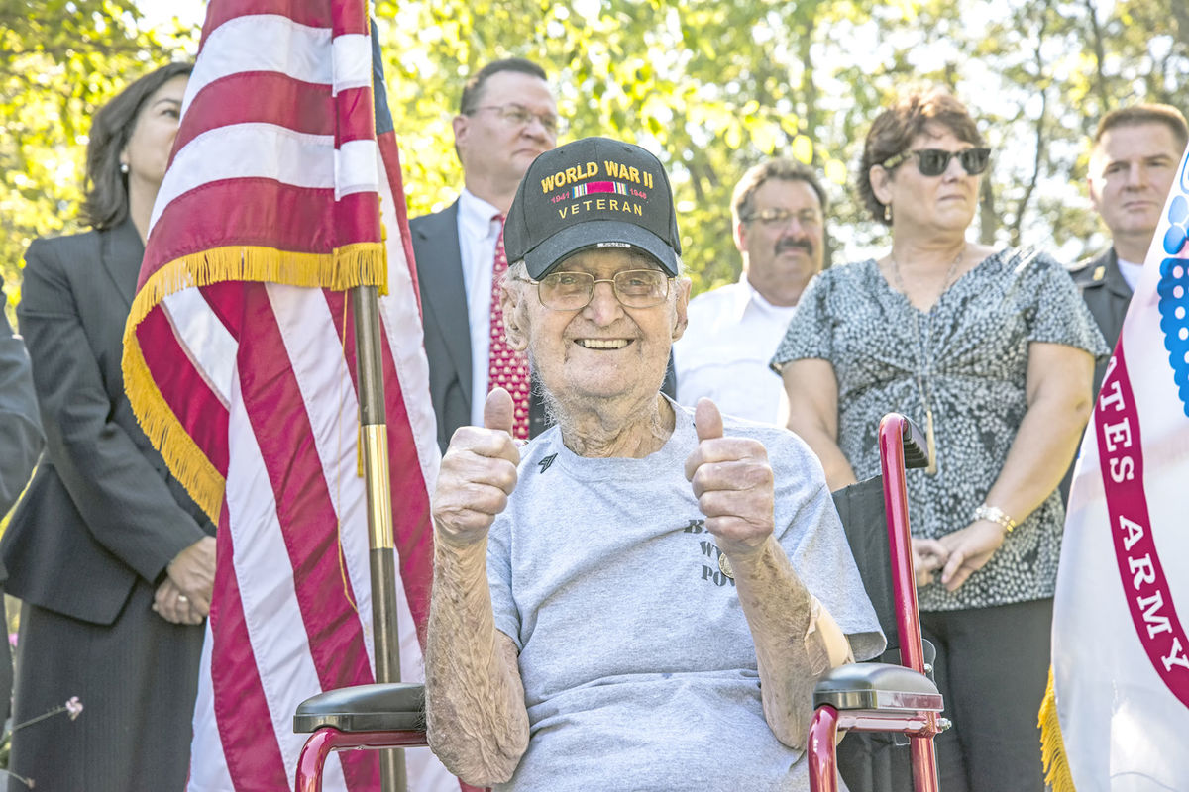
Age 100 (Born May 1918)

After a 71-year wait, Reading resident Corporal Bernard M. Pothier, 99, was officially promoted to Sergeant on Thursday, September 28, in a ceremony at his home on Charles Street that was well attended by family, local and state officials, and members of the Massachusetts National Guard.
Corporal Pothier was stationed with Headquarters Squadron, 24th Pursuit Group, at Clark Field in the Philippines in December 1941. Hours after the Japanese bombed Pearl Harbor, they bombed Clark Field. Outmatched, the American and Philippine soldiers were backed into the Bataan peninsula. After a heroic four-month battle they were out of ammunition and food and were ordered to surrender. 75,000 American and Philippine troops were forced to march sixty-five miles in stifling heat. Thousands died along the way. This is now known as the Bataan Death March. Corporal Pothier survived this march and the next three and a half years as a Prisoner of War. He witnessed the bomb destruction over Nagasaki and was finally liberated.
After almost six years of service, Pothier was honorably discharged as a Corporal. While he was aware that others were being promoted to Sergeant, he never pursued the advancement. He returned home to Malden after his service, married his wife Marge, raised five wonderful children, and started a successful printing business.
In a special ceremony during the Veterans Day observance on the Town Common last November, now local resident Pothier,was presented the Bronze Star for his service in World War Two. Making the presentation was Reading Veterans Service Agent Kevin Bohmiller. Pothier is the lone living Massachusetts serviceman who survived Baatan.
Recently, with the assistance of Representative Bradley Jones and Congressman Seth Moulton's office his records were reviewed and he was found eligible for POW advancement as well as a Prisoner of War Medal he never received.
Reading Veterans Agent, Kevin Bohmiller, offered a special thank you to Sergeant Major Doris DeVincent and the many soldiers from the Massachusetts National Guard who came out Thursday to honor this true American hero. Town Manager Robert LeLacheur, Jr., Assistant Town Manager Jean Delios, State Representative Brad Jones, and Katharine Thibodeau from Congressman Seth Moulton’s office also attended the ceremony with Sergeant Pothier’s family and friends.

Card Bernie received in Camp from his niece

