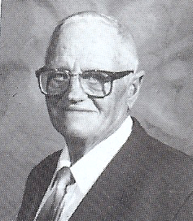
Theodore F. Provost

Born: January 11, 1919 in Finleyville, PA
Grew up on a farm near Navarre, OH
Enlisted in the U.S. Navy September 1, 1938
Great Lakes Naval Training Center

Theodore left for Manila, Philippine Islands in February, 1939.
Duty on the USS Canopus,
March – November 1939, USS Pigeon, December 1939 – May 3, 1942. Ship was sunk.

Captured by the Japanese on Corregidor, Philippine Islands. Became POW, sent to Bilibid; to Cabanatuan in railroad cars.
One hundred men to a car. Lost sight in right eye in October 1942.

Went to Japan July 2, 1944 on board a ship taking 62 days; 1600 men in hole.
No water, food, and terrible sanitation.

Camp 17, Japan, took beating on back. Unable to walk for two weeks. Spent time at Camp 1, Fukuoka.
Liberated September 10, 1945.

Discharged on medical survey on March 26, 1945 (chief petty officer) due to ulcers on eye and malnutrition;
lost sight in right eye. Have no driver’s license.

Married 45 years to Marvella. Have three children and four grandchildren.

