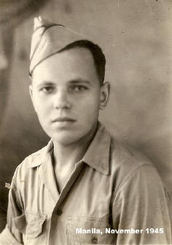
Harry Johan van Ramshorst
Name : Harry Johan van Ramshorst
Born: December 6, 1921 in Bandung, Indonesia
Rank: soldier National Service KNIL
Royal Dutch East- Indian Army) Number: 175121
P.O.W. since March 1942, transported to Thailand January '43,
worked (slaved) for the Japanese Army at these camps:
Kinsaiyok - January 28 - February 1, 1943
Lin Thin - February 2 - April 12, 1943
Chungkai - April 14 - November 17,1943
Nong Pladuk I - Nov. 17 - November 24,1943
Nong Pladuk II - Nov. 24´43 -May 28, 1944
TrTra Transported to Singapore and on to Japan - on the “Teia Maru” (French Aramis).
Worked near Nagasaki in Omuta, Camp 17 (pow#911) - June ´44- Sept´45.
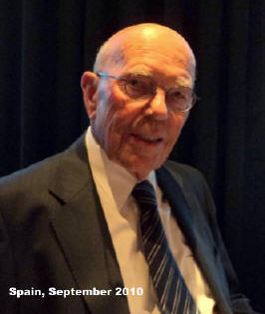
With sorrow and loss we say farewell to Harry who passed on March 4th, 2012
His wife Didi told us, "With great sadness I inform you that my beloved
husband of 38 years. He was a dear man, kind and cheerful and full of little
jokes until the end. In spite of the hardship during WWII he had a good life.
We will all miss him very, very much."
A wasted and sad day in camp 17
A strong, cold winter wind made the daily task of the POW´s – loading huge railway
wagons with coal from the neighbouring mine in Omuta – far from agreeable.
One day I faked an illness. So for just one day, I could forget the hardship outside. ‘Nicely’ installed under my quilt, after borrowing scissors, thread and needle from one of my fellow prisoners, I started to make a pair of gloves to protect my worn-out hands. I possessed an old flannel blanket for this purpose and started to make two patterns of my hand on it. I cut them out and sewed both together, slowly, finger by finger. When one glove seemed finished, I tried to remove my work-of-art. Astonished, I discovered however that it was impossible: I had sewn the glove onto the quilt!
Never being very patient, I nearly wrecked the barrack. However, you have to be strong of mind, if you don’t know your wits. I never made my gloves!
Thanks for the Memory
Our liberation from the slave work in the mining village Omuta, started – at last – on September 15, 1945. By luxury train we arrived at Nagasaki (or what was left of the war port after the atom bomb).
The ravaged station was, as well as it could, cleaned to receive the cheerful ex-prisoners. With the jazzy tones of "when the saints…" from a US band, friendly, attractive Red Cross women treated us to doughnuts and ice-cold "Toddy" – chocolate milk. What an unexpected reception after nearly 15 months of being a POW in Japan! Next we were directed to a disinfection shower. Our worn-out camp cloth was changed to new, fresh army uniform. Helpful US sailors took care of the correct sizes. Thus freshly cleaned and clothed, we boarded the US "Mobile". The crew had voluntarily made their bunks available to us. They found their bed in one of the gun turrets, or slept on deck.
At the arrival on Okinawa, a typhoon had just swept over the island, destroying our campsite for the night. But the Marines were able to set up a new one in no time.
Afterwards, in Manila, housed in the 5th Replacement Depot, Dutch officers tried to take command again by establishing army duty for us ex-prisoners. The US commander of the depot however, forbade this: "they are our guests, and need complete rest after their strain of slave-work."
Free coffee and doughnuts the whole day, and shows at night, were a few samples of the great hospitality of US soldiers, sailors, and Marines.
I also expressed my heartfelt praise of US army, and marine personnel, who not only were very helpful, but also
made me a person again instead of an army number. I will always remember Americans with great gratitude!

Contributed by: Harry van Ramshorst, Fukuoka Camp 17, POW #911

