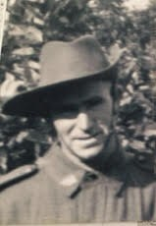
Francis (Frank) Edward Regan
Australian Army Private
Frank was born 08 January, 1912 at Cremorne, Sydney, NSW. His father, Edward Michael Regan, was a Boer War and First World War veteran.
Before enlistment Frank was employed as an omnibus driver and was married to Clare May Evelyn Gordon . They had no children prior to the war.
Frank enlisted in Sydney on 16 April 1941 at 29 years of age. Records show he was originally posted to Australian Army Service Corps, but his driving skills must have been recognized because he was posted to 2/3 Mobile Ambulance Convoy in Singapore. He served there as an ambulance driver.
When Singapore fell Frank was imprisoned at Changi before being drafted for “A” force. On 21 May 1942 he proceeded to Burma as part of Major Greens force, landing at Victoria Point, Burma.
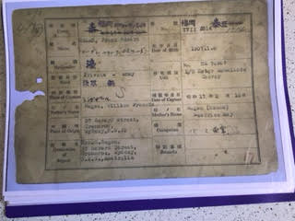
Frank then worked slave labor down the Burmese coast on the railway passing through Mergui, Tavoy, Thanbyuzayat. He suffered much hardship on the Burma Road and suffered two bouts of malaria at or near Thai border camp 105. Amazingly, he survived both malaria and the horrific labor forced on POWs at the railway.
Sometime in 1943 Frank was returned to Changi.
On 23 December, 1944 Frank departed Singapore on board the Awa Maru. He arrived Fukuoka early in January, 1945 and laboured in the coal mines until wars end - in Fukuoka Camp 17 Omuta.

Frank returned to Australia at wars end on 5 October 1945 aboard HMS Formidable and was discharged honorably on 27 November, 1945. He lived in Cremorne and found work as a fencer.
Frank was blessed with a daughter, my cousin, Cheryl, in 1948.
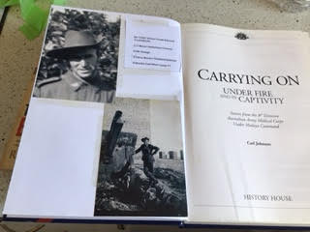
Frank is mentioned several times in these two books, with reference to him testifying at War Trials.
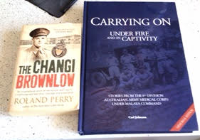

Frank returned to Australia at wars end on 05 October 1945 aboard HMS Formidable and was discharged honorably on 27 November, 1945.
He lived in Cremorne and found work as a fencer. Frank was blessed with a daughter, my cousin, Cheryl, in 1948. He died in 1970 when working on a building site in Manly, NSW. He fell to his death from scaffold. When Frank passed away he was aged 58.

Submitted by Joseph Knight-Smith, nephew of Frank.

