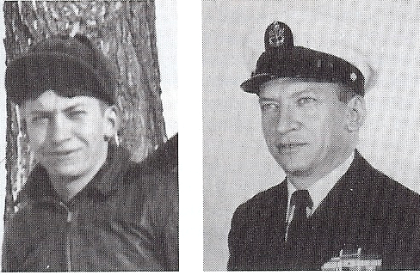
Harold L. Richardson

Born: March 16, 1919 in Lenox, IA
Joined Navy at Des Moines, IA on June 12, 1939. Attended Group III Service School, Norfolk, VA - From Nov 1939 – April 1940

USS Blackhawk, Asiatic Station 1940 – 1941; USS Napa AT-32; Naval battalion attached to 4th Marines under command of Army on Ft. Hughes, Corregidor.

POW May 1942. Interned in Cabanatuan Camp No. 3, Lipa Batanga, Bilibid Hospital, Cabanatuan Camp No. 1, Japan Camp No. 17, July 1943.

Liberated in September 1945. Sent to Los Banos, Philippines. Evacuated to Oak Knolls Hospital, San Francisco. Sent to Great Lakes Hospital for release on rehabilitation leave.

Returned to active duty in January 1946. Group 2 Reserve Fleet, Philadelphia, 1947, San Diego Naval Station. USS Dixie AD-14, Leululei Radio Station, Hawaii, USS Hamel AD-16, U.S. Naval Station service school command, USS Lexington CVA-16. Transferred to Fleet Reserve July 1959 MRC.

Happily retired from Fleet Reserve with rank of warrant machinist living with wife Marjorie and handicapped son in Chula Vista, CA.

