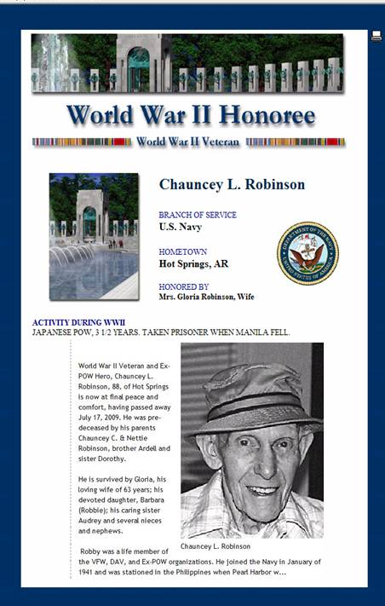
Chauncey L Robinson
Chauncey Leonard Robinson, 88, of Hot Springs, AR
passed away July 17, 2009.
Rob (or Robby as he was known) enlisted in the Navy in January, 1941.
He was stationed in the Philippines at the outbreak of WWII.
He was captured in Manila, then held in Bilibid Prison and Cabanatuan. Rob was later transferred to Japan on the hellship SS Canadian Inventor (the Mati Mati Maru)
along with the second large contingent of American POWs sent to Fukuoka Camp 17 (with POW numbers 1131-1332), arriving on 2 Sept 1944 .
In Fukuoka Camp #17, he was interned and forced into slave labor in the coal mines until the end of the war.
Rob was a life member of AXPOW. He leaves his loving wife of 63 years, Gloria, and a devoted daughter, Barbara.

