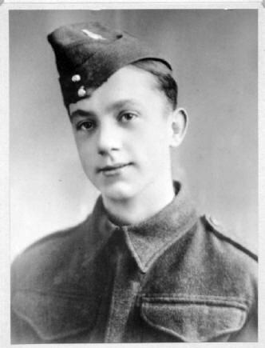

Sidney Rockcliffe
Name: Rockcliffe, Sidney
Rank: Private
Service Number: 7598789
Date of Birth: 30th January 1922 in Sheffield, UK
Died: 4th May 1998 in Sheffield, UK
Parents: William George Rockcliffe born in Salford, England 1874 and
Nellie (nee Clixby) born in Wadsley, England, 1899.
Joined Territorial Army May 3rd 1939 age 17
Civilian Occupation: Rolling Mill hand - Steelworks in Sheffield UK.
Embodied: 2nd September 1939
Posted: 6th Anti-Aircraft division - Royal Army Ord. Corps, Nov. 1939
Posted: 4 Division March 1941 (RAOC)
Embarked to Malaya December 1941
Reported missing in Malaya by telegraph to his mother, January 1942
Liberated September 1945

As nothing was heard for over two years it was assumed that he had been killed in action during the invasion of Malaya by Japanese forces. His mother received a letter dated 9th September 1944 stating that he was held prisoner in a Japanese POW camp. Interestingly Rockcliffe is listed on one roster indicating as having arrived on 19 June 1944 on board the Teia Maru. (POW # 1126) A second record indicates he arrived on 11 February 1945 on the Hioki Maru (Hokko Maru) which indicates he may have been on Taiwan for a short period en route to Japan.

Here is what we know:

Based at Bovington Camp, England until December 1941 when the 18th Army was formed and embarked for Malaya via Nova Scotia and the South Atlantic. Arrived in Singapore in January 1942 just in time to be bombed by the Japanese Air Force.

Captured by the Japanese at the fall of Singapore 15th February 1942 and imprisoned in the infamous Changi camp. Here most of the prisoners were put to work such as repairing the go-downs in the docks area.
During October 1942 the RAOC were amongst 3250 British troops transferred by ‘Rice Train’ to Ban Pong in Thailand. This journey took 5 days and nights where the men were crammed into metal containers that were like ovens during the day and freezing at night. Following their arrival at Ban Pong they were force marched up country to Tarsau and then onto Kinsayok camp by barge.

From October 1942 until May1944 these men worked in the most horrendous conditions imaginable to build the “Railway of Death” through the jungles of Thailand and Burma. Approximately 40% of this work group died during this period, through diseases such as Cholera, Malaria, Dysentery etc or were starved to death or murdered by the guards. All of these men suffered with beri-beri caused by the inadequate food supply which was almost entirely polished rice, vegetable stew and almost no protein. On completion of the Railway in 1944 most of the survivors had lost about half of their normal body weight.

In May 1944 Sidney was located at POW Camp Nong Pladuck No.2 at the southern end of the railway. On 3rd June, 456 of the survivors, including Sidney, were sent on the Hioki Maru hell ship to Moji in Japan. On this journey they were attacked near the Japanese coast by the submarine USS Tang but managed to avoid being torpedoed. At Moji, Sidney was one of about 200 men separated and sent to Fukuoka Camp #17 arriving there on the 17 June 1944. These men were allocated POW numbers 931-1128, Sidney was POW # 1126.

At Fukuoka Camp #17 the British prisoners worked as slaves for the Barron Mitsui in his Zinc Factory, they were paid 1 cent a day – if they received it. The Americans, Dutch and Australians were employed in the Mitsui coal mine. All of the prisoners at this camp received the most brutal beatings from the guards and were fed an inadequate diet, often the only meat available was a truck load of dead dogs.

All of this changed on August 9th 1945 as Sidney and most of the others watched the Atom Bomb explode over nearby Nagasaki, but it wasn’t until September 16 1945 they were transferred to a Colonel Griffin (I assume of the US Marines). At this time Camp 17 was liberated.

It was a long journey back home to England, arriving in Liverpool, December 1945 on the Queen Mary. Sidney finally arrived in his home in Sheffield in January 1946 – his neighbours described him as a “shadow of a man” the result of three and a half years of the most brutal and inhumane treatment by his captors.

Sidney used to laugh about being one of the only men on earth to have survived being bombed by four different Air Forces; The German Luftwaffe in England, The Japanese Air Force in Singapore, The RAF in Thailand and the USAAF at Fukuoka #17 camp.

Continued…

NOTE: Before he arrived in Fukuoka he had already been a POW for 2 1/2 years and had worked on the Burma railway construction for most of that time. It was during his time working on the railway that most of his friends died. There were many problems that my father never came to terms with including the death of so many of his teenage friends through the brutality, many of these soldiers were just pushed into mass graves and did not even receive a prayer.
As you may imagine my father was a remarkably strong willed man to have endured such abuse and the many diseases that the Japanese refused treatment for.

E-mail notes…

Roger Mansell has forwarded me (daughter to Sidney) details of when he arrived at Fukuoka but interestingly he is listed on one roster indicating he arrived on 19 June 1944 on board the Teia Maru. (POW # 1126) A second record indicates he arrived on 11 February 1945 on the Hioki Maru (Hokko Maru) which indicates he may have been on Taiwan for a short period en route to Japan.

Since my father died in 1998 I have been researching the history of what he did during those times but it is very difficult work out and to comprehend the suffering that he endured. Before he arrived in Fukuoka he had already been a POW for 2 1/2 years and had worked on the Burma railway construction for most of that time. It was during his time working on the railway that most of his friends died. There were many problems that my father never came to terms with including the death of so many of his teenage friends through the brutality, many of these soldiers were just pushed into mass graves and did not even receive a prayer. As you may imagine my father was a remarkably strong willed man to have endured such abuse and the many diseases that the Japanese refused treatment for.

As you may imagine my father was a remarkably strong willed man to have endured such abuse and the many diseases that had from this time. I am glad that people like you are making the effort to record what these brave men did so that we can enjoy our freedom. If you have any further information on him I would appreciate it if you would let me know. Also if you would like any other information about my Dad please let me know.

Awards:
1939-45 STAR with clasp
PACIFIC STAR with clasp
WAR MEDAL 1939/45

Continued…..
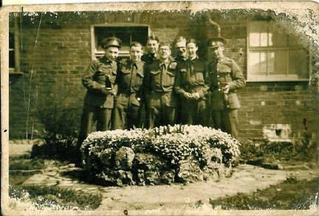
Photo right and daughter's note:
Happier Times - Bovington Army Camp, Dorset, England c1940
Sidney is second to last soldier on right (hands clasped in front of him), during happier times. I think this is one of the photographs dad managed to keep with him during the time he was a prisoner. It is battered and stained.
I don’t think any of the other chaps in the photograph survived, although it would be lovely to think that they did.
It is terrible to imagine that my dad may have seen these friends murdered on the Burma-Siam railway and to have had to bury them in unmarked graves. It was always his wish to go back and find them and to make sure they were properly buried, honoured and remembered.
Daughter's note:
When my father arrived in Liverpool in December 1945 aboard the Queen Mary, there were no fanfares or joyous crowds waiting on the quayside. He did not experience VE day or VJ day and all the victory celebrations and street parties were becoming memories by then. After disembarking from the Queen Mary he was sent to Aldershot where, after a few days, he was demobbed (demobilized). Sidney was 5 feet 9 inches tall and his weight at that time was recorded as being 5 stone 3 pounds (73 pounds) and this was after he had spent two months in America being treated for malnutrition and tropical diseases! He passed through dispersal centres at Leicester – 12th December 1945 and York (Fulford Barracks) on 19th December 1945 from where he was released. After demob (demobilization). Men like my dad were told not to speak about their experiences for fear of upsetting civilians who had little or no idea about the atrocities he had witnessed or what he had suffered at the hands of the Japs. They were expected to get on with their lives; to pick up where they had left off as if nothing had happened. In those days there was no such thing as ‘Post-traumatic Stress Disorder’, no counseling, and certainly no provision for him to grieve for the fallen comrades he had left behind. There was no hero's welcome waiting for him. Nothing but the grim austerity of post-war Britain and the poverty of the 1950s.

Continued….

Linda's (project manager) note: Men such as Sidney did not receive the financial, physical, or emotional support they so deserved after their military service. If my website can, at the very east, prevent their sacrifices from being forgotten, I will continue to do what I do.
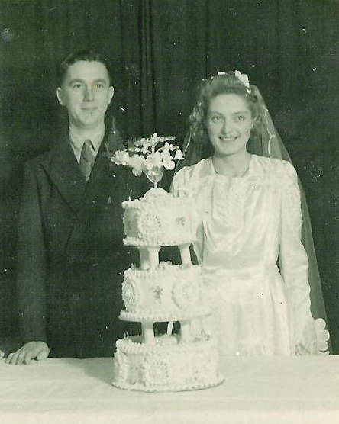
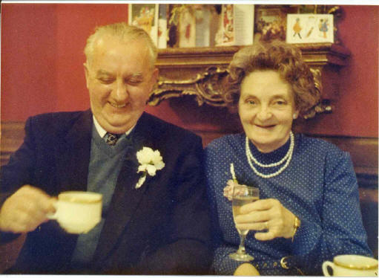

Above left: Sidney Rockcliffe and Mary Goddard on their Wedding Day 2nd February 1946. They were married at St Barnabas Church Highfield Sheffield. Mary's dress and veil were borrowed from a cousin and the cake wasn’t real. Under the top tier there was a small sponge cake which was all that rationing would allow.
Above right: Stephen, with his wife Mary, early 1980's.
Submitted by Stephen Rockcliffe, son of Sidney Rockcliffe srockcliffe@btinternet.com
and daughter, Yvonne, maidinsheffield@gmail.com

