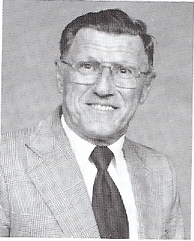

Eugene F. Rogers
Born: October 31, 1917 in Milroy, IN
Joined the Navy in October 1940

I was a hospital corpsman and was on duty at the U.S Naval Hospital Canacao, P.I. when the Japanese bombed Pearl Harbor on December 7, 1941. They bombed us the next day at Canacao and Cavite, P.I. The next day we discharged as many patients to duty that we could and moved the naval hospital to Manila because it was supposed to be declared an open city. We first moved the hospital to Holy Cross College, then to Sternberg Army General Hospital and from there to Santa Scholastic University where we surrendered to the Japanese on January 2, 1942.

Prison camps, Nicholas Field, P.I., Bilibid, Oryoku Maru, Enoura Maru, Brazil Maru, Omuta, Japan Camp No. 17 where I was liberated in September 1945. Retired as master chief hospital corpsman from the Navy in July 1967. Then worked civil service as educational service officer and retired from personnel support activity, Portsmouth, VA in October 1983.

Awarded the Army Distinguished Service Unit with Oak Leaf Cluster, Navy Unit Commendation, Purple Heart, Good Conduct with four Stars, Asiatic Pacific, Philippine Defense, World War II Victory Medal, American Defense and POW Medal.

