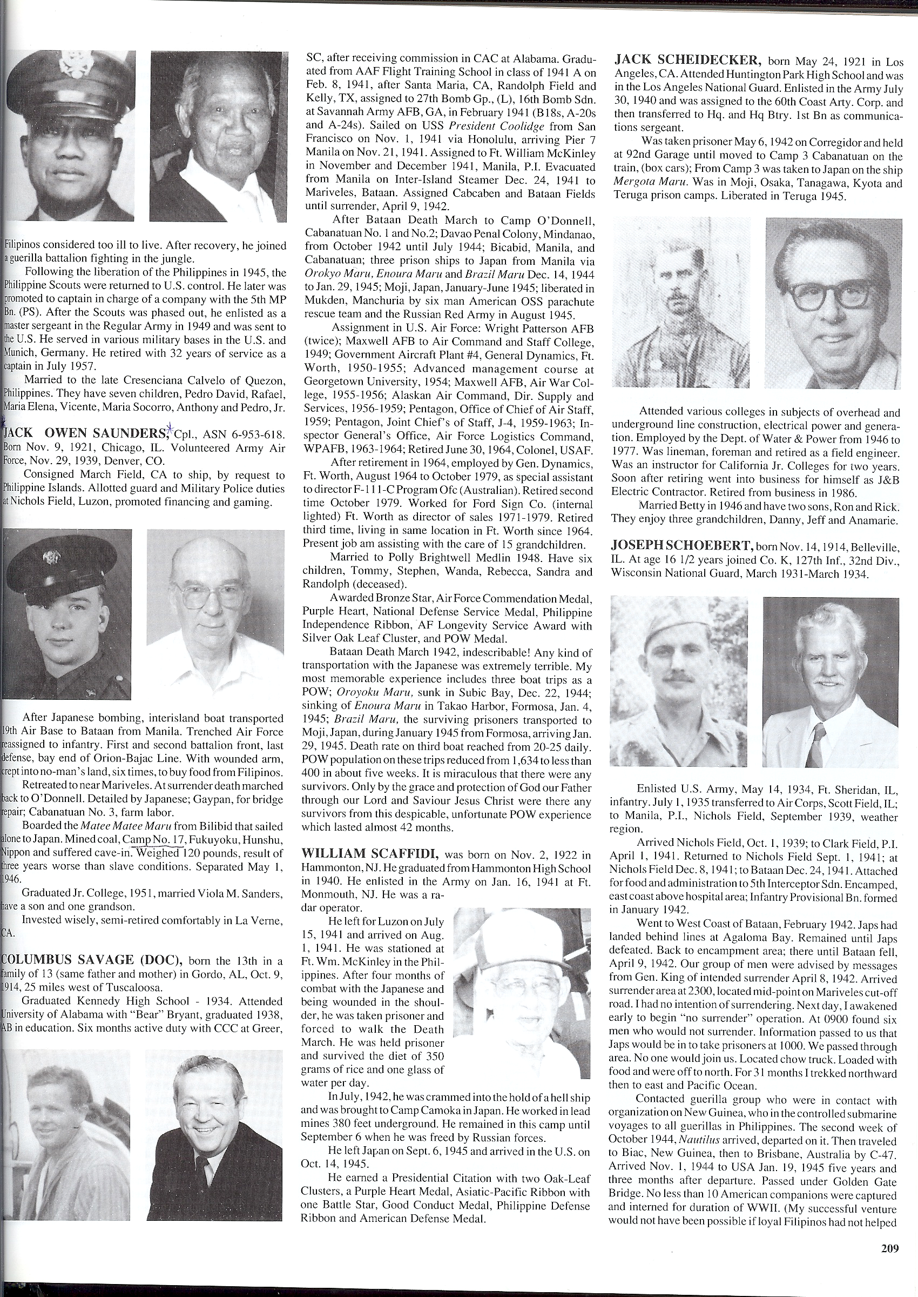
Jack Owen Saunders

Army - 19th Air Base

Born Nov. 9, 1921, Chicago, IL

Jack volunteered Army Air Force, Nov. 29, 1939, Denver, CO. Cpl., ASN 6-953-618.

He was consigned March Field, CA to ship, by request to the Philippine Islands. Allotted guard and Military Police duties at Nichols Field, Luzon, promoted financing and gaming.

After Japanese bombing, an interisland boat transported the 19th Air Base to Bataan from Manila. The trenched Air Force reassigned to infantry. First and second battalion front, last defense, bay end of Orion-Bajac Line. With a wounded arm, Jack crept into no-man’s land, six times, to buy food from Filipinos.

Later they retreated to near Mariveles. At the surrender Jack was forced on the Death March back to O’Donnell. He was forced to be a part of a labor detail by the Japanese; Gaypan, for bridge repair; Cabanatuan No. 3, farm labor.

As part of the second large contingent of American POWs (#1131-1332), Jack was placed on a hellship, leaving Manila (Bilibid Prison) and arrived on 2 Sept 1944 aboard the SS Canadian Inventor (the Mati Mati Maru) in Camp No 17.

Forced to mine coal, he suffered injuries in a cave in. He weighed barely 120 pounds; the result of three years of worse than slave conditions. Separated May 1, 1946.

Graduated Jr. College, 1951, married Viola M. Sanders, has a son and one grandson. Invested wisely, semi-retired comfortably in La Verne, CA.

Jack’s Obituary

Jack Owen Saunders, age 84 of LaVerne, California died August 8, 2006 at his home surrounded by his family.

He was born on November 9, 1921 in Chicago, Illinois and was a La Verne, California resident for the past 32 years. Jack was a property management owner. He was a Veteran of the United States Air Force during World War II, a member of the Veterans of Foreign Wars and was a P.O.W. survivor.

He is survived by his wife of 55 years, Viola Saunders of LaVerne, his grandson, Owen Saunders of LaVerne, his brother and sister-in-law, Gerald and Irma Sanders of Chino, CA and his nephew and his wife, Owen and Maria Matchell of Upland, CA.

He was preceded in death by his son, Owen Steven Saunders and his brother and sisters, David, Rea Dawn, Bobbette and Yvonne.

