Leland Wallace Sims
In recognition of National POW Day, Leland Sims, of San Antonio, Texas came to Idaho to meet the "Patriots" (students) behind this web site.
Inspired by a letter from one of the students volunteering on this project, Leland traveled to Lewiston not only for the students, but to meet the Petrie's; family of Wayne Petrie who Leland had been interned with in Camp 17.
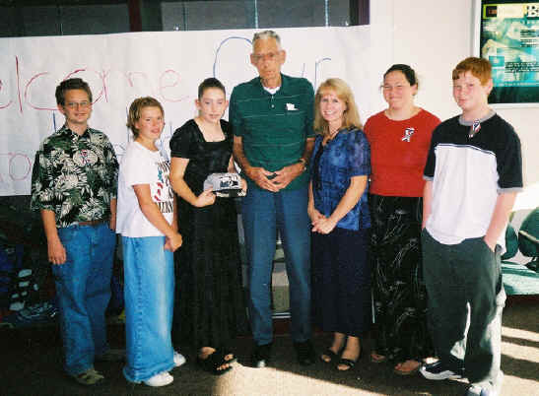
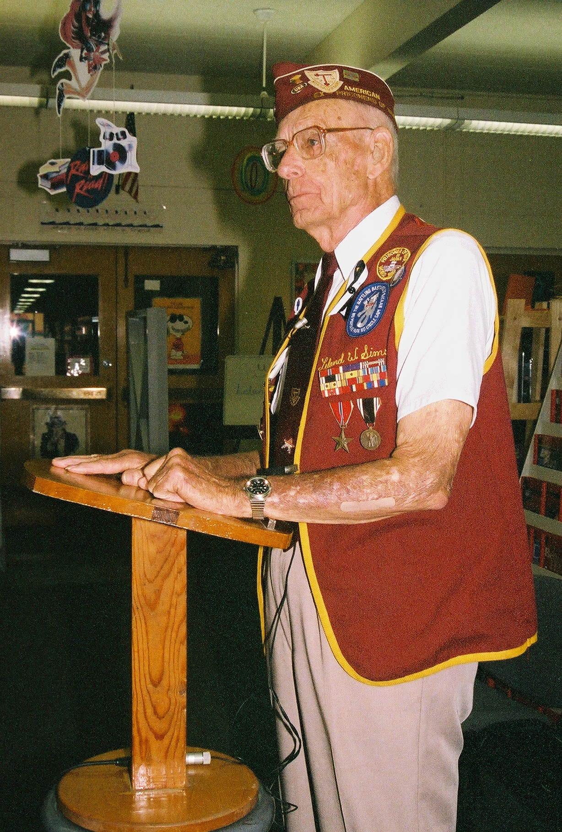
Accompanied by his daughter, Brenda MacDonald, Leland was received as a special guest of honor for several planned events during the week of his visit. They would be hosted by the Project Manager, Linda Dahl Weeks, who was very honored to have them stay with her, and the "Patriots" – who were given special permission to be away from school for all the activities, such as meeting Leland, along with others and the local news and TV stations, at the airport.
This events of the week began with a special greeting at the airport, followed by Leland as guest speaker for National POW Day at the Junior High the "Patriots" attend.
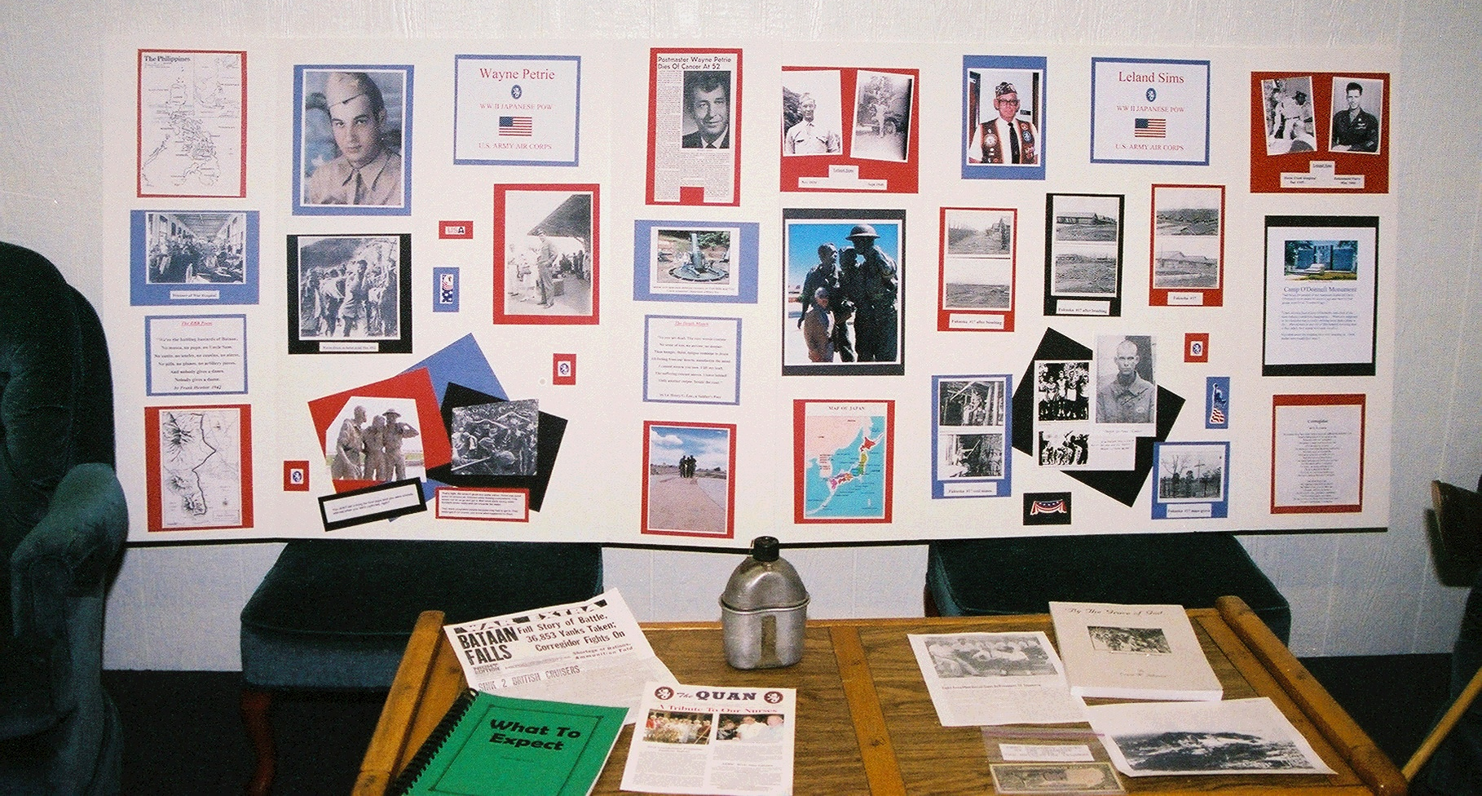
A "POW Day" was held at the local library; Leland, along with another Japanese POW, Lewiston resident Warren (Bill) Smith, were guests and held a presentation.

The week ended with a barbecue at the home of the youngest son of Wayne Petrie, James, and his wife Karla. Here the families were able to spend a special evening together before Leland and Brenda were to fly out the next day for a national POW reunion.
The accompanying article from the local newspaper perhaps best tells how much this visit meant to everyone involved. And how enriched are the lives of all who were able to partake in the week's events.
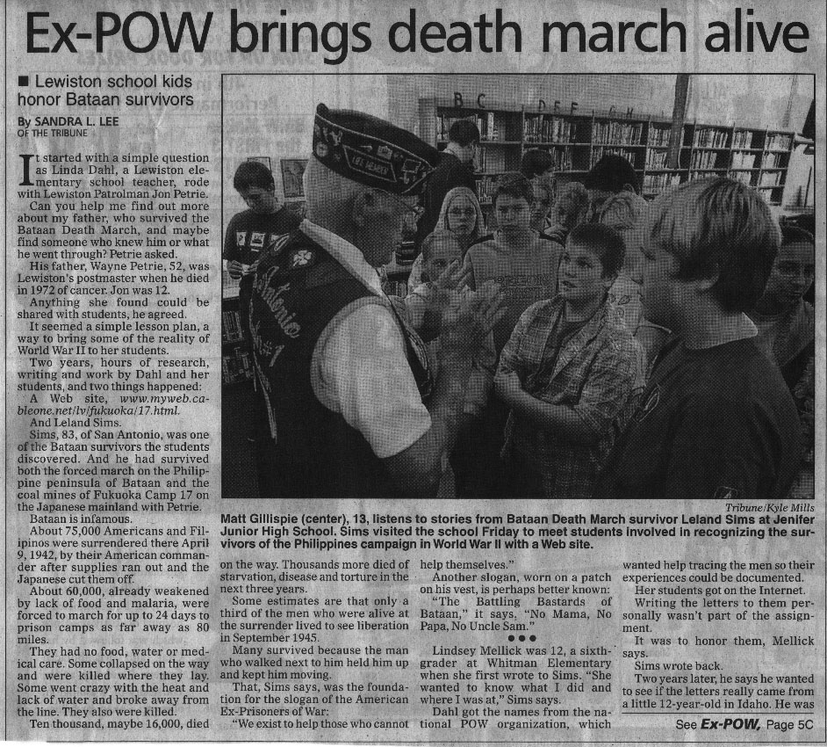
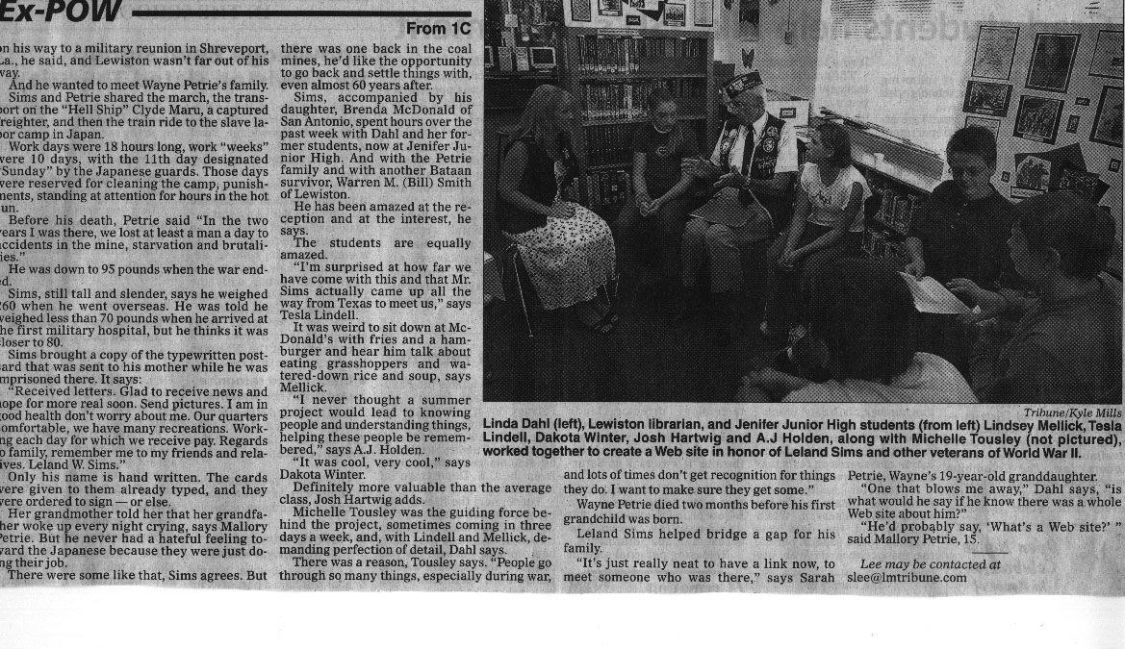
Leland's POW Cards & Photos - following pages

Prisoner of War Cards from Leland that made it home!
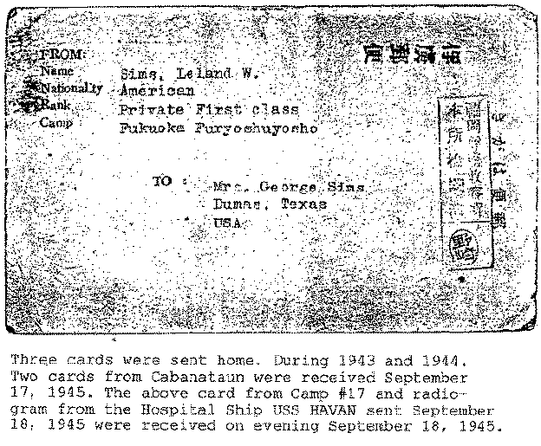
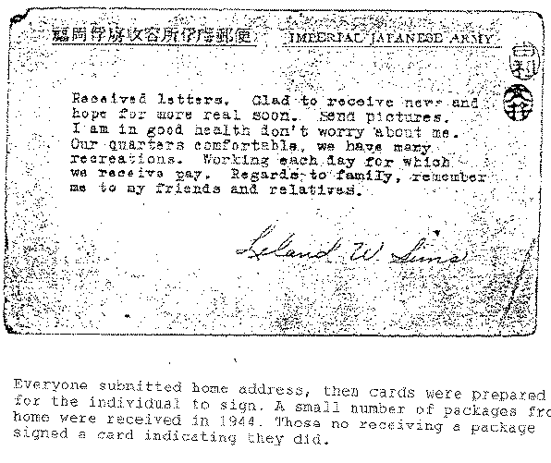
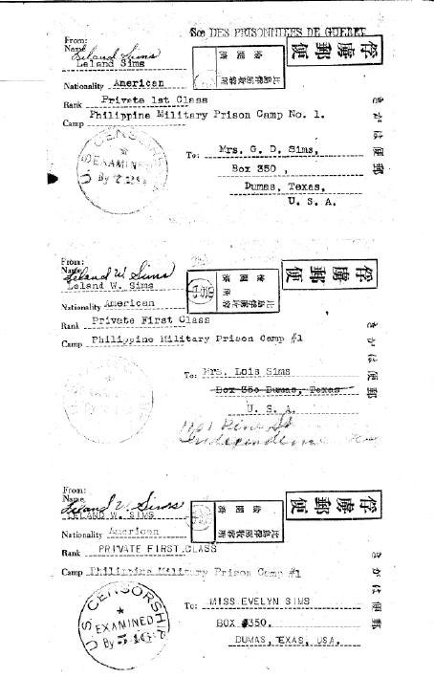
Cards sent from Cabanatuan
Front and back

Back of cards -
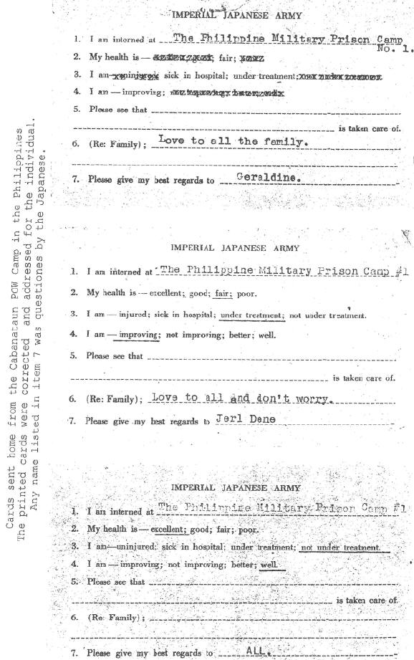
Message from card was
censored by the Japanese

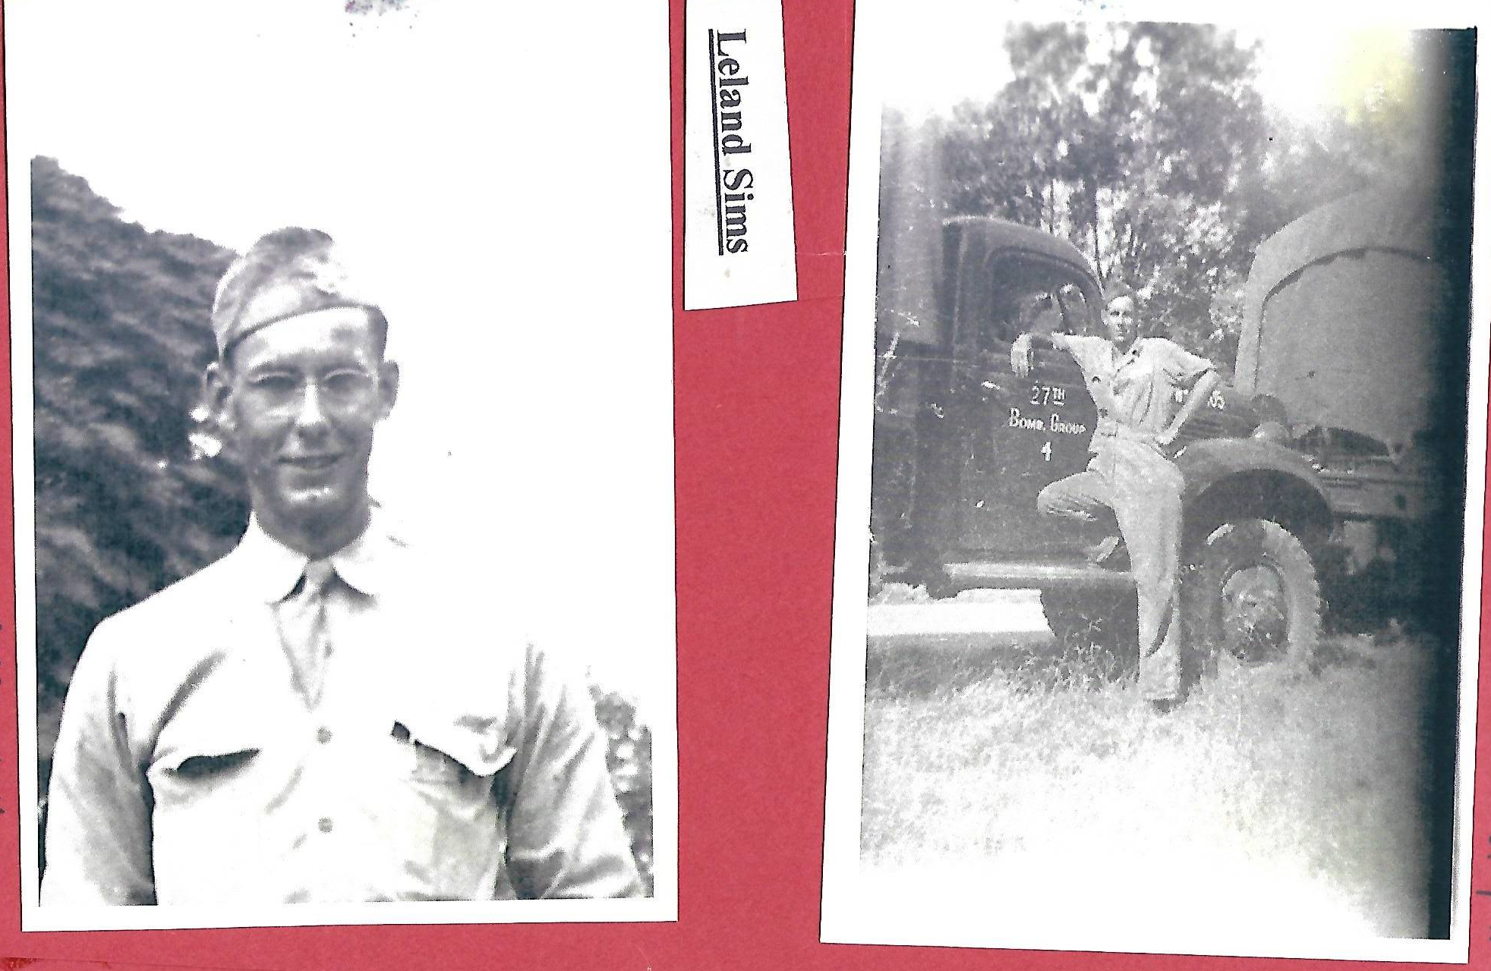
Leland – (left)
1st leave home - 1939

(right) Ruston Sept 1940 - pre war -
notice the 27th Bomb group name on the truck?

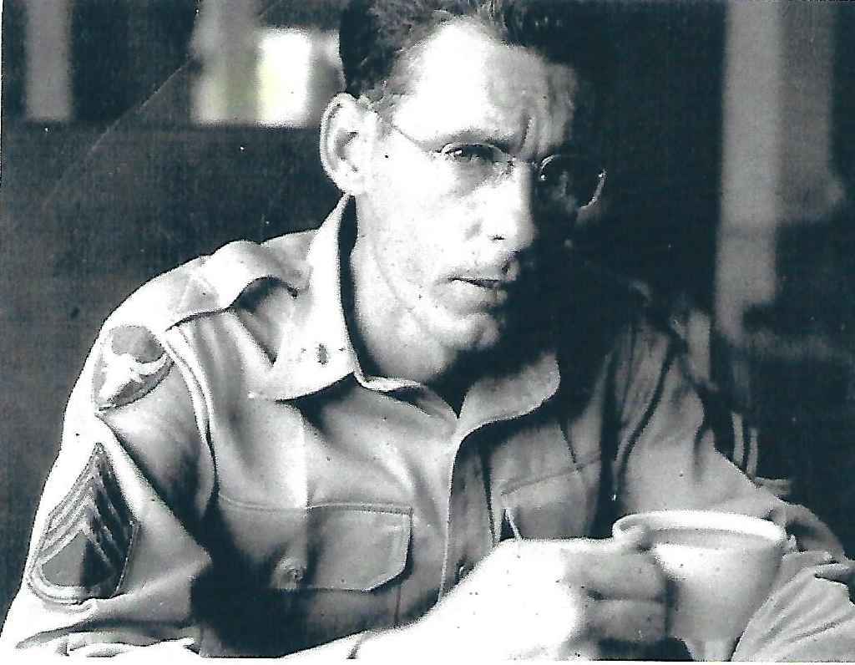
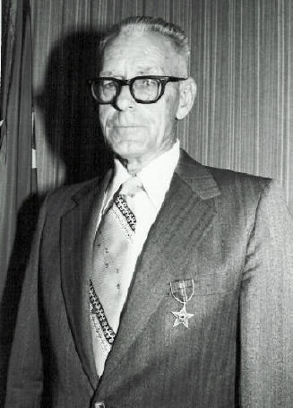

(R) Okinawa -after the war

(L) Wearing Bronze Star 1989

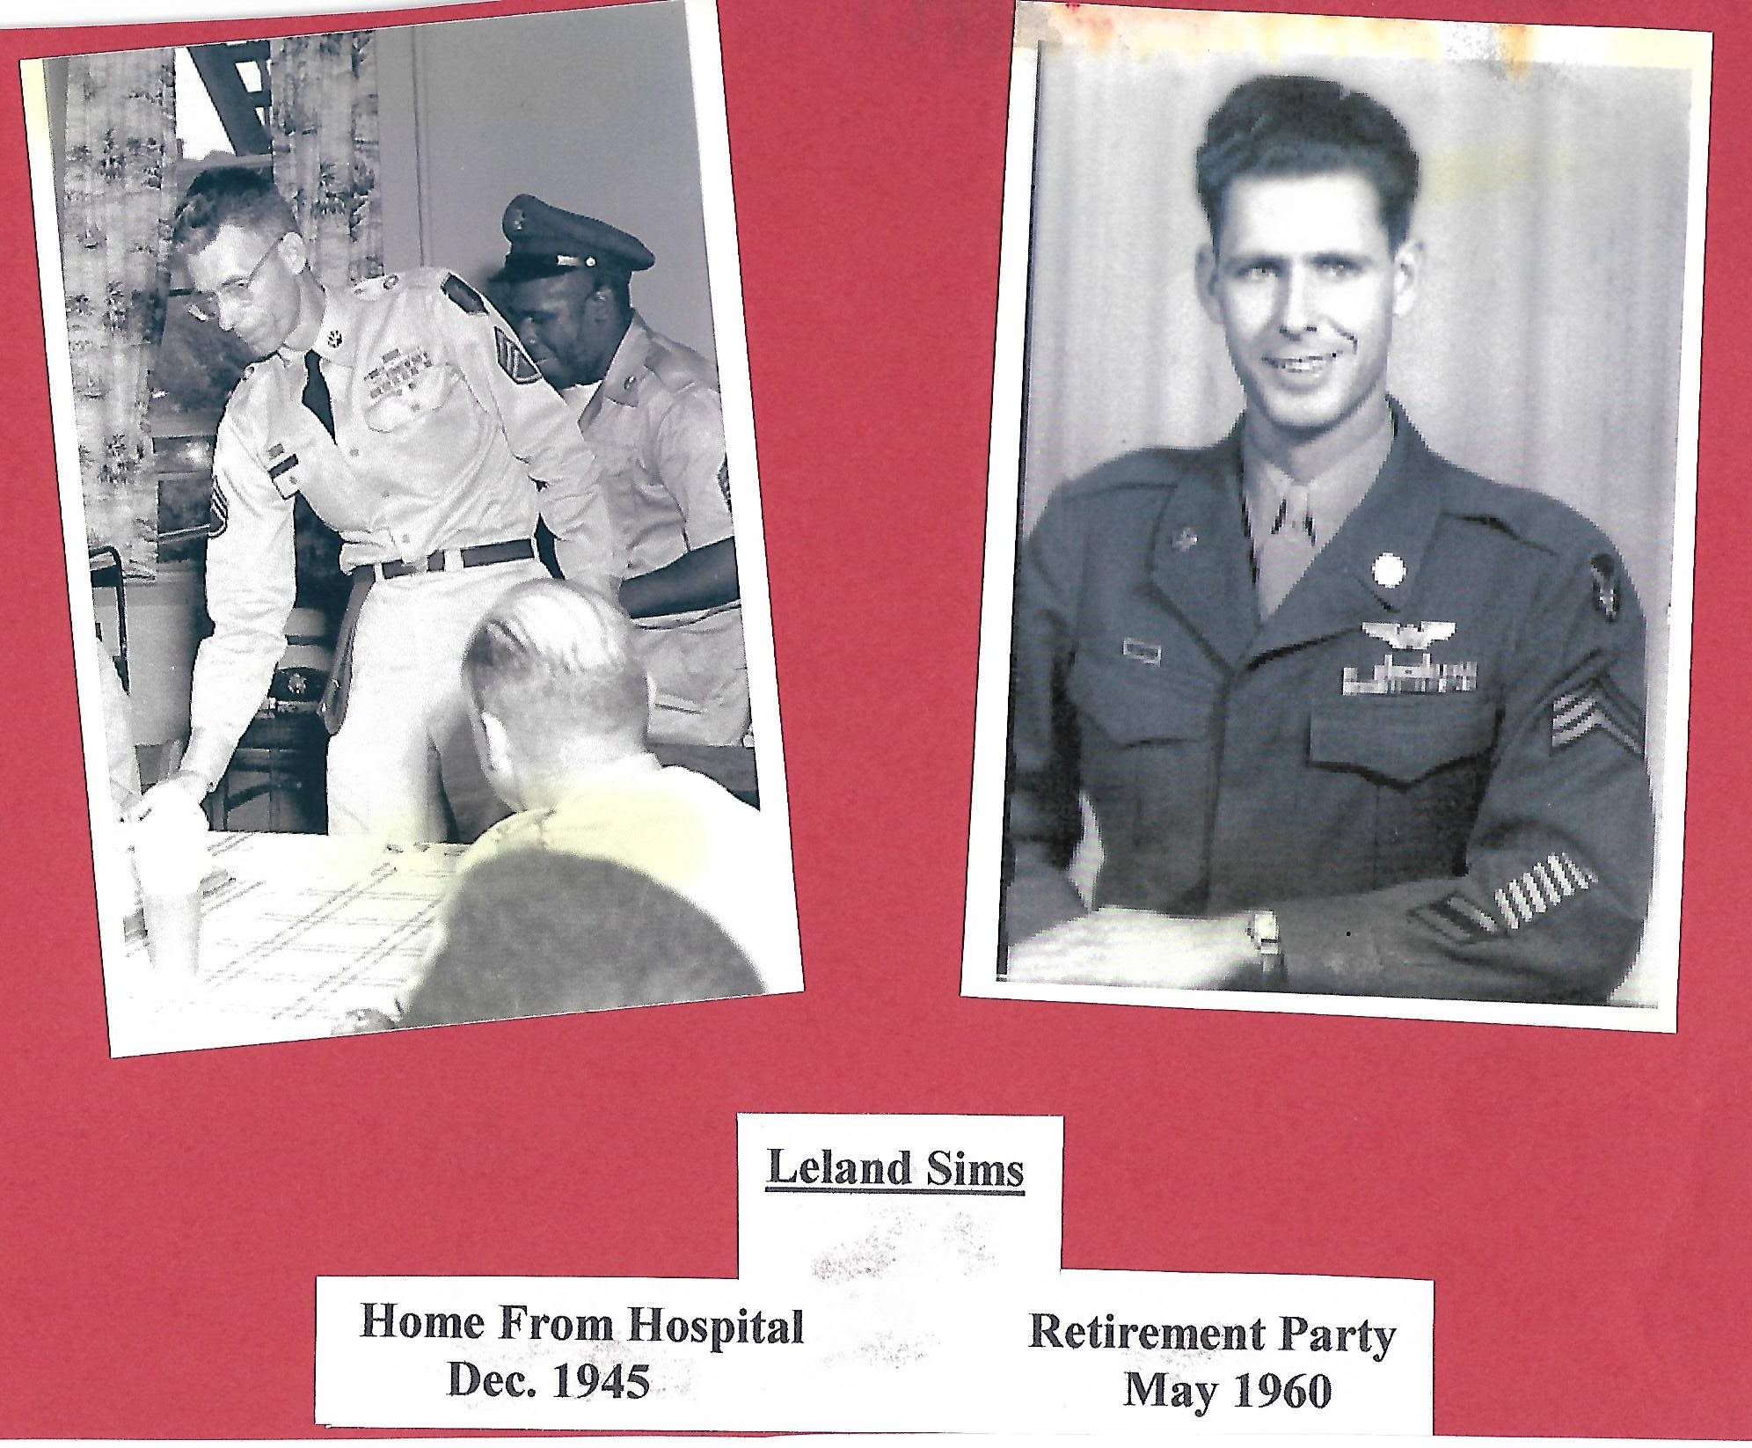
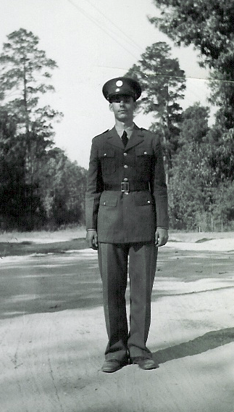

Leland Sims Obituary
Leland Wallace Sims - SAVANNAH - Leland Wallace Sims went home to be with the Lord Sunday, January 3, 2010, at the age of 89.
Leland was born in Smackover, Arkansas July 21, 1920. On September 9, 1939, Leland enlisted in the Army Air Corps. He was assigned to the 27th Bomb Group. He was a survivor of the Bataan Death March. He then spent three and a half years as a prisoner of war in Japan. He continued to serve his country in the military until 1960. He retired from civil service in 1980. He had been awarded the Purple Heart and the Bronze Star. At first, Leland did not speak much about his experiences while he was a prisoner of war. He joined the National and San Antonio Chapters of the American Ex-Prisoners of War. The 27th Bomb Group had yearly reunions.
It was through these organizations that he was able to share his experiences with others. It was later that he began writing about his years as a prisoner of war. His book was completed and published in November of 2009. He held no ill-will toward the Japanese.
Leland lived a long and fulfilling life. He married Joyce Henry in 1947.
Together they had two daughters, two grandchildren and four great-grandchildren. They finally settled in San Antonio, Texas after his retirement from the Army in 1960. In 2004, Leland called Jean Southwell in Savannah. Leland had met Jean while he was stationed in Savannah in 1940 when she was 14 years old. Her family often fed and visited with the soldiers. Leland and Jean married October 28, 2004.
They spent five loving years together laughing and holding hands.
He is preceded in death by his wife of 54 years, Joyce Sims. He is survived by his wife of 5 years, Jean Sims, daughters Brenda and husband Jim McDonald, Ginny and husband Raymond Flint. Sister Evelyn Higgins, niece Fran Higgins and nephew Steven Higgins. Grandchildren Nora Valdez and David Sims.
Great-grandchildren Niko, Nathan, Aron and Noah Valdez. And many, many friends.
Interment, with full military honors, will be in Fort Sam Houston National Cemetery in San Antonio, Texas.

Leland wrote “My War Story”. Contact webmaster if you would like to receive a copy.

