In memory of Clarence Henry Sosvielle
This following account was submitted by Charles E. Alburger
57 years have passed since serving in Shanghai China, assigned to the Port Director's office
in the Glen Line Building. Our group consisted of 4 officers and 10 enlisted men (really boys).
Chief Sosvielle was in charge of the enlisted men, in general he was somewhat a quiet person with a great sense of dry humor. Each week he would give us a full dress inspection; on one occasion when he arrived he shouted out the orders in Japanese. We just stood there not knowing what to do.
Another time we all went to a base football game. While there the Chief said: "We are out of beer; who is going to get it?" I volunteered (I was a non-drinker). When I got back with the canned beer everyone
moaned--the canned beer had a bad taste. I was supposed to bring back bottles. The chief said, "That's what happens when you send a boy out to do a man's job".
I still laugh every time I think about it."
We all loved and respected Chief Sosevielle. God bless him.
Sincerely, Charles E. Alburger
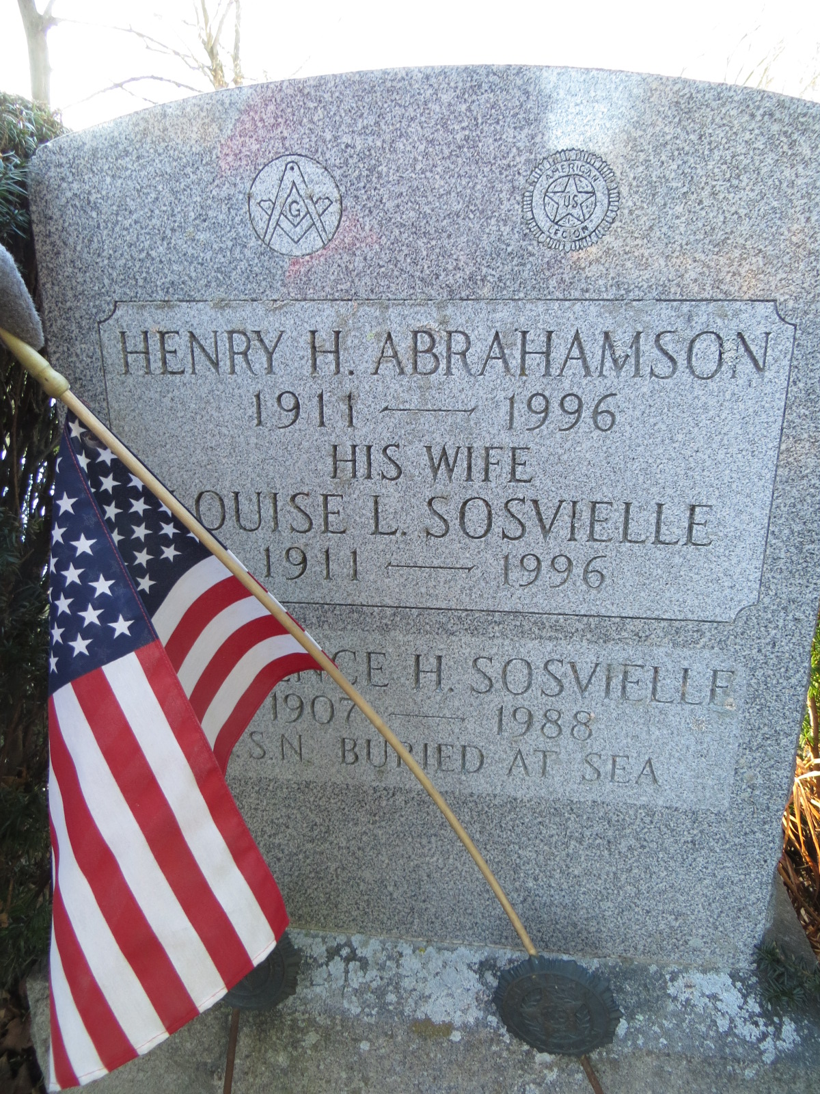
Deceased 31 October 1988 ~ Clarence was buried at sea

