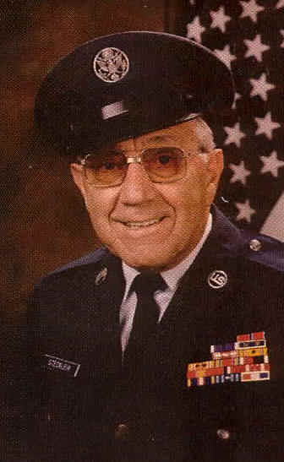
Frank C. Stecklein

Army Air Corps - S/Sgt. - Headquarter 20th AB Group

"These are my WWII experiences as a POW"

I was taken prisoner by the Japanese on May 5, 1942 as a direct result of General Wainwright’s surrender to Japan of all U.S. troops stationed in the Philippine Islands. On MAY 24th I and other troops stationed on the island of Corregidor were taken by freighter to the shore near Manila. We were force marched from the docks through the city of Manila, which was later referred to by the Japanese as the “victory march”. We became to know it as the “Death March”.
Our destination was an old penal compound called Bilibid.

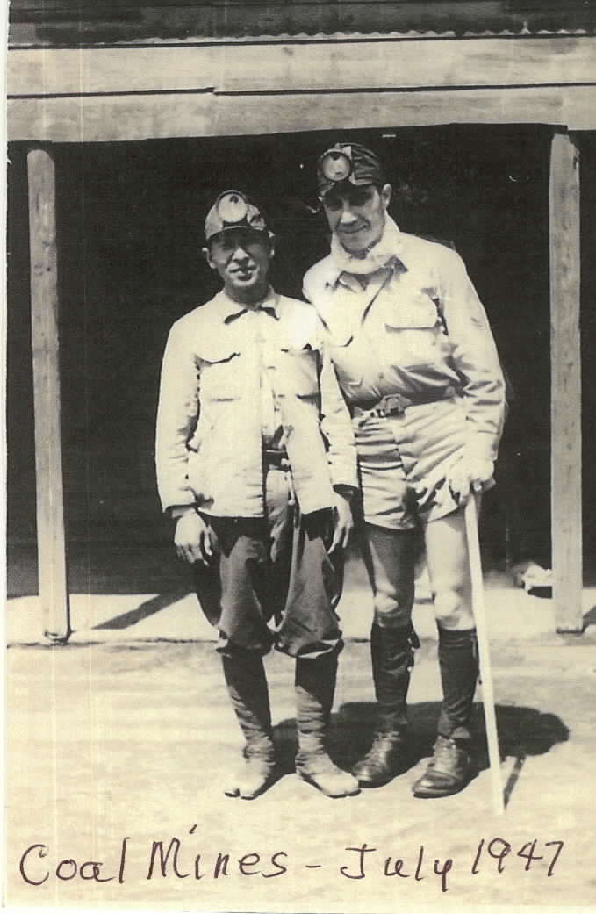
Early the next morning we marched to a railroad station where we were loaded into boxcars and taken to Cabanatuan. Upon arrival to our destination, we were then marched another twelve miles to a Philippine Army Camp called Camp #3. For the next twenty-five months I worked in the jungle. My time was spent building landing fields and working on a farm near camp. On June 25th, 1944, I was taken to Manila and we were loaded on a coal-carrying freighter. This voyage took two months before we reached Japan. We sailed from island to island while dodging U.S. submarines because the Japanese did not mark the ships as carrying prisoner’s-of-war.

After arriving in Moji, Japan, I was taken by train to Omuta, where we stayed at Camp #17. I worked in the coal mine for one year. I was beaten many times for not meeting their standards in terms of daily output.

Japan surrendered on August 15th 1945 and I left camp on September 12th. We traveled by train, and I finally met up with American troops on September 14th. I finally returned to the States on October 20th 1945.

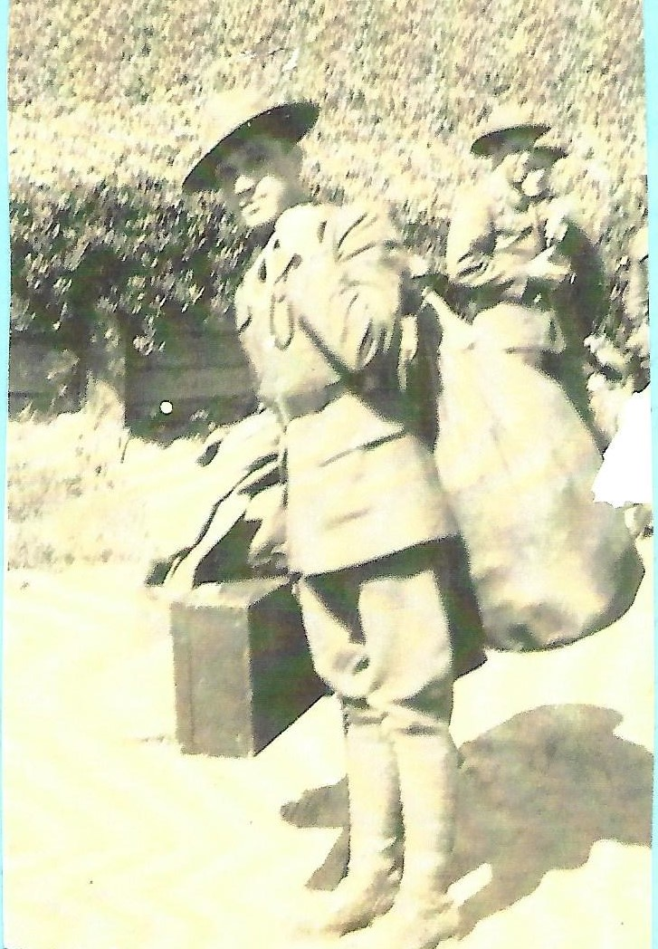
The following is labeled
“Evidence submitted for the Japanese War Crimes Trials.”

On 13 May, 1945, I was in charge of a detail working near Red Cross boxes in the Japanese store. I refused to let the men steal but later one of them gave me a can of salmon, with which I was caught. I was investigated by an American Officers, found guilty of stealing and taken to Japanese HQ with three other members of the detail. The camp Commander immediately punched me in the face and kicked me many times on the shins. He then commenced to ‘examine’ me. I had to strip off my upper clothing and kneel down. I was then terrifically beaten with a bamboo pole, 1 inch in diameter, with the end shredded. I was beaten until the whole of my back and shoulders were badly lacerated and bleeding.

We were taken and made to kneel down outside the guardhouse. Small rocks were placed beneath our knees then pieces of timber placed under our shins, so that the weight of our bodies rested on a few sharp jagged points of the rocks. We were only a few feet from the guard and any movement on our part and relax our legs was immediately punished by kicks our punches. We were not allowed to sleep at any time during the four days of our detention. When our eyes closed from sheer fatigue we were immediately kicked into wakefulness.

At 7pm we were lined up and given 6 strokes across the buttocks with a piece of timber two inches x two inches and about four foot long. The guard used all his strength and swung the pole as one would swing a baseball bat. Each stroke left a great purple buries. The bashing was repeated at 10:00 P.M. and every subsequent day at 7am, 7pm and 10pm. During the night the guards amused themselves by pouring buckets of icy water over us and taking turns to punch or kick us or crack us over the head or back with rifle butts. I was given the terrible task of plucking the mustache of one of the party. I refused and was beaten until I commenced to pluck it out hair by hair.

At 10 A.M. the following morning the new guards came on duty. They also took turns to beat us according to their fancy. Everything was used on us, fists and heavy boots, sticks, heavy poles, straps, heavy leather belts and rifle butts. During the afternoon ‘the Sailor” a notorious guard known by everyone in camp for his brutality, went to work on me with a strap, double and doubled again until it resembled a cat o nine tails. I thought he would never stop, I begged for mercy but he kept on and on.

All day and night we were kept bitterly cold by having water thrown on us at frequent intervals. The constant kneeling by this time had caused our feet and legs to become swollen to twice their normal size. To add to our discomfort we were tied to a post with our hands behind us for the whole night – still in a kneeling position of course.

The next morning we were forced to do calisthenics, owing to my badly swollen feet and legs I could not perform the exercise to the satisfaction of the guards came on at 10am and as usual during the day we received our quota of kicks, etc. Late that night one of the guards decided to relieve his boredom by practicing ju-jitsu. He flung over his shoulders about 6 times onto the rough ground, besides subjecting me to several painful holds.

About midnight a guard urinated in our faces. We were given short heavy sticks and made to beat each other over the head. This continual beating was one of the worst features of our torture. On the morning of the 4th day we were given a drink from a trough which was used for cement making. This dirty water was the first substance we had received since being turned into the guardhouse.

About 10am I asked permission to speak to the Camp Commander with a view to termination of our punishment. Immediately upon entering the Commandant’s room he slapped my face, kicked my shins and told me to kneel down. I was then given all sort or instructions which I promised to obey and we were released after signing a declaration to the fact that we would never again cause the Japanese authorities any trouble whatsoever. During May the weather was cool, with very cold nights and frequent rain. The weather was an important factor, as we were kept outside the whole time. Even during the heavy rain we were not permitted to seek shelter, As my back was badly lacerated from the first beating I was allowed to wear my shirt for the first day and night, after that I was stripped to the waist the same as in my companions. In order to increase our discomfort our boots were also removed.

When we were sent to the guardhouse we were classified as ‘Light Duty Sick’ but notwithstanding that fact the Japanese sent us to mine with our shift at midday on the day of our release. Owing to the condition of our feet and legs we could hardly walk and we could not perform our work to the satisfaction of the mine Forman we were reported to the guards at the mine who gave us a severe beating, mostly with a pole about 2 inches in diameter.

I declare that the above is the truth without any exaggeration whatsoever.

(signed) Frank C. Stecklein
S/SGT U.S. Army

Frank’s Obituary and Memorial

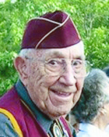
Frank had become a good friend, and so it was with a heavy heart I (Linda) added this addendum to Frank's page;
We lost a great man on January 8th, 2013, yet Heaven gained a faithful servant.

M/sgt Frank C. Stecklein, Air Force retired, entered into rest on January 8, 2013 in San Antonio, Texas, 3 months prior to his 100th birthday. He was the eldest of eight children born to the late Carl and Anna (Younger) Stecklein. Frank was born on March of 1913 in Ellis County Kansas and is preceded in death by siblings Henry Stecklein; Mary Resley (Mars); Evelyn Scala (Louie), Agnes Ann Maupin (Bob), and Josephine Gross (Alphonse). He is survived by his wife Judy Stecklein; daughter, Sharon Ann Graber (Larry ); son Carl Stecklein; sister Rose Linenberger (Raymond); brother Richard Stecklein (Maryanne); granddaughter Aiyin Graeber; step-daughters Beth Alm, Brenda Cheesman (Larry); Beverly Johnson (Andrew); Bridgotte Griffin (Ed); and step-son Brad Alm (Rhonda).

Frank graduated from St. Joseph Military Academy of Hays Kansas in 1932. Soon after graduation, he joined the US Army Horse Cavalry at Ft. Riley, KS. After Ft. Riley, Frank re-enlisted and was stationed in Hawaii where he played the trumpet in the Coast Artillery Band. He re-enlisted in the Army Air corps, and in Febuary of 1941, Frank was transferred to Nickols Field, Philippine Islands. He was placed on Detached Services in General MacArthur's Headquarters. May 6, 1942, all troops in the Philippine Islands were surrendered to Japan and he and fellow prisoners of war worked on the island of Luzon. Frank cut wood in the jungle, and carried manure to local farms. On July 2, 1944, Frank and 1500 fellow prisoners were transferred, confined in a coal carrying ship. For two months, the ship dodged US submarines and the prisoners were given little to eat until their arrival at Moji Japan. From Moji, the prisoners were taken by train to Omuta, Japan where Frank worked for one year in the coal mines until the surrender of Japan.

After nine months of hospitalization and rehabilitation, Frank re-enlisted in the US Air Force. In 1947, Frank was recalled to Tokyo, Japan to be a witness in the War Crimes Trials. Frank testified to the brutal beatings he and other received while working in the coal mines.
From Frank's family and community upbringing, Frank spoke German quite well and in 1949, attended Intelligence school in DC where he was then transferred to Frankfurt, Germany to interrogate German Prisoners of War. While in Germany, Frank traveled all countries outside the Iron Curtain, took accordion lessons, and enjoyed visiting with friends.
In 1959, Frank returned to Washington DC to learn Spanish before being transferred to Ascuncan, Paraguay on Air Force Mission Duty. He was able to visit every country in South America during this time. In Sept. 1962, while stationed at Randolph Air Force Base, Frank retired from the military and then served until 1972 in the Civil Service.

Frank was a recipient of the Purple Heart, the Bronze Star and all medals connected to service in WWII in the Pacific as a POW. He is a Life member of the Defenders of Bataan and Corregidor, Prisoners' of War, VFW, and DAV. Frank was an Honorary member of the Fourth Degree Knights of Columbus, and also member of the American Legion and the Moose Lodge.

Frank loved to travel, visiting family and friends across the US, and also returned to Germany several times. He loved to dance and play music on the accordion and organ. Frank sang in church choir every year since he was 13 years old. He was a member of St. Helena's Choir and sang with Judy for Christmas Eve Mass this year. His greatest pastime was watching his favorite Texas Football, Baseball and Basketball teams on TV.

