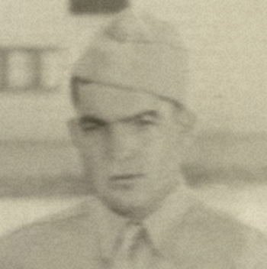
Pvt. Charles Harold Steel

Born: 27 June 1919 - Oklahoma - Home: McCurtain County
Inducted: U. S. Army - 21 March 1941 - Oklahoma City, OK
Training: Fort Knox, Kentucky, Camp Polk, Louisiana
Units: 753rd Tank Battalion and 192nd Tank Battalion Hq Co.
Overseas Duty: Philippine Islands - Engagements: Battle of Bataan, Northern Luzon
Prisoner of War: 9 April 1942, Death March
POW Camps: Philippine Islands: Camp O'Donnell, Cabanatuan
Japan: Fukuoka Camp 17 - coal mining
Hell Ship: Clyde Maru, Sailed: Manila - 23 July 1943, Arrived: Moji - 7 August 1943
Liberated: September 1945
Died - 2 May 2000 - Oklahoma City, Oklahoma

For a complete outline of Charles’ training, overseas duty, POW labor and liberations, see
192nd & 194th Tank Battalion

Credit: Jim Opolony

