DONALD EDWARD TAPSCOTT
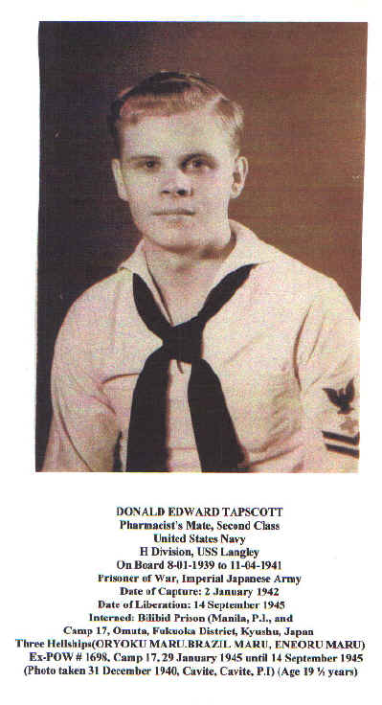

Obituary Tribute…..

In Loving Memory of
Donald Edward Tapscott
1921 - 2011

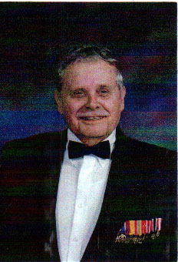

A Most Loving and Devoted Husband and Father.
A Commander in the United States Navy.
W W 2 Veteran and Ex POW in Japan.
A witnesses to the Atomic Blast in Nagasaki and
A Peaceful Loving Man By Nature and His Experiences.
A True Loss to Mankind,
Love you Dad.

