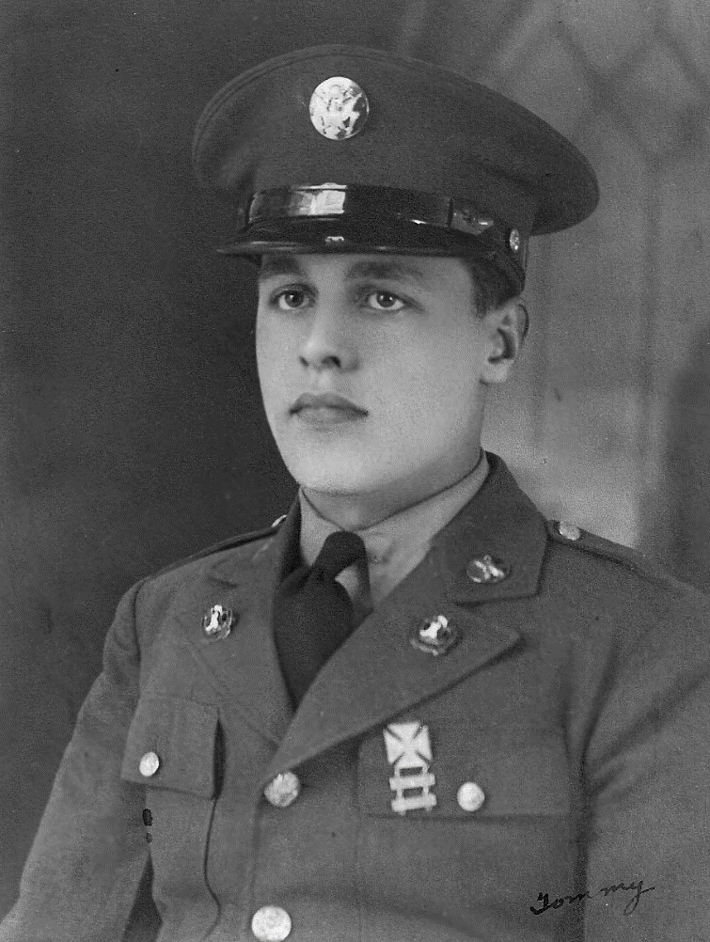
Thomas P. Kolatsky
Thomas was born in Hazelton, PA, October 26, 1918, son of Peter and Anna Kolatsky. He lived in Watertown, NY most of his life, attending schools there.

Thomas joined the Army in 1936 and was assigned to the Philippines in 1939 where he was a supply sergeant. He served on Corregidor and was engaged in battle against the Japanese the winter of 1941 and 1942.

In a 1950 interview, Thomas spoke of the attacks. “I was walking along the beach when suddenly an anti-aircraft battery near me began to open up, jamming shells into the air. It scared me half out of my skin and I looked up to see a flight of big bombers. Suddenly, I heard a fluttering noise, and no one had to tell me, I hit the ground.

Thomas was captured, along with other soldiers and Filipinos, and they were marched (not the Bataan Death March) to various places until they were sent to Cabanatuan. He was later forced to Japan where he was kept as a POW for over 3 years and forced to work 10 hours a day in a coal mine.

In August of 1945, Thomas was witness to the dropping of the bomb on Hiroshima, as he was just 40 miles away. In a newspaper interview, Thomas said he and the other POWs had become used to the sounds of bombing, as they increased near the end of the war, paying it no attention at first. They thought it was a Munitions explosion, until a Red Cross worker later explained “this new weapon.”
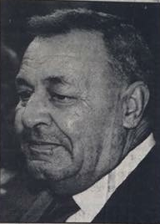
After liberation, Thomas received several medals, including the Purple Heart, as he convalesced in the US for several months.
When he was dismissed, he returned to Connecticut and enrolled in the University of Connecticut ROTC program.

Thomas retired from the Army, after 20 years as a Sgt. Major, and joined the postal service where he worked as a letter carrier for 17 years.

Thomas passed on 9 March 1991. Burial: Mount Olivet Cemetery, NY

At the time of death: Survived by his wife, Irene (Handura) son – Thomas J Kolatsky, and daughters – Mary Todden and Joann Barthelmess.

