Achille C. Tisdelle, Jr
US Army 26th Cavalry Philippine Scouts

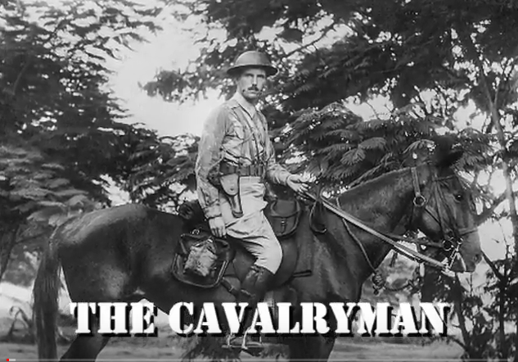
Prior to, and during the war, Tisdelle was assigned to Headquarters as an Aide to General King - Luzon Force.

Tisdelle was acting commander at Camp 17, entering the camp with the “The First 500” and staying throughout
most of his POW years.

The first 500 POWs arrived at Camp #17 on 10 Aug 1943 after a 15 day journey from Manila to Moji aboard the Clyde Maru (known to the men as the Mate Mate Maru).

Captain Tisdelle stayed at Fukuoka Camp 17 until his transfer to Camp Muken 25 April 1945.

Achille Carlisle Tisdelle Jr. was born March 17, 1909, in Chicago. Died: April 30, 1986 in Orange Park, Florida.

The Fall of the Philippines includes Tisdelle accounts:
https://ibiblio.org/hyperwar/USA/USA-P-PI/USA-P-PI-26.html#cn28

Excellent Video of Tisdelle and his account of Bataan, the surrender, and after events.

https://www.youtube.com/watch?v=_9kyj169YPY

Credit Ash Tisdelle

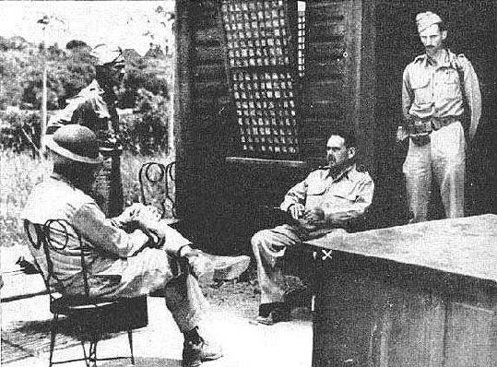
Capt. Archille Tisdelle standing, far right. Disarmed, his canteen replaces his weapon. Major General Edward P. King sits by Tisdelle on his right, waiting to discuss surrender terms.

At the end of World War II the world faced a massive judicial endeavor in bringing to trial those individuals responsible for the carnage and deaths of some 60,000,000 military and civilian lives. The Nuremberg Trials, as they are known, were largely responsible for war crimes committed in the Atlantic and European theaters of the world, while the Pacific trials, covered the Orient and Pacific theaters. Justice would be difficult, costly, and time consuming. Among the countless individuals serving the litigation process was Major Achille C Tisdelle of the US Army 26th Cavalry Philippine Scouts. He was stationed in the Philippines at the outbreak of the war and was aide d camp to General E P King who was the commander of the American forces on the main island of Luzon. Together they would advance in a jeep on the morning of April 9 1942 to meet the Japanese and discuss surrender terms. They would be bombed and strafed the whole way and it would be their last day of freedom for 3 ½ years. Tisdelle was at the surrender table and was a witness to the negotiations. At the end of the war he was the only man left alive who could testify that he was at the surrender table and also endured the atrocities of the Bataan Death March. He saw it all. The beatings, starvation, diseases, and other indignities were all a part of everyday life.

Of the 9,400 American soldiers who were on the Death March and subsequent internment, only 5,600 came home alive. In January of 1946 the US Army ordered Tisdelle back to the Philippines to be a key witness in the Army’s prosecution of Japanese General Masaharu Homma who had been Japan’s Imperial Army commander. Tisdelle’s testimony and presentation of his war time diary, along with one of the “surrender leaflets’ dropped from Japanese war planes, which he had secreted for the duration of the war were largely responsible for Homma’s conviction and execution in April 1946. This is not a reenactment. There is no music or narrator. Homma and Tisdelle are seated in plain view of each other. The courtroom drama is intense.

Tisdelle Engagement & Wedding

