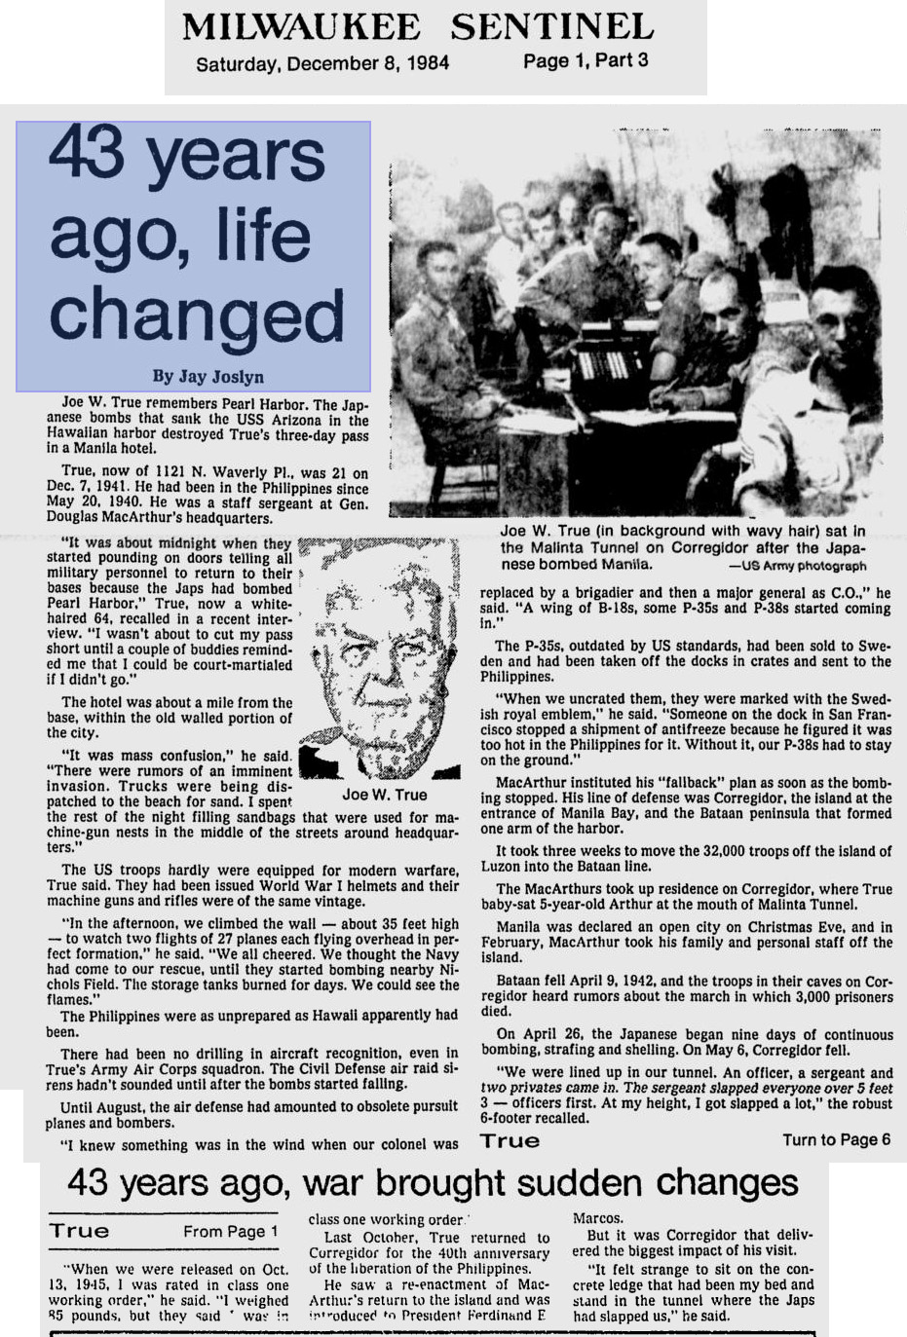
Joe Wheless True

Army Air Corp - S/Sgt.

Credit: Milwaukee Sentinel Dec. 1984

