Joseph Alfred Vaillancourt
U.S. Army – Private - CAC A Btry 59th CA Regt HDM & SB
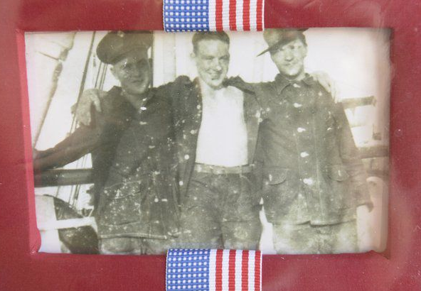
In the mid-1950s, at only 5 years old, through her father Joseph’s recollections, the horrors of World War II became vivid to Patricia Vaillancourt. Yet, instead of terrifying her, his stories gave her an enormous respect for her father, and his will to survive in conditions so terrible dying would have been easier than living.
“I would wake up at night because I’d hear my father screaming in his sleep,” Vaillancourt said. “He was having night terrors, dreaming about when he was a Japanese prisoner of war. I asked him about it. I was lucky, my father would talk to me. Most men who endured it didn’t.”
Lawrence born and raised before the start of World War II, Joseph Alfred Vaillancourt was stationed on the Philippines, the 7,000-island archipelago the United States annexed in 1898 and its westernmost outpost. He was there when the United States declared war after the Japanese bombed Pearl Harbor on Dec. 7, 1941, destroying nearly all of this nation’s Pacific fleet of ships. And he was there when their planes flew across the Pacific in less than ten hours to bomb American air fields on the Philippines largest island of Luzon, taking out most of the America’s Pacific air power.
He was there when the Japanese invaded Luzon, and there when American generals retreated to the Bataan peninsula and to the fortified island of Corregidor, where he was stationed. He was there when the Battles of the Philippines and Corregidor were lost and when America’s military surrendered the Philippines to the Japanese, with tens of thousands of soldiers American and Filipino troops left behind at the mercy of their captors.
He survived to spend years in Japanese prison camps when thousands of others did not. Although many lost hope and their lives, Joseph Vaillancourt endured three and a half years of hard labor, little food and cruel treatment as a prisoner of war.
He was there when the United States dropped its second atomic bomb on Nagasaki, witnessing the mushroom cloud that killed so many Japanese but ended a devastating war. He was there, a survivor, when the prison camps were liberated. He endured, according to his daughter because he’d held fast to his values and memories of family and his desire to return.
Her father’s stories and the World War II memorabilia saved by her grandmother, Margaret Vaillancourt, while her son was imprisoned inspired Patricia Vaillancourt to spend years researching the circumstances surrounding his World War II experiences.
“I interviewed 100 survivors of the Bataan Death March and Japanese prisoners of war,” Vaillancourt said. “Only three are still alive. Most POW’s didn’t forgive the Japanese. My father did. He told me, ‘I’m not going to live my life in bitterness and regret.’ “
Vaillancourt will talk about her research and the courage and sacrifice of her father and others like him in a presentation at the Hilton Center in Salisbury on Aug. 17.
A former educator, 68-year old Vaillancourt is an active retiree. Splitting her time between Salisbury and Florida, Vaillancourt still works as an inspirational speaker and a volunteer at the Armed Forces Military Museum in Largo, Florida.
It was a question she was asked by a teenager while giving a tour of that museum that led her to realize the importance of relaying her father’s experiences.
“She asked ‘Who won World War II?’ “ Vaillancourt said. “There’s an entire generation who doesn’t know or understand the sacrifices these men made to keep this country free.”

Credit: Angeljean Chiaramida, Staff Writer Aug. 2016 / Daily News New England

