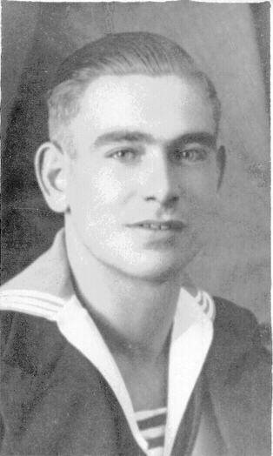
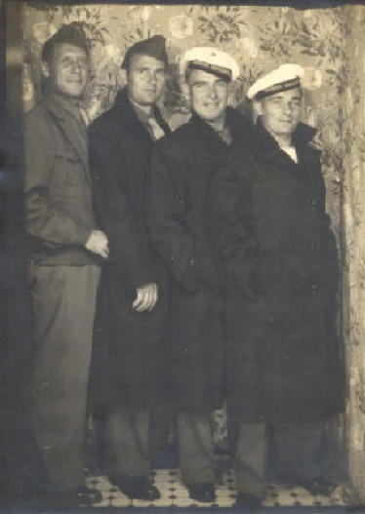
Hermanus Verbrugge
Marine - Stk 1 / Royal Dutch Navy
Born 30 Juli (July) 1915 – 2 Januari (Jan.) 1995
Verbrugge was in the Royal Dutch Navy and
served on "Hr. Ms. De Ruyter" where a torpedo
sunk his ship. He was one of the 92 survivors.
NOTE: De Ruyter was laid down (completed) on
16 Sept. 1933 at the Wilton-Fijenoord dockyard
in Schiedam and commissioned on 3 Oct. 1936.
She was commanded by Captain A. C. van der
Sande Lacoste. She was sunk in the Battle of the Java Sea in 1942.
1937
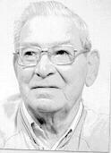

Herman, 3rd from left, his friend,
Klaas van de Ketterij (also Camp 17) on the far right.
1933

Awards and Documents – following pages

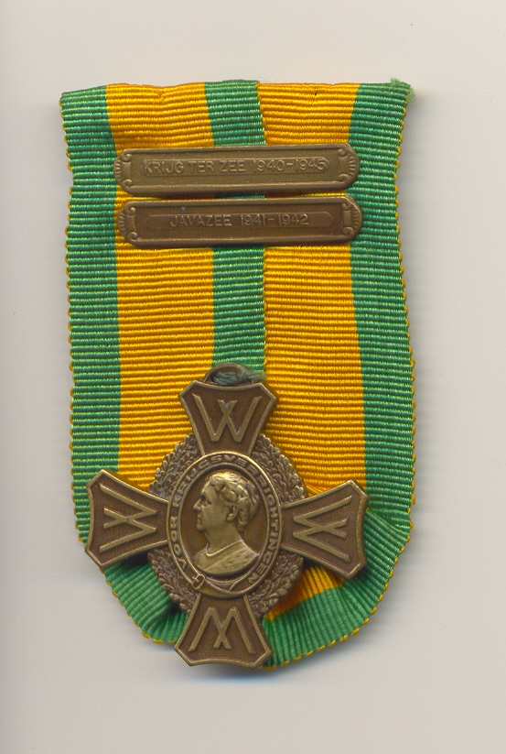
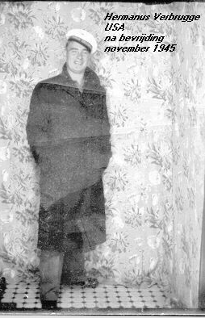
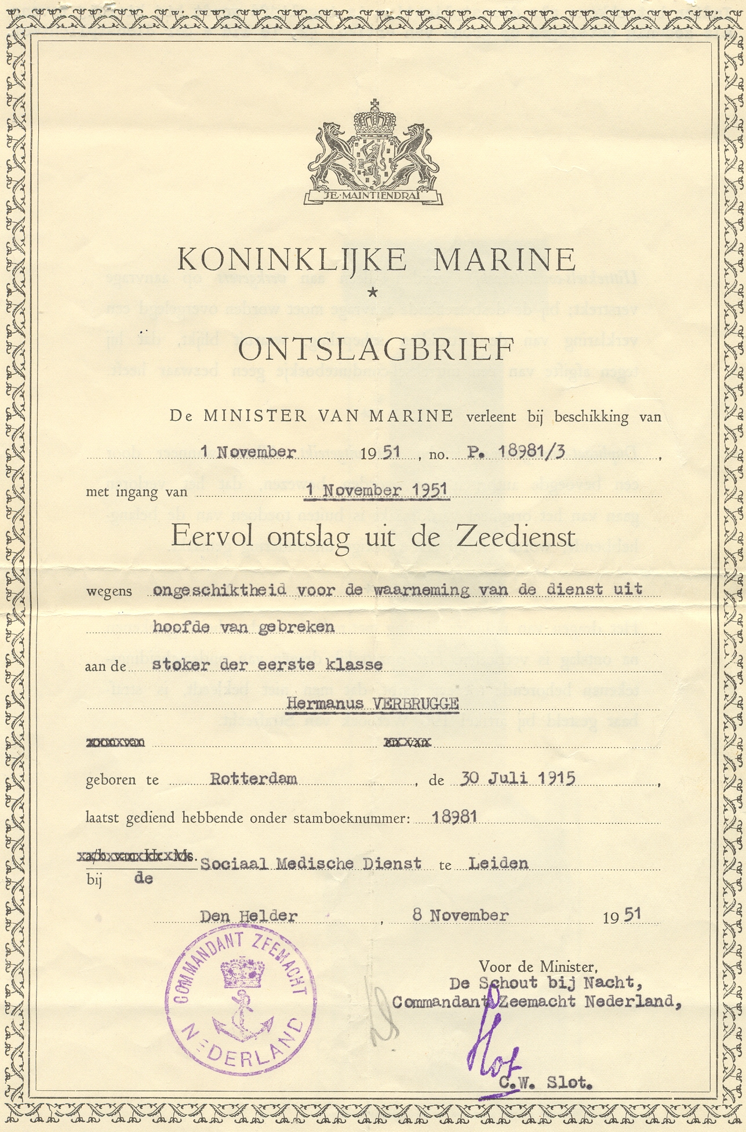

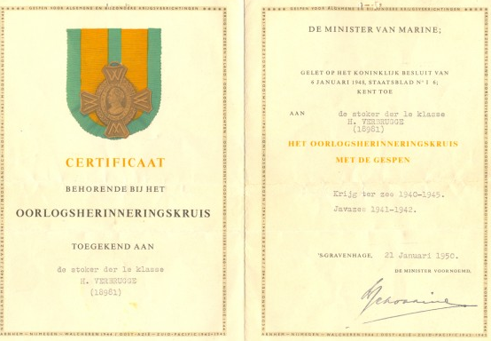

Herman’s POW cards
