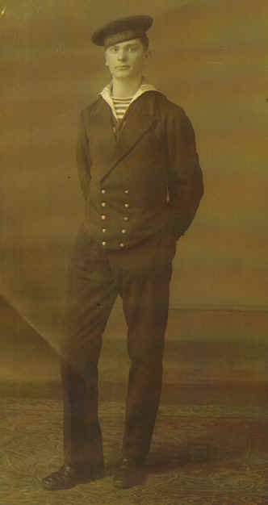
Cornelis Vleugel Navy - Cpl.
A Grandson’s Tribute
by Matthew Dare, in honor of his grandfather Cornelia
Cornelis Vleugel was born in Wemeldinge, Netherlands,
on the 15/03/1913. In 1930, at the age of 18
he joined the Royal Netherlands Navy (Koninklijke Marine).

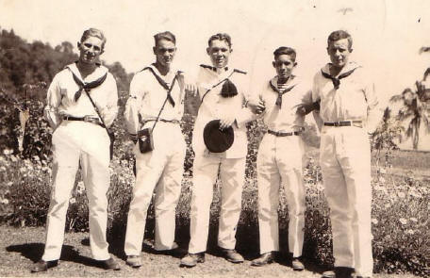

Cornelis is the 2nd sailor from the left. The photo was taken in Bali,
1935 during his first trip to the Dutch East Indies.
Cornelis was approximately 22 years old.

At the fall of the Dutch East Indies he was ranked Corporal, Chief Radio Telegrafist, where he served on board Submarine Hr.Ms.K.X, (K10). The crew of the K.X were taken prisoner at Surabaya, after she returned with major damage. The K.X was to be scuttled by her crew to avoid being captured by the Japanese.
Cornelis arrived at POW Camp Fukuoka 17 on approximately 18 June 1944, via the Teia Maru from Singapore. Prior to this he was forced to work on the Burma Railway.
After liberation he was taken to hospital in Manilla, then to Craigeburn, Dutch Navy Radio Base in Melbourne, Australia. It was at this base where he met his future wife (my grandmother).
After returning to the Netherlands they came back to Australia with their first born, (my mother) and settled in Australia.
Cornelis Vleugel passed on 20/11/1976 due to illness from imprisonment. At the time of his death, he was survived by his family, who reside in Australia: his widow, five daughters and ten grandchildren along with many great-grandchildren. I am one of those grandchildren and I will never forget this man.
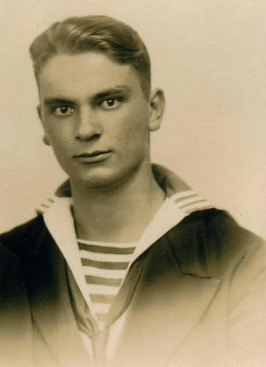
In 2005, for the first time, I marched with the Dutch Contingent on ANZAC Day, proudly wearing his medals on my chest. It is something I continue to do, honoring these men and especially my grandfather.
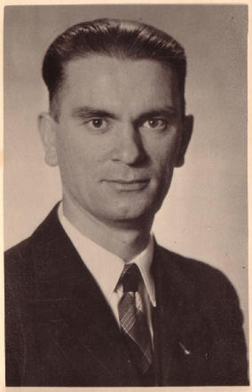
Photo left was taken in Bali, 1935",
during Cornelis's first trip to the Dutch East Indies.
He was approximately 22 years old.

Photo right was taken post war - 1948

