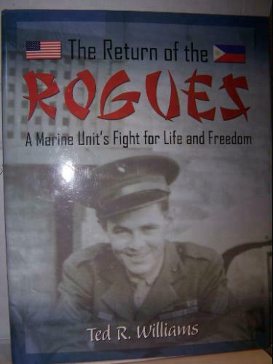
Ted Ralph Williams
Ted Williams was born Hawthorn, CA April 24, 1921.
He joined the USMC Jan. 12, 1940. Ted served with Hqs. Co.,
3rd Btry., 4th Regt., Air Warning Co., fighting an unidentified battle at
Wa Wa Beach, Batangas, Agalo, a Point.
He was discharged March 30, 1946 as sergeant
and retired April 30, 1975.
Williams in the Philippine Islands on April 24, 1940, his 19th birthday, immediately following 10 weeks of intensive boot camp training at the San Diego Recruit Depot, USMC. He was assigned to duty at the Marine barracks. Cavite Navy Yard and performed as an admiral’s orderly, commanding officers’ chauffeur, mechanic/driver and power plant operator, respectively. A two months assignment to the naval reservations, Ted was privileged to meet and equate with people and traditions which continue to draw him back to the islands.
December 8, 1941 found Williams one day detached to an Air Warning Group that was setting up on Wa Wa Beach, Nasugbu, Batangas Province, Luzon Island. The 270 B Unite was a duplicate of the one ignored on Oahu when the Japanese bombed Pearl Harbor on that infamous Sunday morning. It was Monday in the Philippines when Radio Manila, featuring Don Bell, shouted the news of the dastardly attack. On December 24, this beleaguered group of the 34 men and its equipment, were ordered to move to the Bataan Peninsula. Pushing through a chaotic and burning Manila, they reached a small barrio on Northern Bataan early Christmas morning and spent three months feeding placement and Japanese air movement to the U.S. Air Corps.
April 9, 1941, Gen. King, USA, surrendered Bataan hoping to reduce the inevitable casualties consequential to continued fighting. Williams walked the Death March from Mariveles to San Fernando and endured the box-car torture ride to Tarlac, sight of a living hell known as Camp O’Donnell.
Over the next 42 months he endured the slave labor of Clark Field, Bilibid and Cabanatuan in the Philippines. On July 5, 1944, he and 1,000 other prisoners were herded aboard the Canadian Invader, nicknamed the Mati Mati Maru, to survive a 62 day trip to Moji, Japan via Formosa Island. This voyage was followed by stints as a coal minter at Camp 17 and an electrician and “coolie” laborer at Camp No. 1, Fukuoka, Kyushu, Japan. The horrors of incarceration ended on Aug. 15, 1945, with Japan’s unconditional surrender. Williams “hitchhiked” his way to Oakland, CA, via Army and Navy units. Following hospital stays in Oak Knoll and Long Beach Naval Hospitals, he was discharged from the Marine Corps in 1946.
Following two and a half years of soul searching and body healing. Williams attended college and graduated as an auto engineer.
After a 24 year career with Sears, Roebuck and Company, he and his wife, Lillian, retired to their vacation home in Baja, Cfa, Mexico. A massive coronary compelled him to return to California and subsequent open heart surgery. After authoring the book, Rogues of Bataan, and the death of his wife, Ted has busied himself with travel and co-chairmanship of the Corregidor School Project which provides a quality education to children who now reside on the “Old Rock” in Manilla Bay. A widower, his pride in the grandchildren resulting from his marriage to Lillian May (Phipps) Williams who preceded him in death on Dec. 26, 1980. Ted currently fills his life with the widowed Shirley Stakemiller, Anaheim, CA, loving and enjoying her family and three grandchildren as his very own.
Mother, Iris Mary (Chase) Night, deceased: sister, Velma Lorraine Cook, brother, Raymond Grant Williams and sister, Virginia Anne Kelley, widowed. Step-children, Denis McGeough, Linda May Fichtelman, James McGeough and Randall McGeough. Children of late wife, Lillian May (Phipps) Williams. The family includes seven grandchildren.

Credit: History of the Defenders of the Philippines Guam and Wake Islands 1941-1945 Turner Publishing Co 1991

