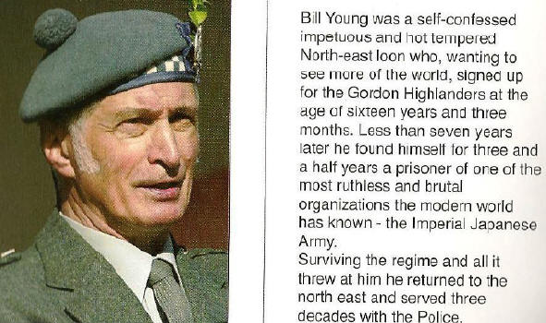
William Ross Young
The following is part of William’s book.
The Hellships
At Ban Pong, the surviving prisoners were divided into two groups. Those in better condition were to be shipped to Japan, in or on the notorious hellships,
destined as slave labour in factories or mines, with the remainder staying in Thailand to maintain the railway. Unknown to this second group, they were to be housed
in camps situated near strategic points where they
would suffer many casualties from Allied bombing.
Because of his bad jungle ulcer, Bill was selected to stay in Thailand, but his pal Albert was going to Japan, and Bill finally prevailed on the MO to allow his name to go on the Japan list so that they could stay together. They were then taken by rail to Singapore to join a small freighter convoy bound for Japan, a journey of over 3,000 miles, which normal conditions took about 18 days. Bill tried for many years to find out the name of this freighter, which, like nearly all Japanese freighters, eneded in "Maru", but he was unsuccessful.
She sailed from Singapore for the South China Sea about April or May 1944, laden to the gunwales with rubber,
tin, and all sorts of war materials looted from Malaya. As deck cargo, huddled on the foredeck in their loin cloths,
were about three hundred prisoners. The weather was stormy, the small convoy of about six ships was heading
steadily north, and the seas were breaking over the bows, drenching the prisoners, who had no shelter. It seemed to Bill that he had merely exchanged the frying pan for the fire, and it was to get much worse. He was in no doubt that the period spent traveling by boat from Singapore to Japan did him more damage than all of the time spent on the railway. Not only were the conditions on board Spartan in the extreme, with no opportunity for exercise, but also the food was the most nauseating he had ever tasted, and it was impossible to get away from the many dysentery cases and the all-pervading stench.
However bad the conditions were on the ship, they were nothing to what prisoners had to endure on ships like the Canadian Inventor, whose trip, with 1,100 prisoners, took sixty two days, or the Nissyo Maru, with 1,600, where the prisoners were packed into the hot and suffocating holds like sardines, without access to fresh water or toilets.
On these ships, men went mad, drinking urine, fighting and sometimes killing each other; some even resorting to vampirism in their desperation for fluid. The Japanese guards wore masks when they had to go near them, and once ashore, caked in excrement and filth, the prisoners had fire hoses turned on them.
Photo Left: George Cowie, fellow Highlander, and POW. Photo Right: William in 1935.
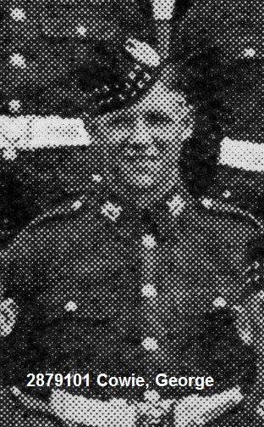
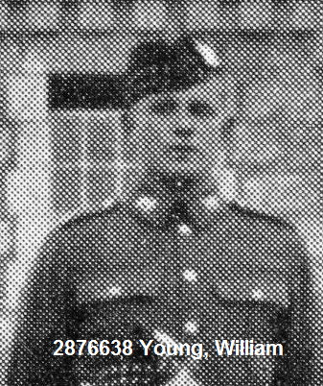
In 1944, Japanese secret codes had been broken, and American submarines in the Far
East were taking an increasingly heavy toll of their shipping. During the first night out,
Bill’s ship was torpedoed. The previous evening, he had seen five other ships in their
convoy, but in the morning none were visible; he wondered if his ship was the convoy’s
only survivor. Although badly damaged, she was not sunk, and managed to limp to an
island in the Philippines, where she was beached and the prisoners taken ashore.
After a day or so, they were rounded up and taken to Manila, and eventually there they
were lined up in two ranks to be re-assigned to other ships. It was common practice for
the Japanese, when allocating prisoners, to parade them in this manner, and normally
any division would be made by a guard walking along the
front rank and indicating where the partition was to be.
This meant that front and rear ranks would stay together,
and Albert and Bill, in expectation of this and determined
to stick together had lined up, one in front of the other.
On this occasion however, the front rank was allocated to one ship and the rear rank to another, so that they were split up. This was a severe blow to both, as not only had they become fast friends, but also to have a working partnership with a mate, where each helped and looked after the interests of the other considerably increased one’s chances of survival.
They would not meet up again till after the war.
Bill’s second ship was a repeat of the first, again a “Maru”, and again he was unable to trace the name, but in light of recently acquired information, it appears that it was very possibly the Hiyoki Maru.
Like the first, she was laden to the waterline, and the prisoners, several hundred in number, were huddled in bows area, again without any cover, and exposed to any breaking seas. As well as the normal ship’s crew, of course, there were soldiers guarding the prisoners. By this time, he had been separated from all of his old comrades, and was surrounded by strangers of several different nationalities.
During the passage it was stormy, and indeed the convoy, if convoy it was – it may merely have been a single ship – was hit by a typhoon. As the ship clawed its way northwards, so did the thermometer gradually drop, and Bill, who by this time had lost count of time, was merely trying to survive from one miserable day to the next.
One night he was lying, as were the other prisoners, on the steel deck trying to sleep, soaked, with only his loin cloth and a groundsheet he had managed to lay hands on, between him and the incessant spray. The ship was blacked out, of course, and the only light was that supplied by an intermittent moon. The old freighter plunged on, heading steadily north in the darkness. There was a lavatory, or banjo, for the prisoners in the bows of the ship (these were nominally lavatories, but in fact they were nothing more than a wooden box with a hole in the centre, slung over the ship’s side). A guard may have been making for this, or it may have been pure chance, but he decided to go forward, and in doing so kicked Bill quite hard on the back of the head with his steel shod boot. Possibly it was an accident, but in any case it was the straw which broke the camel’s back. Before he realized what he was doing, the old, fiery, Bill had jumped up, clutching his groundsheet, to confront the guard, who immediately lunged at him with his bayonet. Bill instinctively grabbed the bayonet to deflect it, and at that moment he realized that in grappling with a guard, he had burned his boats. If he was overpowered, the guard would certainly kill him.
The struggle which ensued must have been the stuff of which great films are made; the stormy darkness relieved only by stray moonbeams illuminating the spray; the wallowing tramp steamer with her deck cargo of emaciated prisoners watching the puppet silhouettes of a desperately weakened, ragged and bearded scarecrow enraged in a life or death struggle with a fully armed guard. It should surely have had only one ending, but desperation gave back to Bill the power which the long months of sickness, deprivation, and hunger had taken away. He realized that at all costs he must get the rifle and bayonet away from the guard, and fought for it like a maniac, slowly gaining the upper hand. The rifle clattered onto the deck, and Bill now grappled with the guard, who was probably shouting for help; he had no idea, and the whole episode later seemed to him like a nightmare.
Backwards and forwards they fought, stumbling over deck fittings and prisoners alike, until finally he managed to get his hands round the man’s throat, squeezing and squeezing till the guard lost consciousness. There was a hole in the bulwarks close by; Bill dragged the limp body to it, and with a last supreme effort managed to shove it through, to fall into the waves below.
It was the work of a moment to throw the rifle and bayonet after it, and all trace of the deed had gone. No alarm sounded, and it became clear that neither the ship’s lookouts nor the other guards had seen anything amiss.
During all this time, he had no idea of how long, but believed the struggle to have gone on for quite a few minutes, none of the prisoners had intervened, although nearly all must have been aware of it. He retrieved his groundsheet and collapsed back exhausted onto the cold deck, to spend what remained of the hours of darkness wondering what fate had in store for him when the guard was found to be missing. The other prisoners were a mixed bunch, all of them total strangers to him, and so none of them owed him any special loyalty. None of them spoke to him or said what they had witnessed, but he knew that all or most of them must have seen him kill the guard. If there were to be another ordeal such as the one at Tamarkan, where the prisoners were forced to stand to attention till the culprit or culprits were identified, he had no doubt that someone would break, and give him away. After that, a quick death was the very best he could hope for; to think of the possible alternatives turned his stomach to ice.
Next morning, however, Lady Luck once more, as so often before, smiled on Bill. There was an enquiry, but it was a rather half-hearted one, and he got the impression that the guards thought that the missing soldier had somehow fallen overboard in the storm. The idea that an unarmed and emaciated prisoner might actually kill a guard was probably too ridiculous to be entertained. In any case, the authorities had much more to worry about than one missing guard, especially if, as is probable, he was a Korean. By this time many Japanese boats were failing to reach their destinations; the threat of a torpedo was ever more likely. Sure enough, quite soon afterwards they were again torpedoed but not sunk. They were then transferred to a destroyer and taken to Formosa (Taiwan). After another transfer, the voyage finally ended at Moji, a port in Kyushu, the most southerly of Japan’s main islands. Once more, he had survived: it had been estimated that roughly 40% of prisoners transported on hellships perished en route, mainly by torpedoing. Bill believed that his journey time from Singapore to a snow covered Moji, in his loin cloth and bare feet, was about two months, and that they arrived in June or July, 1944. This of course is only an estimate, as the prisoners had usually no means of telling the time or the date. In Siam, the time of day was guessed by the distance from sunrise to sunset, and the period of the year by the monsoon season, which was roughly from May to October. Within this context, certain definite dates, such as the fall of Singapore and the start and completion of the Siam/Burma Railway, give fixed reference points for retrospective calculations.
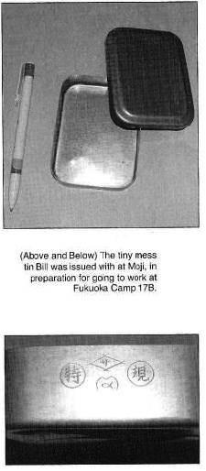
Next Stop - Japan
At Moji, the prisoners exchanged their loin cloths for green cotton suits of reasonable thickness, were given sandal type footwear, and also a small tin and lid. This tin, measuring 3 inches x 4 inches x 7/8 of an inch deep, was a little bigger than a 2 ounce tobacco tin, and Bill managed to finally bring his one home with him. They learned that they were to be sent to Fukuoka Camp 17B. a zinc foundry near Omuta which was part of the Mitsubishi armaments and shipbuilding complex.
Camp 17 was one of the most notorious of the POW camps in Japan, and Bill was Prisoner No. 970 of 1721. John M. Gibbs, in his report on Prisoner of War Camps in Kyushu, said of Camp 17 that, “British, Australian, Dutch and American prisoners evacuated (at) the last minute from Philippines and Siam were in desperate physical condition when they arrived.”
The Camp Commandment was Asao Fukuhara, later to be sentenced to death, along with three other staff members, for war crimes. Bill was there for fourteen months, and it almost killed him. It was to be the worst part of his internment as a POW; worse than the Death Railway.
The prisoners at Camp 17B were mostly Americans, taken prisoner in the Philippines.
They had been the first prisoners in the camp, and they ran the internal
administration, under the Japanese. Bill was extremely critical of the way the camp
was run, saying it was run by a clique, entirely for the Americans, to the detriment
of the small minority of other nationalities. (This distain was also spoken by many Americans from Camp 17) Indeed he often seemed to beat more animosity towards the Americans in this camp than he did towards the guards. In addition, at least one of the America officers appeared to be on very good terms with the Japanese, and any goodies went to his own cronies. (After the war, an American officer from this camp was Court Martialed for cruelty to his men).
Note: The American officer mentioned is in reference to Navy Lt. Edward Little, tried for treason,
but acquitted, much the chagrin of most of the men from Camp 17 who witnessed Lt. Little's treasonous
acts and cruelty (many used the word “betrayal”).
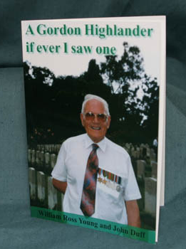
In particular, it was obvious from the physical condition of some of the Americans that they were getting better rations than the British, who in addition invariably ended up with all the hard and dirty jobs. Bill grimly remembered how, following an altercation with an American prisoner, the Yank (Lt. Little) went to a Japanese guard and complained about him!
The camp routine and work was hard and demanding. Reveille was at 3 a.m., when their mess tin was filled with rice. This had to last them till their evening meal of rice, followed by a watery vegetable stew, made from grass or whatever was available. Then they followed a walk of over 3 miles to the foundry, followed by a twelve hour shift
with a thirty minute break. Return to the camp was normally about 7 or 8 p.m. Bill was put to shoveling zinc ore into the furnaces, and then manhandling the ingots of zinc, each weighing about one hundredweight. The heat in the foundry was intense (about 120° F), and the slipper-like sandals supplied to the prisoners gave little protection from the burning hot steel floors. The workers were obliged to go outside every five minutes or so and jump in a tank of cold water to avoid collapse through overheating.
It would have been a hard and demanding job for a fit man and Bill, whose once strong
constitution had been by this time undermined by the privations suffered on the railway,
was in poor shape and suffering from Beri-Beri, brought on by prolonged vitamin
deficiencies, starvation and abuse.
For information to order William Young's book, visit the Gordon Highlanders Museum.

Credit: Stewart Mitchell, Gordon Highlanders Museum - Scotland

