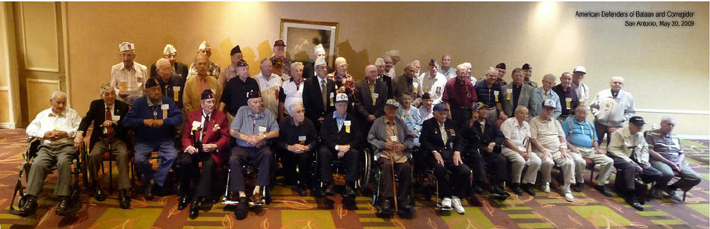
WWII ADBC Veterans Convention San Antonio Texas 2009

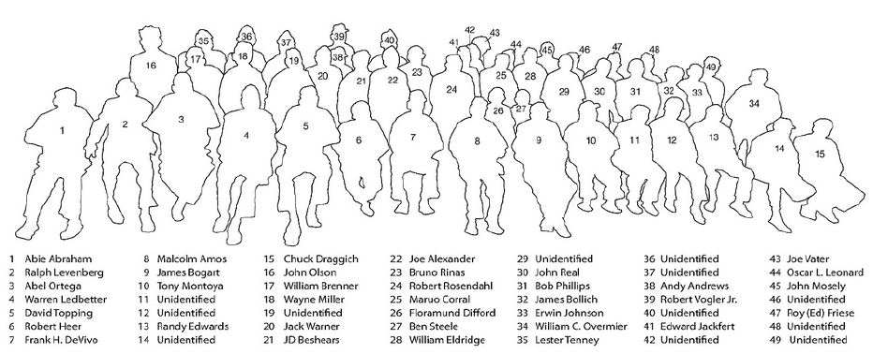

Credit: Shane Boyd - Nephew of POW Ted Kern

