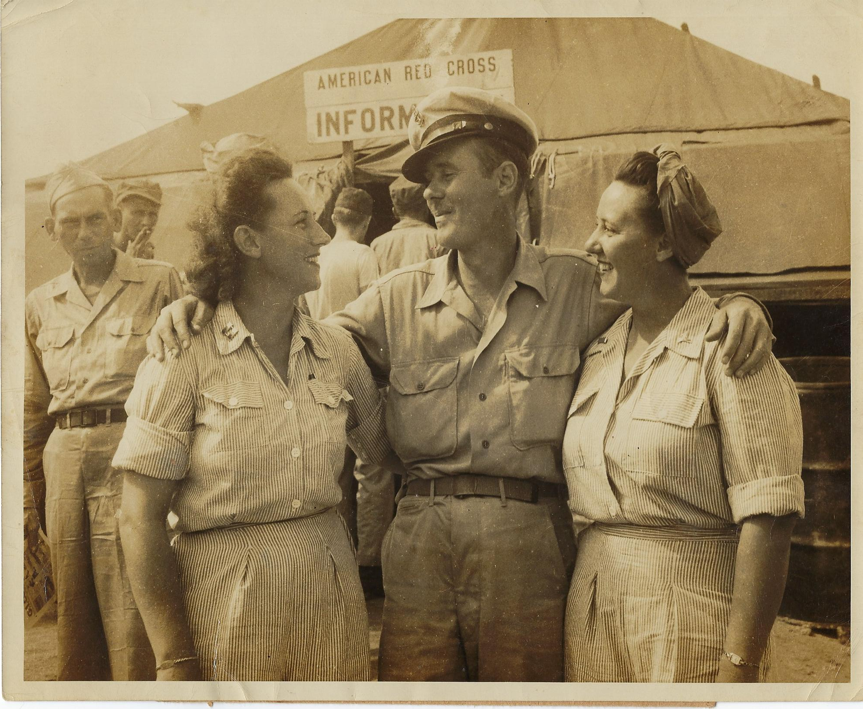

The above photo was published in George’s home town paper with the following caption. “Okinawa, Sept. 1945 – C. Ph. M. George Crowell, a former prisoner of the Japanese is reunited with his sisters, Capt. Aller Crowell, left, and Lt. Thelma Crowell, Army nurses from Berry, Alabama, who appealed to the American Red Cross recovered personnel locator service to help find their brother. They located him the moment he arrived at the Okinawa transient camp.
(American Red Cross photo by Hamlin) E879.”

