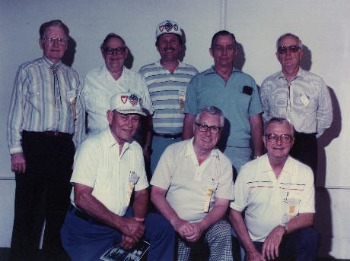

Oryoku Maru Hellship Survivors Reunion Photo

Kneeling on Floor (left to right): Jack Heinzel; Harold (Snuff) Kurvers; Art Beale
Standing: Chaplin Robert Taylor; Graham H. Andrews (?); Fred Rothor; ? ; and Lloyd Mills

