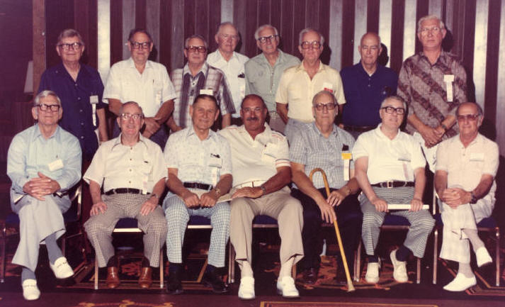

Oryoku Maru Survivors Reunion
First Row: Second Row:
1. ? name 1. Art Beale (?) Moji Hospital, Fukuoka 22, Mukden
2. Geo. Moore, Fukuoka Camp #3 Mukden 2. Graham H. Andrews (?), Fukuoka #1, Jinsen
3. Jack Heinzel, Fukuoka #3 Mukden 3. Russell J. Hutchison (?), Fukuoka #3
4. Jay B. Harrelson, Fukuoka #3 Mukden 4. James Donaldson, Moji Hospital, Fukuoka 22,
5. Burton Ellis, Fukuoka #1, Jinsen 5. Charles Brown, Fukuoka #3 Mukden
6. Harold Kurvers, Fukuoka 17 6. Lloyd Mills, Fukuoka #1 Jinsen
7. Louis Loicano, Moji Hospital, 7. Ted Spaulding, Fukuoka #1 Jinsen
& Fukuoka 17, Jinsen 8. Ken Vick, Fukuoka 17

