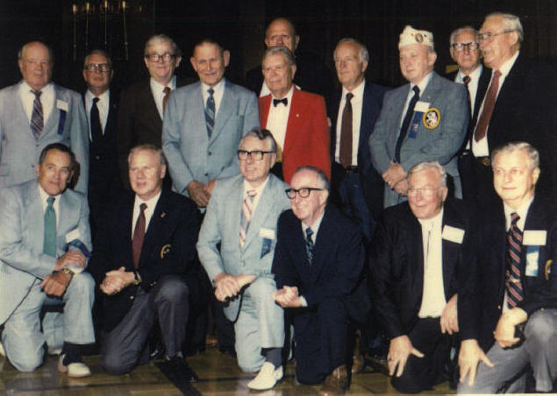

Oryoku Maru Survivors Reunion
Front Row: (left to right)
Ed Konik; (next man -?); Harold Kurvers - Fukuoka Camp 17; Geo. Moore - Fukuoka Camp #3, Mukden; (next man -?;
and Art Beale -Moji Hospital, Fukuoka 22, Mukden
Second Row: Otis Saalman- Fukuoka #3, Mukden; Graham H. Andrews - Fukuoka #1; Jinsen, Columbus "Doc" Savage -
Fukuoka #3, Mukden; Jack Heinzel - Fukuoka Camp #3 Mukden; ? man in red suit; Lou Kolger (behind man in red suit);
Lloyd Mills - Fukuoka #1, Jinsen; Next man (in blue jacket/ribbon/cap) is a Phony POW Imposter (per Harold Kurvers &
attending Vets; Charles Brown - Fukuoka Camp #3, Mukden; (last) Harold M. Ferrell - Moji Hospital, Fukuoka 17, Mukden

