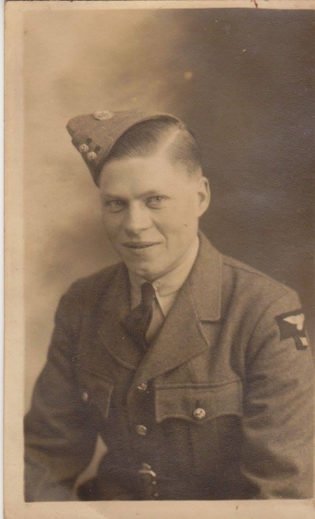

Harry Wilding
RAF 1272514
In 1940 at the age of 19, Harry from Cambridgeshire enlisted into the Royal Air Force his role was in Observations, he was then posted to Singapore.
After the attack at Pearl harbour in December 1941, Harry had been playing football with comrades when planes approached, they believed the aircraft to be their own, Harry’s response was to wave to them. Such a misconception was soon dismissed though, once aircraft began firing on them. With bullets raining down from all directions Harry, along with the other men, quickly made for the cover of the trees. Amazingly enough there were no fatalities, although a number of men did sustain injuries. Later that day orders arrived telling them to report back to Singapore and a new chapter of the war was about to begin.

Harry was soon to realise that the Singapore he had arrived back at was indeed somewhat different to the one he had left behind. Japan was pushing forward its forces at an alarming pace. It was shortly after his return to Singapore that orders came through for Harry and his unit to evacuate and make their way down towards the docks.
It was during this evacuation that Harry got hit in his left leg by a piece of shrapnel. Unable to walk he was carried onto what is believed to be one of the last boats to leave Singapore.
Harry remembered as they were leaving, watching through a small window in the cabin, the Japanese planes were bombing the other boats in the convoy. Unbelievably, given all the chaos and speed with which they evacuated, Harry’s boat was not hit and he was convinced that their saving grace came from an ambulance situated on top of the craft.

Whatever the reason, it was truly a miracle that they even made it alive to their destination of Java, as they not only had air attacks from the planes to contend with but also an unstable boat. Harry recalled how the men were made to walk from one side of the craft to the other to ensure the boat remained afloat, as both tanks upon the vessel were broken.

Upon arrival in Java, Harry who was then suffering from blood poisoning from the wound in his leg, was immediately transported to the Batavia Hospital. Due to the nature of tis wound and his illness, it further meant that Harry needed to stay quite some time in hospital, eventually he was discharged. Harry learnt his original unit had moved on and unable to follow them he was reassigned back into Observations, although this time his unit was made up of mostly Dutch personnel, of which only a few could speak English.

He remained there in Java until 8th March 1942 when, due to the defeat of the Java Sea on 5th March when Java fell to Japan, he received immediate orders to evacuate the area because of the approaching enemy. Harry fled, along with his Dutch colleagues, although his bid for escape did not see them get far, for after only a few miles his group ran straight into a Japanese ambush.

Once captured he was sent to Changi Jail, back in Singapore, where he was held until a boat became available to take him along with other prisoners to Japan. Harry remembered the poor and cramped conditions on board the vessel that transported them, he was made to sleep on barley which was their food supply for the journey. The prisoners were only allowed a short time on deck, once or twice a day to relieve themselves overboard.
Once in Japan, Harry was sent to Wakejama Camp to begin work in an iron foundry. It was while he was there Harry had the misfortune of getting a piece of steel in his eye, he was taken to the local hospital to have it removed. Needless to say no recuperation was given and the next day he was back at work in the forge.
Life was tough within the camps. What little time the prisoners did have was spent trying to gather extra food. Harry remembered how he would scour the area for anything edible; orange peel, tree maggots, snake, dog and even frying rice with engine oil. Undeniably it was due to improvising with foods such as these that enabled Harry with many others to stay alive, for many did succumb and die. Diseases such as beriberi ( a vitamin B1 deficiency), dysentery and cholera were rife.

The prisoners were also made to attend daily ritual called Tenko, that being a parade which saw the men lined up and made to bow to the Rising Sun (Japan’s Flag) and swear allegiance to Emperor Hirohito.
Harry remembered the day he witnessed the beating of four escapees, whilst made to watch and stand with the other POWs in his camp in silence as the Japanese used both their sticks and fists upon the men. After which the Japanese guards added further drama to this scene, by issuing a stern warning “that should any further attempts be made by any of the other prisoners to try and escape they too would be hunted down and shot”. With this the four men were then tied and bound, before being led ceremoniously by guards holding both guns and shovels in their arms towards a nearby aerodrome, needless to say the four men in question were never seen again.

It is hardly surprising, given such bleak and harrowing circumstances, that mentally many men gave in and succumbed to death. ‘Grub Happy’ is a word that Harry used to describe this condition. He explains that once a man lost his mind he would just sit and pick each individual grain of rice and slowly eat it.

Once this medical condition had set in, it almost inevitably meant within a few days or weeks that person quite simply would lose their will to live, and die.

Though on contrast, strength of character is one thing that Harry undoubtedly did possess, he emphasised how he would daily wash and shave his face. He stated it instilled a sense of pride within himself, thus enabling him to remain inwardly a psychologically stronger person.
Yet still, he remained a man who neither seeked acclamation nor praise in any way for his battle against survival during his years of capture.
Life was to improve slightly towards the latter part of the war. He was transferred to Osaka Camp #4 in Ikuno to work in a copper mine in the mountains, he and the other men for the first time received a Red Cross Parcel. For some this was seen as a sign of good fortune, believing that it signalled a turning point of Britain and America’s fortune in the war.
However, for others they thought the receiving of such a parcel spelt doom believing that if the Allied Forces were now beginning to fare better in the war, the Japanese would devise a plan to kill them all. Though on his part Harry quite simply dismissed such an idea , deeming it to be nothing more than rumour and pure speculation.

In August 1945 Harry awoke to find the campsite free of all Japanese guards, apart from a few who had commited suicide by hari kaii. It caused confusion, later that day thousands of leaflets fell from the sky to announce the surrender of Japan. Unbeknown to Harry at the time, this surrender was as a result of the two Atomic bombs dropped on Japan. The first on 6th August at Hiroshima, and the second on the 9th at Nagasaki, giving a combined death toll of 215,000 people. Harry’s saving grace was that when these bombs fell he was beneath ground in the copper mine.

The leaflet explained that food and clothes would be dropped at some point in the next two hours, in and around the region. Ironically, it was during the dropping of these goods, that Harry once again came close to losing his life. This time his assailant came not in the form of a Japanese bullet, but as a single tin of American boot polish. The polish having broken free from the main cargo was to narrowly miss Harry’s skull by only a matter of inches. He recalls at the time feeling something whizzing past his head so fast it literally embedded itself straight into the ground at his feet.
The men responded to the long awaited food supplied by gorging themselves upon the chocolate, candy and the like. Even Harry, whose weight had plummeted from a healthy 10 stone to a mere 7, fell prey to this overwhelming desire of indulgence and like so many others, he too suffered the ill effects of stomach cramps and sickness for doing so.

The following period of Harry’s life saw him stranded in Japan, having only been 180 km from HIroshima, he was now forced to wait until transport lines surrounding them could be repaired and mended enabling the POWs passage home.

Harry remembered travelling by train in an open topped carriage through Hiroshima and seeing the devastation. Not realising the risk of the radiation he was subjecting himself to.
The next and final leg of Harry’s journey saw him placed aboard the HMS Implacable and taken to Vancouver in Canada for repatriation.

Harry finally arrived back home in England on 1st November 1945, though needless to say his experiences in the Far East had a resounding effect upon him. For even though he was discharged fit and well from the Royal Air Force on 7th Oct 1946, after returning from a recuperation centre for servicemen in Scarborough, he still went on for a number of years to suffer graphic nightmares and flashbacks.

In 1949 Harry married Brenda a girl from his village, they had 61 very happy years together.
Harry was so thrilled when his daughter Linda was born in 1951.
After a very good life until the last two when Harry became very ill, he peacefully passed away in 2011 with his wife, daughter and granddaughters Justine and Zoë by his side, he was 89 years old.

