Map 1 of 2
Carl's POW journey

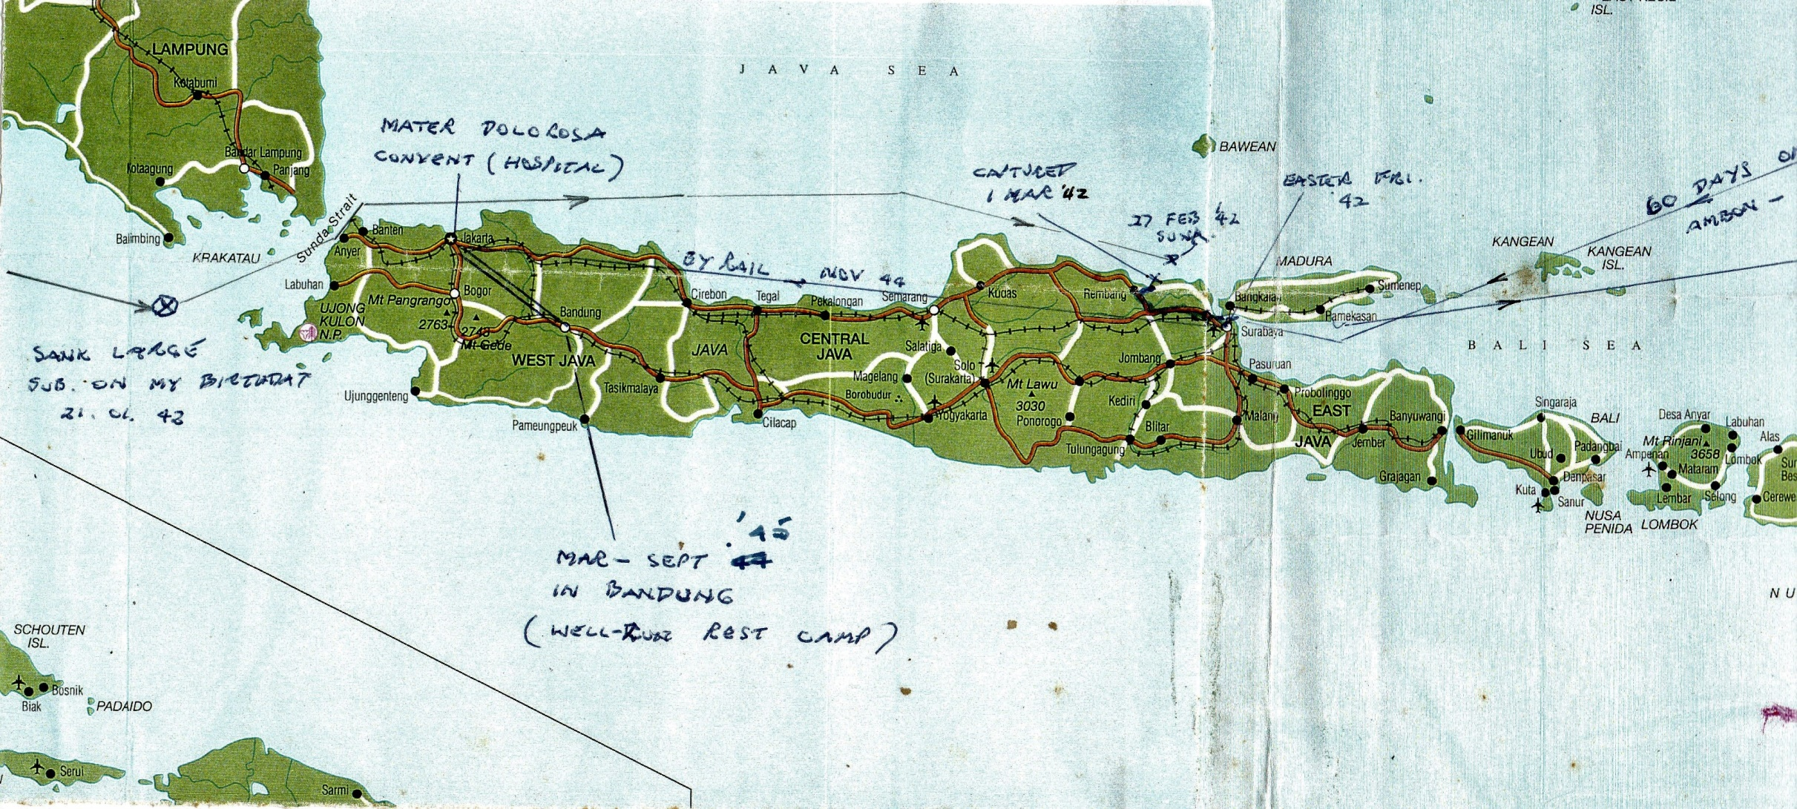

Map 2 of 2
Carl's POW journey

