Omi Memorial Unveiling

We flew on the 11-30 flight from Heathrow on the 3rd September with Keiko Holmes OBE, leader of Agape UK. Mr and Mrs Chris Brown, Chris’s father was at POW at Omi he came from Tibenham, Norfolk and was in the Royal Norfolk Regiment as was Arthur Robert Jones from East Dereham, Norfolk, Linda’s Father. Mr John Cove, John’s father came from Rhonda Valley, South Wales and was in the Surrey Regiment. Also in the group were our good friends, Terry and Lalitha Smyth who travelled with us in October 2010 on our first Pilgrimage of Reconciliation. Terry’s Father was also a POW in Southern Japan.

We arrived at Haneda airport Tokyo at 07-20 on the 4th and soon after boarded a train for Itoigawa, Niigata Prefecture and arrived at our hotel at about 3pm feeling quite tired after a long trip. Omi is a suburb of Itoigawa City.
That evening we met some family members of two British POW’s now living in New Zealand and Australia. The first family members were the family of Harry Carver originally from Nottingham, he is still alive and lives in New Zealand, and he is now in his late nineties and unfortunately was unable to travel because of ill health. The second family were the family members of Harold Frost, now deceased, originally from London. The Frost Family had been in touch with the Anzac Organisation in Christchurch New Zealand and they came with poppies for us to wear donated by them.

The following morning we awoke to heavy rain and our thoughts went to the POW’s who were held here 69 years before and had to work in all weathers.
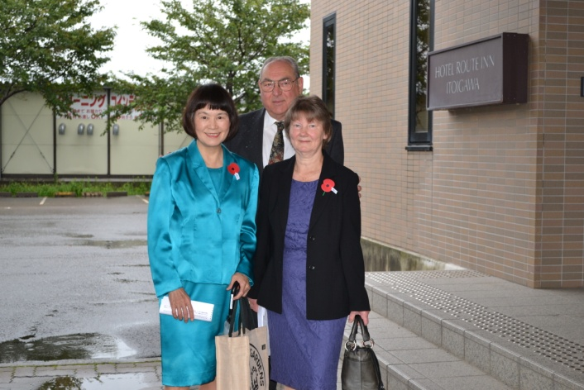
We were sent the days arrangements a few days before departing for Japan and it was evident it would be a tight schedule.
We along with Keiko Holmes were collected from the hotel at 10-30 by a manager from Denka and taken by limousine to the railway station where we waited for the train to arrive carrying the British Ambassador, Mr Tim Hitchens, also from the British Embassy were Captain Charles Ashcroft, Royal Navy, the Defence Attaché, Rebecca Wells and Isamu Suzuki. Also in the group was Captain Jim O’Leary, United States Navy the Senior American Defence Attaché. The Ambassadors limousine and another car with the Embassy staff and ours went in procession to the Denka Factory.
On arrival at the Factory we were greeted by the President of Denka, Mr Shinsuke Yoshitake, and his managerial staff and taken in to the office for introductions before the main ceremony.

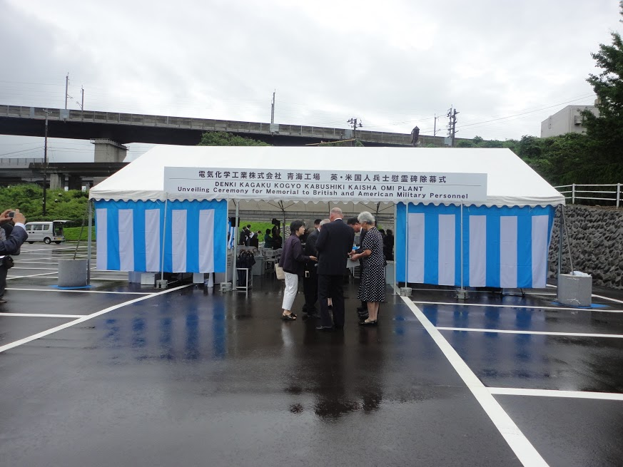
We travelled to the memorial site where we joined the other family members and our friends, who had been taken from the hotel to the memorial site by coach, and to everyone’s relief it had stopped raining but we needn’t have worried as Denka were well prepared and had covered the whole area with a marquee.
We were ushered to our seats and shortly after the ceremony commenced.
The first speech was given by the President of Denka, Mr Shinsuke Yoshitake, translated by an interpreter. The second speech was given by Mr Tim Hitchens who translated his own speech. The third speech was given by Naoki Ito the Deputy Director General of the Japanese Ministry of Foreign affairs and was translated by an interpreter.
The forth speech was given by Kevin Nicholls representing the families interpreted by Keiko Holmes. Kevin spoke of September the 5th being a very significant date in Omi history as it was on the 5th September 1945 that the survivors of Omi camp 13b marched out of the camp for the last time and proceeded to the Omi railway station for the first part of their long journey home and now sixty nine years on we are here to unveil this memorial to those who died. Kevin also spoke of the great sacrifice made by the prisoners who survived the horrors of their captivity and also acknowledged the sacrifices made by the Japanese families during this period in history.
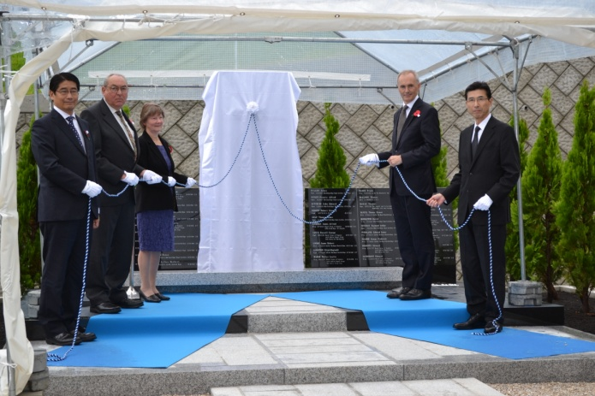
Following the speeches we were directed to the memorial and given white gloves to wear for the joint unveiling. The others involved in the unveiling were the British Ambassador, the President of Denka and Mr Naoki Ito. At the given signal we gently pulled on the rope and the memorial was unveiled displaying the main stone with a cross cut into it and beneath it an inscription, on either side were three more stones, six in total with ten names on each listing all of the sixty who died during their time at Omi camp. This was a very emotional time for Linda and Kevin and all family members.
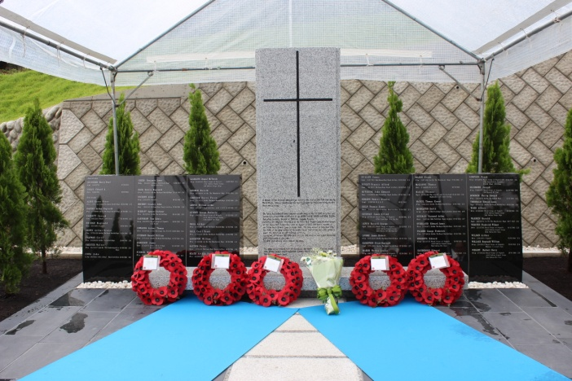
We were then handed a wreath provided by the British Embassy and were first to place it on the memorial. Following us wreaths and flowers were laid by the Ambassador, Denka president, Mr Ito, Captain Ashcroft and Capt O’Leary.

Following this official photographs were taken of the whole group who attended which was over sixty guests including several of our Japanese friends from our previous visit.

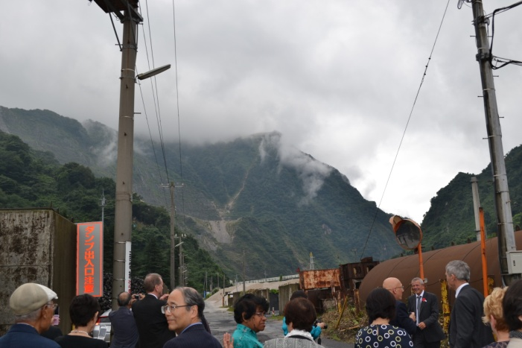
We were then all taken to the area believed to be where the camp was located this again was a very emotional moment for the families and friends and many photographs were taken.
A luncheon reception had been arranged by Denka which gave a chance for everyone to talk about their Fathers and what life was like after their return home to make a life as best they could under the circumstances.
After the reception we were taken to the railway station to bid the Ambassador and his staff farewell and thank them for attending.

We must the say at this point without the help and support of the British Embassy in Tokyo in particular Rebecca Wells and Susan Izumi, Henry Bellingham our local MP, Keiko Holmes and the friends of Agape World, POW Research Network Japan, Mansell POW Research, COFEPOW for whom we are members, the family members who were at the unveiling and those families of POW’s who have been unable to be at the unveiling we would not have been able to get this memorial erected.

The memorial we were told cost £150,000 so we must give our grateful thanks and appreciation to the President of Denki Kagaku Kogyo Kabushiki Kaisha (DENKA) Mr Shinsuke Yoshitake, Mr Asami also of Denka, and in addition the designer and craftsmen for all their hard work in getting this memorial erected which far exceeds anything we hoped for.

We started this journey almost four years ago and to have it completed is really special in honouring those who died and also remembering the sacrifice made by those who survived.
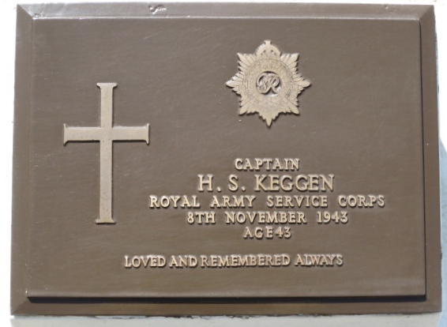
During this time we have only been able to talk to one family member of a POW who died at the camp. His name was Tom Hallworth, he was the son in law of Hubert Stanley Keggen who died at Omi on November 8th 1943 aged 43. Tom told us that Joyce, the only Daughter of Hubert and Marion Keggen, was in a nursing home suffering from dementia. Tom said how pleased he was to hear that we were trying to get a memorial erected and offered his full support. We said we would like to meet Tom but before we were able to meet him we were told that he had died. We are not sure if Joyce is still living but we were told it would be no point in contacting her due to her condition. Whilst in Japan we visited the War Graves Cemetery at Hodogya, Yokohama. During our visit we had a short service and Linda and Chris Brown laid some flowers on the main memorial. We then searched out the plaque beneath which are placed the ashes of Hubert Stanley Keggen and placed some flowers on it.

We cannot imagine what the POW’s went through but perhaps it is worth thinking about when we feel times are tough it is nothing compared to what they endured during their time at Omi. We also believe strongly that this monument offers peace and reconciliation between Britain and Japan and hopefully will contribute in some small way in making this world a better place for us all.

If there are any family members of those who died or survived who wish to contact us please do so at: nicholls57@btinternet.com

